Why We Must Demand Charter Accountability: Part 1
10 Charter Holders Spent less than 85% of their revenue and netted over $25 million Last Year
(Full report at: azcsa.org)

Ten charter owners netted over $25 million in 2018 by simply not spending their tax revenue. Four of the ten are alternative schools that serve the most at-risk students in the state. Alternative schools have no A-F rating so they can’t be closed by the Charter Board for poor academic performance. But instead of hiring counselors or additional teachers to improve academic performance, the alternative charter owners added millions to their bottom lines.

The two for-profit charters gave the windfall to their owners as profit distributions. The rest are non-profits that have growing assets, often used to make real estate transactions.

What does the Arizona State Board for Charter Schools say? The ten charters holders all meet the Board’s Financial Framework expectations - they are making money and are successful businesses. We think each school should be thoroughly investigated and audited.

There is nothing wrong with having a little cushion – charters average having 4% of revenue left over at the end of the year and public districts are allowed to have and annual 4% carry over. The ten schools in question put $25 million in the bank.

The worst are:
- Alternative online schools run by for- profit Pinnacle Education MGRM, a wholly owned subsidiary of the multi-national software corporation WGRM based in India. Pinnacle spent less than half of their state revenue last year and netted $4,348,615 in profits that were sent back to the parent company in India. (Full report at azcsa.org)
- Alternative schools owned by Steve Durand. Mr. Durand spent 53% of his state revenue and netted $3,619,572 in 2018. Durand’s schools are non-profit but are buying expensive real estate – his newest “school” is at 6710 W. Calle Lejos, a 5500 square foot mansion with a six-car garage purchased for $1,350,000. A photo of the “playground” of the new school is at the end of the report. (Full report at azcsa.org)
- “F” rated Star Charter School chartered by Painted Desert Demonstration Projects, Inc. and owned by Mark Sorenson. Star School serves Native American students outside of Flagstaff and receives an additional $750,000/year in Federal Impact Aid. The non-profit had over $2 million in assets in 2017 and added another $1,156,546 last year, spending 65% of their revenue - while providing an “F” rate education.
- Alternative Southgate Academy owned by Sherry Matjasik. Southgate spent 78% of revenue and added $1,232,875 to the non-profit’s bottom line of over $2 million. The charter invests its money in real estate. Southgate bought a piece of desert land outside of Tucson for $4 million from a company owned by a member of the Southgate board. After making mortgage payments to the board member for several years, they still owed $2,481,706 in 2017. Southgate then decided that they didn’t need the land after all and gave it back to the board member. This is a classic example of how a related party can benefit from the assets of their non-profit.
- Alternative for –profit online GAR, LLC. The online charter spent 83% of their revenue and made $1,250,736 in profit for its owners Patrick Meehan and Scott Lopez. The owners have collected over $11 million in profit and management fees since 2012. (Full report at azcsa.org)
- Three charters owned by Reana James netted $4,383,304 while expending 84% of their revenue. Ms. James had one “D” and one “F” school and made the news recently when they refused to pay teachers promised Prop 301 funds and face multiple allegations of sexual misconduct by one of their principals, who is a board member.

The four other charters spending less than 85% of their revenue that netted over $1millon in 2018 are:

- Mohave Accelerated Learning Center chartered by Vickie Christensen netted $1,503,138, spending only 75% of revenue
- Vista College Preparatory Inc. chartered by Julia Meyerson netted $998,624, spending 78% of revenue
- Kingman Academy of Learning chartered by Betsy Rowe netted $2,238,282, spending 81% of revenue
- The Paideia Academies Inc chartered by Robert Winsor netted $1,058,558, spending 83% of revenue

The Legislature needs to rein in related party transactions, require the Charter Board to monitor charter spending, and give the Board the power to audit charter owner’s finances when they suspect fraud. Maybe charter schools are over funded – some seem to have a hard time spending tax funds in the classroom.

Charter Holders spending less than 85% of revenue and netting over $1 million
A-F Grade | Charter Holder | Owner | Total Revenue | Total Expenses | Net Gain | % Spent
ALT | Pinnacle Education-Tempe, Inc | Pinnacle Education- Muhammad Padela | $6,353,782 | $3,112,338 | $3,241,444
ALT | Pinnacle Education-Kino Academy, Inc. | Pinnacle Education- Muhammad Padela | $674,937 | $434,334 | $240,603
ALT | Pinnacle Education-Westmark Chandler Boulevard, Inc | Pinnacle Education- Muhammad Padela | $1,055,481 | $188,913 | $866,568
ALT | Pinnacle Total | Pinnacle Education- Muhammad Padela | $8,084,200 | $3,735,585 | $4,348,615 | 46%
ALT | Educational Options Foundation | Steven Durand | $5,120,329 | $2,340,977 | $2,779,352
ALT | AIBT-NON PROFIT CHARTER SCHOOL | Steven Durand | $1,472,950 | $1,146,549 | $326,401
ALT | James Sandoval Preparatory High School Crown Pointe | Steven Durand | $817,254 | $417,681 | $399,573
ALT | Kestrel Schools, Inc. | Steven Durand | $275,256 | $160,610 | $114,646
ALT | Steve Durand Total | Steven Durand | $7,685,789 | $4,065,817 | $3,619,972 | 53%
F | Painted Desert Demonstration Projects, Inc. | Mark Sorensen | $3,331,719 | $2,175,173 | $1,156,546 | 65%
B | Mohave Accelerated Learning Center | Vickie Christensen | $6,062,279 | $4,559,141 | $1,503,138 | 75%
ALT | Southgate Academy, Inc | Sherry Matjasik | $5,607,369 | $4,374,494 | $1,232,875 | 78%
A | Vista College Preparatory, Inc. | Julia Meyerson | $4,504,879 | $3,506,255 | $998,624 | 78%
B,A,A, | KINGMAN ACADEMY OF LEARNING | Betsy Rowe, Susan Chan | $11,787,614 | $9,549,332 | $2,238,282 | 81%
ALT | GAR, LLC | Patrick Scott Meehan | $7,576,507 | $6,325,771 | $1,250,736 | 83%
C | The Paideia Academies, Inc. | Robert Winsor | $6,247,265 | $5,188,706 | $1,058,559 | 83%
F,B,B | Arizona Community Development Corporation | Raena James | $15,451,653 | $13,428,630 | $2,023,023
B,A | Heritage Elementary School | Raena James | $7,861,356 | $6,381,685 | $1,479,671
D,B | Liberty Traditional Charter School | Raena James | $4,589,231 | $3,708,621 | $880,610
 | Raena James Total | Raena James | $27,902,240 | $23,518,936 | $4,383,304 | 84%
 | Total |  |  |  | $25,377,642

Educational Options new “school” playground area at 6710 W. Calle Lejos Phoenix, AZ
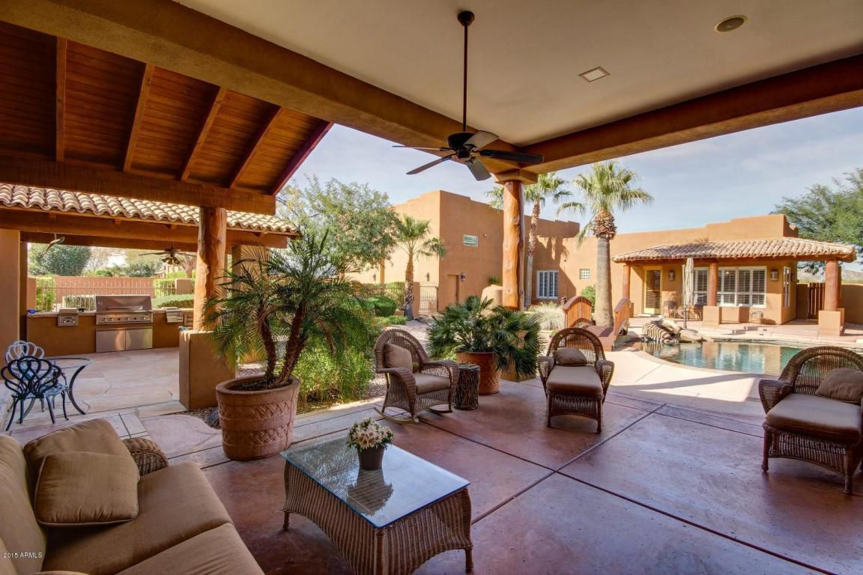

2018 Annual Financial Reports page 1 revenue and page 2 M&O expenditures found at: http://www.ade.az.gov/schoolfinance/forms/leaquery/submittedfiles.aspx
Financial Framework performance can be found at: https://online.asbcs.az.gov/
Details of the real estate transaction can be found on the 2017 Southgate Audit at: https://online.asbcs.az.gov/charterholders/view/122/southgate-academy-inc
https://www.azcentral.com/story/news/local/glendale-education/2018/07/30/top-execs-glendales-heritage-charter-school-face-harassment-claim/802498002/

