Arizonans for Charter School Accountability
December 14, 2021

Complaint Re:
- EdKey Sequoia Choice is in violation of their charter contract by subcontracting the majority of their online students to private schools that do not have a written curriculum or grade level scope and sequence of instruction based on Arizona State Standards. The private schools also do not provide the minimal course of study as required by Arizona State Board of Education regulations and EdKey’s contract with the Arizona State Board for Charter Schools.
- EdKey has fraudulently submitted twenty percent or more of AOI instructional hours logged by subcontracted private school students that were not based on Arizona State Standards or AOI courses taken by students.
- EdKey misrepresented revenue gained by private school partnerships to qualify for a $87 million bond loan in 2020.
- Sequoia Choice collected over $3 million in additional revenue from state and federal programs 2020-2021 because of increased enrollment of private school students. Private school students did not receive the benefits provided by these programs and the private school educational programs did not meet the requirements stipulated in the grants. The additional grants fund were supplanted by EdKey in existing Distance Learning programs

Background
Many school districts send students to private schools when they cannot meet the student’s educational needs. There are 37 private special education schools in Arizona that serve students with severe disabilities districts are unable to adequately educate. These private schools have many statutory requirements delineated, in R7-2-402, including the requirement that the schools provide a curriculum that is aligned with Arizona State Standards. There are no other private schools, to our knowledge, where charters or districts place non-special education students – except EdKey Sequoia Choice charter school.

Sequoia Choice had 797 full-time K-8 Arizona Online Instruction (AOI) students in 2020. That number exploded to 4,213 K-8 AOI students in 2021 as the result of “partnerships” with private home-school companies including Preda Inc., Venture Upward and Tech Trep Academy (“private schools”). EdKey enrolls the private school students and submits time sheets from the companies to ADE for funding, documenting student minutes engaged in AOI instruction. EdKey collects approximately $8,000 for each private school pupil they enroll and kicks back approximately $5,000/pupil to the private schools as a “purchase service”. Sequoia Choice has no other responsibilities for the education of the 3,000+ students that are enrolled in the private schools, keeping the remaining $3,000/pupil as profit.

EdKey is responsible for administering state AZM2 testing to the micro-school students, but in 2021 Prenda was allowed to have parents administer the tests, rather than being proctored by Sequoia Choice. The 2021 test results for the private school students were mixed into all of Sequoia Choice test data (by ADE policy), so there is no way of knowing how the private school students performed.

EdKey claims they are offering parents additional educational options with this arrangement and the Arizona State Board for Charter Schools (ASBCS) and the Attorney General have allowed the practice to continue. ASBCS contends that EdKey is merely buying a “purchased service” from the private schools, just like another school might buy the services of a speech therapist if one was not available in the school. Again, no other district or charter school subcontracts their non-special education students to private schools as a “purchase service”. And no other district or charter school collects $3,000/pupil for simply enrolling and collecting time sheets for AOI students they do not educate.

Sequoia Choice has a Program of Instruction that was approved by ASBCS that includes a complete curriculum and scope and sequence of instruction based on Arizona State Standards. ASBCS conducted a Five-Year Review of Sequoia Choice in 2018 that included an extensive Academic Systems Review that monitored their program of instruction, classroom observations, and documentation of teacher training and evaluation.

The Academic Systems Review specifically details the requirement for an explicit written curriculum that aligns with State Standards and the content taught at each grade level:

I. An explicit, written curriculum for core content areas that aligns with Arizona academic standards.
i. Evidence of curriculum alignment with state academic standards for core content areas and grade levels within an academic year.
ii. Evidence of explicit content and skills to be taught for each grade level and/ or content area.

The Sequoia Choice Online curriculum and instruction met the requirements of the Five-Year Review. The online program at Sequoia Choice has a complete scope and sequence of instruction, curriculum maps and pacing guides based on state standards for each grade level. It also provides detailed descriptions of teacher training and evaluation.

Unfortunately, the private schools do not utilize any of the Sequoia Choice AOI program or teachers. Most students at Sequoia Choice are not being educated with the ASBCS approved curriculum and program of instruction. Instead, students enrolled in the EdKey private school partnerships utilize diagnostic, self-pacing commercial language and math programs provided by the private schools that are aligned to Arizona standards, but do not follow a grade-level scope and sequence. The private schools also allow parents to choose their own educational programs without regard to grade level state standards or the required program of study for all district and charter schools.

The private schools utilize some software programs that are aligned with Arizona State Standards, but these programs, do not constitute a curriculum as defined by the Arizona State Board of Education:
Standards are what a student needs to know, understand, and be able to do by the end of each grade. They build across grade levels in a progression of increasing understanding and through a range of cognitive demand levels. Standards are adopted at the state level by the Arizona State Board of Education. While the Arizona English Language Arts Standards may be used as the basis for curriculum, they are not a curriculum. Therefore, identifying the sequence of instruction at each grade - what will be taught and for how long- requires concerted effort and attention at the local level. Curricular tools, including textbooks, are selected by the district/school and adopted through the local governing board.

All Arizona school districts use the state standards to create a scope and sequence of instruction for every core subject and elective at each grade level that includes curriculum resources to be used, the time to be spent in instruction, and evaluation criteria for mastery.

Language arts and mathematics standards rely on students building sequential skills at each grade level. Social studies standards assure that K-8 students have been exposed to U.S History, World History, Civics, and Economics. Science standards make sure students understand key concepts in Biology, Earth Science, and Physical Science, so they will be prepared to take these courses in high school.

Charter schools have the same responsibility to provide curriculum and instruction based on grade level standards. For example, the Arizona Charter School Association has these guidelines for charter school curriculum development:

ACADEMIC INDICATOR 1.2: CURRICULUM AND INSTRUCTION - The school creates a comprehensive curriculum, instruction, and assessment system aligned to required standards, college and career readiness measures, and the school’s mission and vision. The curriculum and instruction includes effective strategies to meet the needs of a diverse student population.

1.2 KEY QUESTIONS
• Are curriculum materials aligned to state standards and used to drive instruction
• Do the curriculum materials provide a scope and sequence for instruction throughout the year?

The Sequoia Choice AOI program has an approved scope and sequence of instruction, curriculum maps and pacing guides to assure that students are receiving instruction in all grade-level skills in each subject. The Sequoia Choice students that attend private schools, however, do not have the opportunity to have an education based on state educational standards and are missing out on required grade-level instruction in science, social studies, health/PE, music, and art.

- The private schools are not providing a minimal program of instruction as required by ADE regulations and do not teach grade level concepts and skills based on state standards

State Requirements: Minimum Course of Study
All district and charter schools are required by R7-2-301 to have a minimum course of study that includes the core subjects of language arts, math, science, and social studies plus health/physical education and two electives, which are usually visual arts and music – all to be based on grade-level state standards:

R7-2-301. Minimum Course of Study and Competency
Goals for Students in the Common Schools
A. Students shall demonstrate competency as defined by the State
Board-adopted academic standards, at the grade levels specified, in the following required subject areas. District and charter school instructional programs shall include an ongoing assessment of student progress toward meeting the competency requirements. These shall include the successful completion of the academic standards in at least reading, writing,
mathematics, science and social studies, as determined by district and/or statewide assessments.
1. English language arts;
2. Mathematics;
3. Science;
4. Social Studies; including:
a. Civics; and
b. Instruction on the Holocaust and other genocides at
least once in either grade seven or grade eight;
5. The Arts, which may consist of two or more of the following: visual arts, dance, theatre, music or media arts;
6. Health/Physical Education.

There are state grade level standards for each of these required subjects. The private schools, however, allow parents/students to select topics of interest for science and social studies instruction and often teach the same lesson to mixed aged classes without regard for grade level standards. The private schools relegate Health/P.E., visual arts and music as options parents can ignore if they choose. Core subject instruction is provided by diagnostic self-paced language arts and math programs that do not assure students are taught grade-level skills.

EdKey Sequoia Choice has a contractual obligation to provide students an education based on state educational standards. Instead, EdKey has provided “school choice” by subcontracting most of their AOI students to private companies that educate children anyway they see fit, without regard for the state required course of study or state grade level educational standards.

Descriptions of the private school educational programs:

Prenda Inc.: (A more detailed description of Prenda’s program begins on page 10)
- Prenda provides language arts and math programs that are aligned with state standards, but the programs are diagnostic in nature and provide instruction based on the student’s current instructional level. These programs are good remedial tools, but do not provide students with comprehensive instruction of required grade-level skills.
- Science and Social Studies topics are selected by Prenda parent guides, or students themselves, with no regard for grade level state standards.
- The state required courses in Health/PE, visual arts, and music are not taught in a systematic manner with no regard for state standards in these areas.
- Twenty percent of all Prenda instructional hours are reported based on “Bonus Time” where parents log AOI time as anything they deem educational including yardwork, housework, babysitting, and spelunking.
  - This a violation of Arizona Department of Education (ADE) AOI rules that require all logged minutes to be related to the AOI courses the student is enrolled in. (See Exhibit 1, p. 9)

Venture Upward: (A detailed description of the Venture Upward program begins on page 16)
Venture Upward, an Idaho corporation, has no scope and sequence of instruction based on grade level state standards and parents can choose any curriculum they wish, regardless of its fidelity to state standards.
Venture Upward:
- Allows parents to choose from 12 computer programs to fulfill the core requirements for Language Arts, Math, Science, and Social Studies “…giving the parent the freedom to utilize resources that are consistent with their educational philosophy.” Parents plug their students into the instructional levels they choose without regard for grade level state standards in each subject.
- Teaches required electives (Art, Music, Health/PE) through Venture School with “hands-on classes such as world geography, art, messy science experiments, cooking, money management, Spanish, taekwondo, and music exploration. “ There is no mention of grade level state standards taught for the elective subjects.
- Gives parents $1,000 per pupil to purchase educational material they may keep. This would be an unlawful gift of public monies in a school district:
  - Computer, laptop, or tablet
  - Textbooks, workbooks, books
  - School supplies (including pencils, paper, notebooks, and so on)
  - Art supplies
  - Musical instruments or supplies
  - Printer or related printing supplies
  - Microscopes, science supplies (non-edible)
  - Additional Subscription Boxes (Little Passports, Tinker Crates, Raddish Kids)
  - Usbourne Books
  - Educational Games / Board Games
  - Subscriptions (magazine, audiobook, etc.)
Tech Trep Academy (A detailed description of the Tech Trec program is on p. 19)
Tech Trep unabashedly advertises its services as a way for home school families to access state funds:
“We help families receive resources to help them better educate their students by accessing state funds’.

Trec Trep Academy:
- Advertises that parents can choose from a list of programs provided by the company, or any other non-religious instructional program they choose, for the core subjects of language arts, math, science, and social studies, regardless of its fidelity to state standards. Tech Trep has no scope and sequence of instruction based on grade level state standards and offers a mishmash of “free programs” for the core subjects. (See the list on page 19)
- Electives are whatever parents deem to be educational activities.
  - “The electives can be PE, fine arts, foreign language, technology, or anything the student is interested in.”
  - Custom Electives – “Families are welcome to create their own custom elective classes according to student interest. Many families choose community resources for these electives, such as gymnastic, dance, music, or karate classes.”
- Parents receive $1,700 per student to purchase any non-religious programs they choose, a potential gift of public funds:
  - “Educational items such as curriculum, online subscriptions, computers/tablets, internet fees, extracurricular classes, tutoring, museum passes, tech items and so many more things can be purchased with the supplemental learning funds. Parents get access to these funds through direct purchases and/or reimbursements.”
- Students can receive instruction any way parents choose – they are not required to use programs provided by Tech Trep or to utilize online learning at all:
  - “…we believe parents should have the flexibility to choose the best format for their student’s learning. Some families prefer a technology-based curriculum while others want to do learning using textbooks. Others prefer hands-on activities and real-world learning and many choose a mix of all three. It is our goal to support parents as they choose the ways their student learns best. It is the parents who will decide how much time the student spends on the computer, if any.”
- There is no prohibition on religious instruction, as long as parents supply the curriculum:
  - “ Parents are free to supplement their child’s education with religious materials using their own private funds. As this program is in partnership with the public education system, only secular materials are approved for reimbursement or direct orders. “

Prenda Inc., Venture Upward, and Tech Trek leave the education of students in the hands of parents, without regard for state grade level standards. If EdKey is to subcontract its students to these private schools, they, like the private special education schools, need to have a curriculum and a grade level scope and sequence of instruction based on the required course of study and state educational standards prescribed by statute. The EdKey transfer of state education funds to private schools not meeting state educational standards is a misuse of public funds.

- EdKey’s windfall profits are based in part on fraudulent reporting of instructional hours by private schools that do not offer the required minimum courses of study and do not have required grade level scope and sequence of instruction based on state standards for core subjects or electives.

EdKey Sequoia Choice has recorded record profits - increasing their revenue by $35 million between 2019 and 2021 because of its partnerships with private schools and is “kicking back” close to $20 million back to the private schools:

AFR | Expenditures | Revenue | Profit | Purchase Services
2019 | $5,504,698 | $6,749,687 | $1,244,989 | $2,390,634
2021 | $30,945,840 | $41,856,927 | $10,911,087 | $21,027,309
Change | $25,441,142 | $35,107,240 | $9,666,098 | $18,636,675
2022 Budget | $43,625,056 | $49,047,548 | $5,422,492 | $27,863,323
More than 20% of the student AOI instructional hours EdKey has submitted to collect $8,000/pupil in state funds from 2020-2022 was fraudulently reported based on random “Home Time” parents logged that was not related to the AOI courses students were taking. Worse, students enrolled at Tech Trec are logging AOI hours even when not taking AOI courses. If only half of the $77 million EdKey received in additional revenue since 2019 was the result of enrolling private school students, $15 million was collected based on parent reports of AOI time that had no relationship to AOI courses or grade level state standards. We believe it could be double that amount.
- Sequoia Choice is in violation of its charter contract
Sequoia Choice’s contract with ASBCS specifically states:
- Academic Performance Indicators and Evaluation: The Charter Holder shall:
  - Provide a comprehensive program of instruction that aligns with the state academic standards prescribed by the Arizona State Board of Education for the grades approved to operate.
EdKey is not providing such a program to the students they subcontract to private schools. There is a total lack of transparency regarding how public funds are being expended by EdKey’s subcontracting of thousands of charter school students to private schools. The private schools are giving gifts of state funds provided by EdKey to parents to buy and keep computers, musical instruments, karate lessons, and art supplies. And, worst of all, there is no educational accountability for these students – their 2021 AZM2 test results are not available.
Arizonans for Charter School Accountability contends that EdKey Sequoia Choice charter school is in violation of their charter contract by subcontracting most of its K-8 AOI students to private schools that do not provide a curriculum or instruction based on state standards and are not meeting the minimum course of study required ADE regulations. Additionally, twenty percent or more of AOI instructional hours logged by private school students are from random home activities and are not related in any way to AOI courses taken by students based on state standards.

EdKey is fraudulently profiting from millions in state education funds by subcontracting the majority of their online K-8 students to private schools that do not provide the state prescribed course of study and are submitting instructional hours that are not related to AOI courses taken.

- EdKey misrepresented revenue gained by private school partnerships to qualify for an $87 million bond in 2020

Executives at EdKey are aware of the dubious situation created by subcontracting students to private companies – so much so that they failed to disclose the arrangement in their 2020 application for $87 million in bond loans facilitated by the Pima County IDA.

EdKey leveraged the $20 million increase in revenue created by subcontracting K-8 AOI students to private schools to qualify for the $87 million loan, but did not disclose the arrangement with private schools that created the revenue surge in their bond disclosure.

The EdKey financial projections used to qualify for the bond loan indicated that K-8 enrollment was expected to increase by 50% between 2020 and 2021, with elementary enrollment expected to nearly double by 2026.
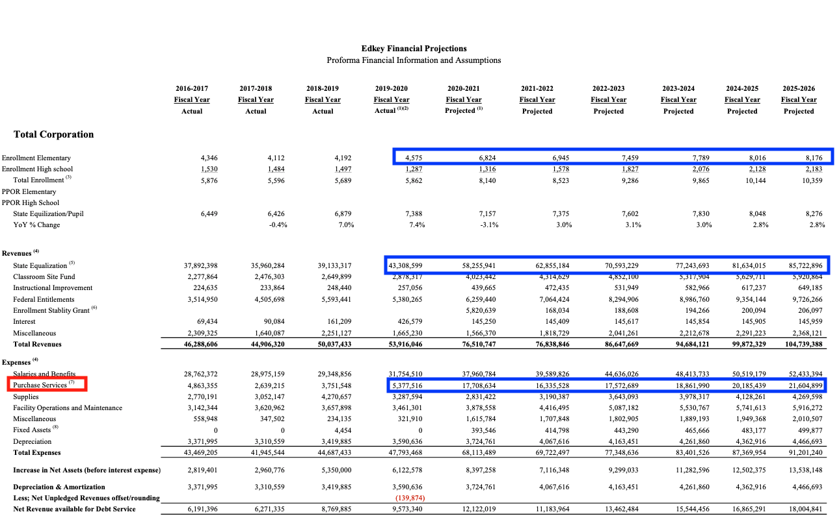

Purchase services were projected to triple between 2019 and 2020, increasing to $21.6 million in 2026. EdKey explained this dramatic increase was the result of:

Footnote 7 – Fy21 increase related to (1) COVID and (2) the Corporation entering into contractual arrangements whereby the Corporation enrolls students from unrelated charter operators and public schools that do not have sufficient online learning capacities to provide virtual education as mandated by the State. Consequently, as a result of these developments and shifting cultural attitudes toward online education, the Corporation anticipates that the demand for the Distance Learning School will remain very high on a permanent basis.”

EdKey did not disclose the tenuous contractual arrangements with private schools that are responsible for the increase in enrollment and revenue the company used to qualify for the $87 million bond loan. Instead, EdKey falsely claimed that contracts were made with unrelated charter operators and public schools. Furthermore, EdKey falsely stated that the revenue increases are the result of a high demand for the Distance Learning School. Private school enrollees are not using the services of the Distance Learning School including its online curriculum and teachers.

Investors were not warned that half of EdKey’s projected income in 2026 could be the result of questionable arrangements to subcontract the majority of online K-8 students to private schools, not contracts with other charters and public districts as stated in the official disclosure.
__________________________________________________________________________________________

- Sequoia Choice collected over $3 million in additional revenue from state and federal programs 2020-2021 because of increased enrollment of private school students. Private school students did not receive the benefits provided by these programs and did the private school educational programs did not meet the requirements stipulated in the grants

EdKey Sequoia Choice receives funding from several state and federal programs that are funded based on enrollment numbers. These funds have dramatically increased between 2020 and 2021 creating $3,535,678 in additional revenue in 2021 because of the additional enrollment of private school students. The EdKey private school partners are not receiving the services provided by the government programs and are not complying with the educational requirements stipulated by the grants. EdKey instead is illegally using the funds to supplant spending in their charter operation.

State K-3 Reading:
Schools received about $145/pupil in 2022 for each K-3 ADM to fund the requirements of ADE’s Move on When Reading program. Sequoia Choice expenditures for their K-3 Reading program increased by $354,627 in 2021 with $331,271 going to pay salaries and benefits for teachers at Sequoia Choice.

Sequoia Choice | K-3 Reading
 | Salary | Benefits | Purchase Services | Supplies | Total
2020 | $47,639 | $0 | $0 | $0 | $47,639
2021 | $296,994 | $34,277 | $66,995 | $4,000 | $402,266
Increase 2020-21 |  |  |  |  | $354,627

Sequoia Choice K-3 AOI enrollment increased by over 2,000 students between 2020 and 2021 as the result private school partnerships. Those students did not benefit from the additional K-3 reading teachers or from K-3 intervention programs at Sequoia Choice - the private schools do not utilize Sequoia classroom teachers and have their own educational programs. The additional K-3 teachers added by Sequoia Choice in 2021 supplanted existing funding and did not benefit the new private school students enrolled in 2021.

The K-3 Move on Reading Program has many requirements for K-3 reading instruction.
The ADE states:
“At all times throughout any given K-3 school year, all children receive 90+ minutes (or 450+ minutes per week) of high-quality instruction from an ESSA evidence-based core reading program (Tier 1) in whole group and differentiated small group. This core reading block is dedicated to reading standards. All schools are required to submit their core reading block schedule directly within the literacy plan. The schedule should reflect Tier 1 minutes for each K-3 grade level served, including additional intervention periods outside the Tier 1 block.”

Sequoia Choice meets the instructional time and curriculum requirements in their K-3 Reading Plan while the private schools subcontracted by EdKey do not. Prenda, for example, requires K-2 students to spend 60-90 minutes a day (240-360 minutes a week) on the “Conquer” mode which includes all instruction in Reading, Writing, Language Arts, and Math. State requirements for K-2 reading alone is 450 minutes/week. The Prenda Reading/Language Arts AOI program, Lexia Core 5, is not an approved ESSA reading program approved by ADE.

None of the three private schools subcontracting with Sequoia Choice meet the K-3 Reading instructional time requirements or utilize an approved ESSA evidence-based core reading program.

Prop 301 Classroom Site Funds
Schools received $425/ADM in 2021 in Classroom Site Funds (CSF). Sequoia Choice CSF allocation increased by $1,399,082 in 2021 as a result of the addition of thousands of private school enrollments. EdKey reported that the $2 million in CFS received in 2021 was expended on:

Program | FY 2021 | Summary of results
 | expenses
Class size reduction | 205,000 | Prop 301 allowed us to purchase services which in turn decreased staff to student ratios. Ultimatly, this led to class size reduction.
Teacher compensation increases | 1,165,844 | Prop 301 allowed us to maintain teacher compensation which in turn helped us recruit and retain higher quality teachers. The quality of teaching continued to have a positive and direct effect on student performance.
Assessment intervention | 312,000 | Prop 301 allowed us to purchase services which provided assesment and intervention to students. Ultimately, this supported students who needed the most help.
Teacher development | 330,000 | Prop 301 has allowed us to purchase services which supported and trained teachers. Ultimately, this provided both new and returning teachers with the training and development needed in order to positively impact student acheivement.
Dropout prevention
Teacher liability insurance premiums
Total expenses (should agree to AFR page 4, line 18) | 2,012,844

It appears that EdKey paid its private school partners $205,000 for helping to reduce Sequoia Choice class sizes but every student subcontracted to the private schools in essence reduces Sequoia class sizes. The rest of the Classroom Site funds went to benefit Sequoia Choice teachers and provide services for academic intervention for Sequoia Choice students. Since the private schools do not utilize EdKey teachers or intervention programs, $1,800,000 in CSF in 2021 went to supplant existing funds to reduce Sequoia Choice expenses for teacher salaries, teacher training, and student intervention programs.

Sequoia Choice ESEA Consolidated funds from Title I and Title II federal programs.

Title I:
Sequoia Choice has run the same school-wide Title I program 2020-2022:

AZ Distance Learning runs a schoolwide Title I program which utilizes a Reading Specialist to increase academic
reading in grades K-12th. Math and reading interventionists (instructors) give additional instruction to academically
struggling K-12 students. The interventionists coordinate with the regular day instructors so the struggling students can
make the academic strides they need. The 9-12 Graduation Coach will help high school students to create plans
beginning in 9th grade so their transition to Post-Secondary career/college is easier. These plans will also include
strategies to keep the students in school for the entire four years of high school. The coach will meet with the students a
minimum of once a year, more often for those students who require interventions to keep them in school and
progressing on their written program.

The Sequoia Choice Title I program pays the salaries of Title I teachers who provide intervention in reading and math by working with their AOI teachers to help struggling students. The Title I program has grown from $126,541 in 2020 to over $2.5 million in 2022:

Title I | Allocation | Low Income Enrollment | Percent Low Income | Program | Number Teachers
2020 | $126,541 | 985 | 44% | Pull out | 4
2021 | $419,116 | 1,181 | 49% | Pull out | 6
2022 | $2,559,132 | 2,169 | 35% | Pull out | 27

It is interesting to note that despite Sequoia Choice claiming to have 27 Title I teachers this year, the staff list on their website shows 9 Academic Coaches, 5 Academic Advisors, and 26 non-special education teachers on staff. Their 2022 Annual Budget indicates there are 132 teachers at Sequoia Choice. (EdKey opened Pathfinder at Verrado Way this year that is chartered under Sequoia Choice. The school had just 7 teachers according to their website). It is unclear just how many teachers are employed by Sequoia Choice and how many have salaries funded by Title I.

Estimated full-time equivalent teachers |  |  |  |  | Prior year 2021 | Budget year 2022
[A.R.S. §15-903(E)(2)]
Number of full-time equivalent certified teachers |  |  |  |  |  | 34.00
Number of full-time equivalent noncertified teachers |  |  |  |  |  | 38.00
Number of full-time equivalent contract teachers |  |  |  |  |  | 60.00

Title I funding appears to include private school enrollments, with the program adding 1,100 students between 2020 and 2022. Since private schools do not utilize Sequoia Choice teachers and interventions, they are not receiving Title I services in EdKey’s “school-wide” program.

Title II
Title II funds are earmarked for teacher training. Sequoia Choice has submitted the same Title II program description 2020-2022:

1. Describe the activities to be carried out by the LEA and how these activities will be aligned with challenging State academic standards:
Through a 2 day training on differentiation teachers will be able to effectively utilize standards to differentiate instruction based on process, product and content. This will be follow up by implementation goals set at each site. These goals will be monitored by data outcomes and evaluation protocol data.
2. Describe the LEA's system of professional growth and improvement, such as induction for teachers, principals, or other school leaders and opportunities for building the capacity of teachers and opportunities to develop meaningful teacher leadership.
Edkey offers a teacher mentor program for all new teachers to Edkey. This 2 year program is meant to provide the necessary support and guidance in order for them to be successful. Principals and school leaders receive training and development by Edkey upper management. As needs are identified outside facilitators are brought in for support. Leadership opportunities are available to help support teacher leaders via outside professional development and site based mentoring and coaching.

Like Title I, Title II funds have increased significantly with the increased enrollment of private school students going from $22,200 in 2020 to $311,867 in 2022, but since the private schools do not utilize EdKey teachers, they are not receiving any of the teacher training benefits from Title II.

EdKey is accepting state and federal funds for students subcontracted to private schools but is only utilizing those funds only in their Distance Learning program, depriving private school students of services by supplanting the funds into existing EdKey programs.
=======================================================================================
Exhibit 1 ADE regulations regarding logged AOI time
SF-0002 AOI Participation, Effective JULY 1, 2014 Page 7 of 7
Policies & Procedures Manual Policy Number: SF-0003 | Issued/Revised: July 1, 2014
Policy Section: General | Policy Owner: School Finance
Subject: AOI Participation

AVERAGE DAILY MEMBERSHIP
Pursuant to A.R.S. §§ 15-808 and 15-901, the ADM of a student enrolled in a school district or charter school and also participating in AOI may not exceed 1.0. Enrollment in a JTED may allow students to generate combined ADM greater than 1.000, not to exceed 1.750. For students enrolled in AOI and non-AOI schools, SAIS allows concurrent membership for students enrolled in one or more non-AOI schools and one or more AOI schools. For students enrolled in an AOI and either a school district or charter school, the AOI instructional time logged by the student shall be reported to SAIS using the CTDS number for the AOI school attended. AOI instructional time logged shall not be reported as time spent by the student in non-AOI courses in a school district or charter school.

DAILY LOG
AOI schools shall maintain a daily log for each pupil who participates in AOI. The daily log shall describe the amount of time spent by each pupil participating in AOI on academic tasks. The daily log must list in minutes the amount of time spent on academic tasks for each course in which the student is enrolled. Pursuant to A.R.S. 15-808, the daily attendance for each student shall be determined based on the instructional time reported on the student’s daily instructional log.
_____________________________________________________________________________
Exhibit 2 - Private School Program Descriptions

Prenda Inc.
Prenda Required Instructional Time includes 4-5 hours/week as “Home Time”:
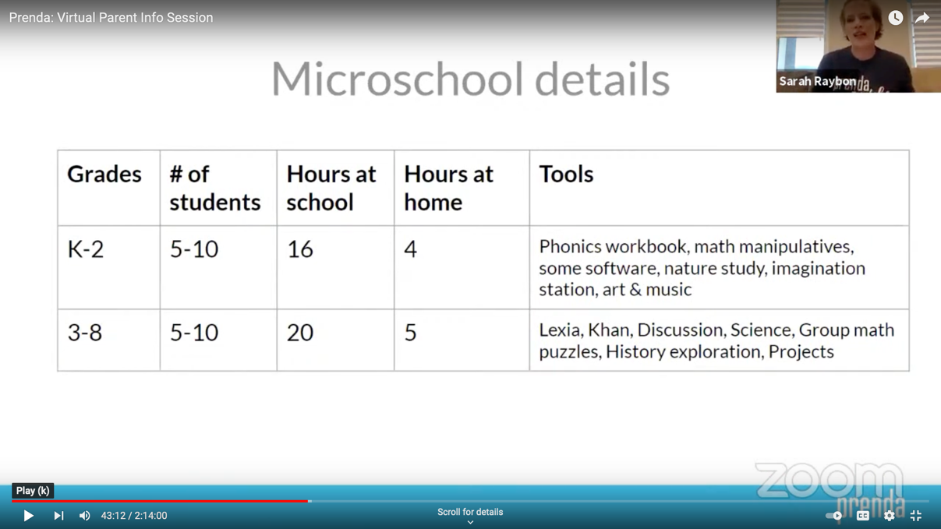

Prenda calls the time spent on Language Arts and Math as “Conquer Time”, utilizing programs that place students at their instructional level, rather than teaching grade level concepts:

Conquer time: what to do and flexibility within Conquer
Each day in Conquer Mode, students aim to work at their individual learning frontiers in 4 core subject areas: Reading, Writing, Language Arts, and Math. Some days a student is really focused on completing a math goal and might not choose to work in any other tools. Some days, a student might just work in 2 or 3 Learning Tools. This is acceptable but students should be encouraged to make sure they are moving forward in all 4 areas over time. For example, if a student is trying to finish a Lexia level and ends up skipping writing that day, that’s fine, but it isn’t ok for students to just opt out of writing everyday.

How long is Conquer time?

As you allot daily time for Conquer, consider the following criteria:
- Grades 3-8 do about 90-120 minutes of Conquer each day.
- Grades K-2 do about 60-90 minutes of Conquer each day.

Math – Zearn

“Zearn is another great math option for kids in grades K-7. It is the Prenda Pick for 1st-7th grade students. https://guides.helpscoutdocs.com/article/267-what-is-zearn-who-uses-zearn-how-do-i-try-zearn-as-a-student

How do I place students in Zearn?
Once you have your student's first i-Ready Math diagnostic results, it's time to change each student in your class to the appropriate grade level--their learning frontier--where they will be working.
If this placement seems off, in your GPS Meeting, you, the parent and the student can use any available student data to determine the student's initial placement level: parent knowledge of past history, Math data from last year, standardized test scores. https://guides.helpscoutdocs.com/article/268-zearn-grade-placement
Language Arts – Lexia Core 5

Lexia is the English Language Arts(ELA) learning tool that Prenda uses that is all encompassing. This program provides each student with adequate reading, grammar, spelling, and reading comprehension skills. Lexia ensures that there are no significant gaps in students' language learning.

Lexia provides a short, non-stressful diagnostic assessment before beginning the program. This will help students, parents, and Guides know exactly what a student may still need to learn.
https://guides.helpscoutdocs.com/article/286-what-is-lexia-core5-what-is-lexia-powerup-who-uses-lexia-how-do-i-experience-them-from-a-student-perspective
Prenda calls time spent on Science and Social Studies as “Collaborative Time” where instruction is based on student interest rather than grade level state standards:
Collaborate
Students will follow the Prenda-created learning formats given in Collaborate mode. We expect that Guides will ensure that students prioritize “history exploration” and “science project” collaboration activities at least half of their class periods as there are state standards and important content/skills embedded into these activities. For the other half of these collaboration activities, Guides and students can plan to rotate through the other Collaborate patterns (math puzzle, discussion, debate, poetry tea time, game school, etc.) as they wish. Guides should feel welcome to allow students to take these activities in any direction students decide.
Core Collaborate Programs: Explore & Science
The Core Programs are Explore (History) and Science which are both fueled by student questions and investigations. We encourage you to spend the majority of your Collaborate time with your students in these two programs.
The Core Collaborate Programs are Explore (History) and Science. These two programs should represent the majority of your Microschool’s Collaborate time. Over the course of a month (roughly 4 weeks), there are roughly 16 Prenda school days. Your Microschool might spend 12 days on Core Programs (for example, 6 days on Explore, 6 on Science) and 4 days on Supplemental Programs (for example, 2 Read and Discuss days, 1 Debate day, and 1 Collaborative Math Day). This is not set in stone, however; for example, you might do 12 Core days of just Science one month and then focus on Explore the next month.
Social Studies:
Explore: In Explore, students learn about history by choosing topics and time periods that interest them, asking questions, and then finding answers to their questions.
Explore activities are how Prenda students investigate and learn about topics in history based on their interests and prior knowledge. The hope is that students’ curiosity and interests will drive their study of history.
Explore consists of Eras which are then divided into related Topics. Examples of this would be:
- Era: Ancient Civilizations; Topic: Ancient Egypt.
- Era: Renaissance; Topic: Tudor England.
Each Topic starts with a 3-Day Activity which gives students a chance to survey that Topic on a broad level. These 3-Day Activities can then be followed by a series of 1-Day Activities which allow for a deeper and closer look at individual focus areas, such as the Pyramids of Ancient Egypt.
Through both 3-Day and 1-Day Activities, students can effectively complete a Unit of Study on a particular period of history. For example, your students might do a 3-Day Activity on Ancient Egypt and realize it doesn’t interest them and move on. However, your students might love Ancient Egypt and spend the next ten Collaborate days doing all of the provided 1-Day Activities on Ancient Egypt.
Explore is a 3-8 Collaborate activity with a K-2 counterpart called Time Travel.
An important step that must be completed before beginning Explore is to decide how your school is going to choose a Topic (for example, Ancient Egypt) and Subtopic (for example, Pyramids in Ancient Egypt). There are different ways your school may choose to do this; however, here is a suggested approach:
- First, Choose the Era and Topic: Hold an Explore Kick-Off during which you project the Explore Prenda World Program so all students can see it. Work with your students to collectively choose an Era and then Topic that students want to focus on for the next period of time. This is also a good time to select a Student Leader for the chosen Topic’s 3-Day Activity.
- Then, Choose the Next Activity: After completing the 3-Day Activity or a 1-Day Activity, you can either:
  - Assign a Student Leader and have them pick an Activity in Explore that is within your Microschool’s chosen Topic. Make sure they are given the Student Leader handout and check the Activity with you first.
  - Decide as a group which Activity you’d like to do next. This could be based on what they found most interesting during the 3-Day Activity. Assign or solicit a new Student Leader.
Students can work within an Era or on a Topic for as long as it interests them by completing the 3-Day Activity in that Topic and then stringing a series of 1-Day Activities together for as long as you think they are getting value from the experience. https://guides.helpscoutdocs.com/article/329-explore
Science
Prenda students can use one of three programs to learn about science: Mystery Science, Generation Genius, and Activate Learning. While these programs target different ages and levels, they all center around asking scientific questions and investigating the answers to those questions.

How to Know Which Program is Right for your Microschool
The grades provided for each program are meant to be a guideline only. You know the proficiency levels of your students. Some older students may benefit from Mystery Science lessons if they are less familiar with science concepts. Conversely, some younger students may enjoy the challenge and rigor of the Activate Learning program.
- Mystery Science, an NGSS aligned program, is perfect for the K-2, third, and fourth grade students. Its pace and presentation of material is engaging for the young scientist.
- Generation Genius, NCSS aligned program, is well suited for students in grades 5 and up who can use their foundation of general science concepts to propel their curiosity and initiate deeper exploration of the science topic.
- Activate Learning (coming soon, Fall 2021) is better suited to students who are confident and competent scientists, or students in grades 6-8. https://guides.helpscoutdocs.com/article/848-science-3-8-collaborate

Which topics/lessons should I select? Are topics assigned to grade levels?
Since Generation Genius aligns to NGSS, lessons/topics are assigned to grade levels. However, if there is a topic your students are interested in that is outside their grade level, please feel free to use this as a resource to foster that interest. https://guides.helpscoutdocs.com/article/326-what-is-generation-genius-science-everything-you-need-to-know-to-get-started

How do I do Mystery Science?
A Guide can choose to work in any grade's content or stick to the content within the grade(s) you are guiding. A Guide may choose to do a single lesson or an entire unit.
When you are using Mystery Science with your class you should make sure you provide a way for the whole group to view the lessons on a screen that is large enough for everyone to see. We recommend casting to a TV or using an HDMI cable to connect a laptop to the TV. Since students need to view this screen while they are doing the experiment, we recommend you choose an area that you don't mind getting wet, dirty, and that has space for students to work in.
https://guides.helpscoutdocs.com/article/313-what-is-mystery-science-how-do-i-do-mystery-science-who-provides-the-supplies
4-5 hours per week is logged by parents as “Bonus Time” that is not related to Prenda’s AOI instruction or grade level state standards:

All About Bonus Time (Hours at Home)
Bonus Time is learning time that takes place outside of school hours and can be logged to count towards the student's education hours. At Prenda, we value parents' autonomy to select extracurricular activities that they feel are important for their children. The Prenda school day/week is shorter than the traditional school day/week, so families have more time together and more freedom to curate their children's academic experiences. The Bonus Time process is:
- Kids learn outside of school.
- Parents and students log bonus time in Prenda World.
- That logged time is submitted to the state to help fund that student's education.
In the event of a student absence, Bonus Time is also encouraged to make up missed classroom hours.

Tracking/logging Bonus Time
All Prenda students in grades 1-8 and their parents will enter/approve Bonus Time as part of the learning experience. Both students and parents will be responsible for logging Bonus Time in their Prenda World accounts. Parents will also be able to approve/edit Bonus Time. Kindergarteners are not eligible for nor do they need to complete Bonus Time.
The amount of Bonus Time a student enters will not impact their Guide's paycheck negatively or positively. Bonus Time is an important part of each student’s Prenda learning experience and a critical portion of the funding Prenda receives. While no longer directly tied to pay, funding received from Bonus Time impacts the amount Prenda can pay Guides in the future.

Activities that can be listed as Bonus Time
Any non-religious activity that a parent deems educational can count as Bonus Time. At Prenda, we value parents' autonomy to select extracurricular activities that they feel are important for their children. Children can log any time spent engaging in meaningful extracurricular activities as Bonus Time. These activities then become part of their personalized educational experience.
Here are some examples of what students do for Bonus Time:
- Music - lessons, practicing, composing, performing
- Sports practices, games, or free play
- Using Khan Academy, Zearn, Matific, i-Ready, Lexia, Treasure Hunt Reading outside of school hours
- Other academic skills practice - math, science, social studies, geography
- Gardening
- Service
- Coding
- Reading to self, to someone else, or being read to
- Cooking and other Home Economics activities (supervised as needed)
- Participating in theater productions or attending a concert or a play
- Art/creating - drawing, pottery/ceramics, painting, origami, photography, videography, animation, etc.
- Writing
- Handicrafts - sewing, crocheting, knitting, cross-stitch, etc.
- Inventing/engineering
- Visiting a museum
- Taking a class
- Building
- Woodworking
- Research
- Listening to educational podcasts, watching educational documentaries
- Learning a new skill
- Learning a language
- Family history research
- Dancing - lessons, practice, choreography, performing, or freestyle
- Martial arts - lessons, practice, competing
- Hiking
- Spelunking (exploring caves or caverns)
- Geocaching
- Working on Conquer goals or Create projects at home

Bonus Time requirements

Everyone benefits from Bonus Time:
- Students learn skills, how to pursue interests independently, and also how to manage their time.
- Parents have the opportunity to curate their own child's education in a highly personalized way.
- Guides and Prenda receive the funding necessary to run microschools.
No one can force students or parents to log or approve Bonus Time, but we do ask that every student in grades 1-8 log approximately five hours each week.

Guides are not paid for Bonus Time
Bonus time is no longer tied to Guide pay. Bonus time is still an important part of each student’s Prenda learning experience and a critical portion of the funding Prenda receives. While no longer directly tied to pay, funding received from bonus time impacts the amount Prenda can pay Guides in the future.
Venture Upward Program
Venturing Ahead Courses are offered for language arts and math – they not based on grade level state standards
Students may select Venturing Ahead as a stand-alone curriculum path or in combination with online courses to fulfill their core academic requirements. A Venture Upward mentor is always available to provide both additional course information and guidance as you move through the selection process to find the best fit for your student.
These courses give parents and students the ability to choose educational materials that best meet the learning style of the students while giving the parent the freedom to utilize resources that are consistent with their educational philosophy. These courses require online (IXL or Studies Weekly) or workbook-based coursework to be completed each week to show progress.

Online Courses
Students may choose to fulfill their core requirements through one of our nationally-recognized curriculum partners. Please click here to see our ever-growing list of online course offerings. Some online courses are fully funded by Venture Upward while others must be purchased using Venture Reward funding. https://ventureupward.org/course-offerings

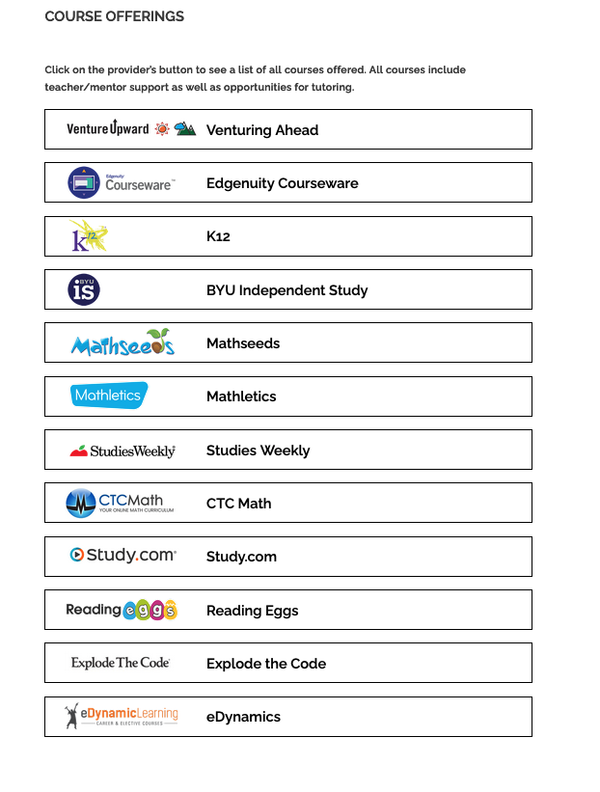

Venturing Ahead

Venturing Ahead is an individualized program designed to give families the highest level of independence and choice possible. Through this unique programming, parents choose the curriculum and resources that best meet the needs of their child and their child’s learning style. These courses allow families who’ve already identified an excellent curriculum, to continue to use it with their student.
Students in grades K-8 may use up to four Venturing Ahead courses to satisfy their core requirements in social studies, language arts, math, and science. Students may also use these courses in combination with other online curricula, for a total of 4 core academic courses.

Venture School
Participating in our Venture School is a fantastic way to fulfill the elective course requirement. Our Venture School is a favorite aspect of the Venture Upward program! Our Venture School is an on-site, drop-off program that allows kids to explore and learn together with other Venture students. Experienced and enthusiastic teachers engage children in interactive, hands-on classes such as world geography, art, messy science experiments, cooking, money management, Spanish, taekwondo, and music exploration. Venture students will automatically be enrolled in Venture School, where an onsite program exists, unless otherwise approved.
Students also work together to serve their community. The Venture School staff coordinates service opportunities, and the entire family is encouraged to join in. A minimum of two service opportunities will be organized each school year. All Venture Upward students are invited to work alongside one another to serve their local communities.
We understand that an on-site elective is not the right fit for every student. We are excited to announce that we will be offering project-based subscription boxes for an at-home alternative to Venture School. There are over a dozen boxes to choose from that captivate a range of unique interests. The subscription boxes, which are yours to keep, will arrive at your door once per month. Boxes are designed to fulfill an elective course at home. A variety of subscription boxes are available and may focus on art, music, cooking, STEM, world history, US history, science, geography, coding, and more.

Venture Reward

Every student that enrolls in Venture Upward in Arizona will receive a $1000 Venture Reward ($500 for Kindergarten)! This reward is designed to provide funding for families to purchase a laptop, tablet, or additional learning materials meant to enrich their student’s educational experience.
Please note: religiously-based curriculum or materials may not be purchased with this funding, including A Beka, Apologia, Sonlight, and others. The purpose of the Venture Reward is to provide additional learning materials and educational resources directly related to the education of your student. Below, you will find general purchasing guidelines and suggestions:
- Computer, laptop, or tablet
- Textbooks, workbooks, books
- School supplies (including pencils, paper, notebooks, and so on)
- Art supplies
- Musical instruments or supplies
- Printer or related printing supplies
- Microscopes, science supplies (non-edible)
- Additional Subscription Boxes (Little Passports, Tinker Crates, Raddish Kids)
- Usbourne Books
- Educational Games / Board Games
- Subscriptions (magazine, audiobook, etc.)
Ineligible items include but are not limited to:
- Furniture
- Clothing
- Food and groceries
- Appliances
- Participation fees for sports camps, athletic teams, or musical groups
- Religiously-based curriculum
- Zoo passes, museum passes, theater passes
- Third Party Courses (musical instrument, swimming, or karate lessons)
Tech Trep Program
Tech Trep openly declares that they are accessing state education funds to allow parents to “…chose the curriculum that works best for their child”.

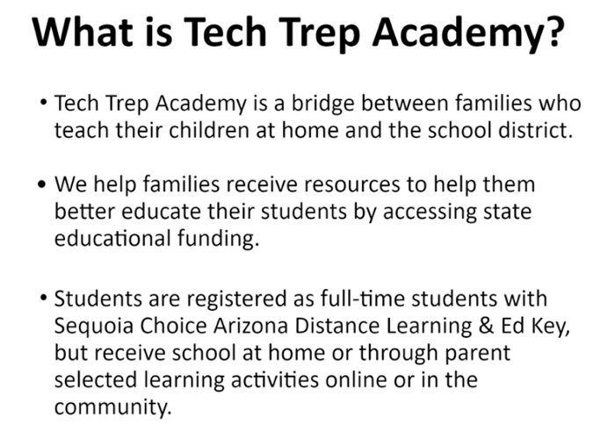
A free curriculum is provided by Tech Trep, but if parents prefer something else they “ …can receive this curriculum through a direct order or through reimbursement”

- Tech Trep supplied software includes commercial programs where parents can pick and chose concepts taught:
  - Brainpop – A collection of short videos and activities on a wide variety of topics
  - Brainpop Jr – Geared for students in grades K-3
  - Epic – Ebook and Audiobook online library available during school hours. Class codes will be sent to you by your Homeroom Teacher in late August and early September.
  - Generation Genius – Standards aligned video based science lessons for elementary students K-8. New math lessons and videos this year!
  - Khan Academy – is a comprehensive math program with videos and exercises. Khan Academy also has some coding, science, and history classes. Class codes will be sent by homeroom teachers.
  - Learn360 – Teachers, students, and parents can access more than 164,000 media resources on any Internet-enabled device, anytime, anywhere, and engaging content landing pages make it easy to find the wealth of videos, interactives, 20,000 printable lessons, audio content, and maps and flags.
  - Tangy Tuesday Math – Weekly math puzzles. Login information is available through InfoCenter.
- Parents are given $1,700/pupil in a “…supplemental learning fund where parents can choose the resources that will benefit their child”.

- Parents are allowed to provide religious education, but cannot purchase religious materials from Tech Trep supplied funds:

  - “Parents are free to supplement their child’s education with religious materials using their own private funds. As this program is in partnership with the public education system, only secular materials are approved for reimbursement or direct orders. “
- Parents do not have to use any online instruction and are free to educate their children any way they wish:
  - “…we believe parents should have the flexibility to choose the best format for their student’s learning. Some families prefer a technology-based curriculum while others want to do learning using textbooks. Others prefer hands-on activities and real-world learning and many choose a mix of all three. It is our goal to support parents as they choose the ways their student learns best. It is the parents who will decide how much time the student spends on the computer, if any.”

https://www.azed.gov/specialeducation/private-special-education-schools
See the Sequoia Choice Five Year Evaluation as: https://online.asbcs.az.gov/dms/view_file/20/25702
https://www.azed.gov/sites/default/files/2016/12/ELA%20Introduction%202016%20Final.pdf?id=585aa764aadebe12481b842a
https://6029440644.sharepoint.com/Shared%20Documents/Forms/AllItems.aspx?id=%2FShared%20Documents%2FCSA%2FQuality%20Standards%2FQuality%20Standards%5Ffinal%2DACSA%2Epdf&parent=%2FShared%20Documents%2FCSA%2FQuality%20Standards&p=true
https://azsos.gov/rules/arizona-administrative-code
Prenda recommends LEXIS Core5 for Language Arts instruction and Zearn Math, both are diagnostic and self-paced and do not require each student to be exposed to all grade level state standards
For example, Arizona standards require eighth grade students to study Civics and Economics. Prenda eighth grade students, on the other hand, select any social studies units that interest them.
https://www.youtube.com/watch?v=az_Qm2qFIPc
https://az.techtrepacademy.com/faq/
See the Tech Trec website at: https://id.techtrepacademy.com/
https://az.techtrepacademy.com/faq/
From Annual Financial Reports at: https://sfbudget.ade.az.gov/Budget/EntitySelection.asp
https://asbcs.az.gov/sites/default/files/New%20Charter%20Contract-%20Modified%2005-21-2014_0.pdf
The complete Official Disclosure for the EdKey 2020 $87 million bond is at: https://emma.msrb.org/P11443910-P11114599-P11524622.pdf
https://www.azed.gov/sites/default/files/2021/12/2020%20Vetted%20Core%20Program%20List%20December%202021.pdf
https://sfbudget.ade.az.gov/Budget/SubmittedFileStatus/SubmittedFileStatus.asp?NS=True&DR=5&FY=2021&TVR=21-3054&RPP=1&PC=&Subm=True&btnSubmit=++++Go%21
Prenda program information at: https://guides.helpscoutdocs.com/
Venture Upward program information at: https://ventureupward.org/
https://ventureupward.org/programs/arizona/venturing-ahead-courses
https://ventureupward.org/programs/arizona/venture-school
https://ventureupward.org/programs/arizona/venture-reward
https://www.youtube.com/watch?v=az_Qm2qFIPc
All Tech Trep program information at: https://az.techtrepacademy.com/faq/

