**Pandemic: Segregation Increases as Charter Schools Enroll Twice as Many White as Hispanic Students**

The segregation of students in district schools is a reality. Every year the percentage of poor, special education, and minority students increases in school districts as a result of the flight of white, middle income students to charter schools.

School districts have become increasingly minority as charter schools have exponentially expanded. White students made up 42.1% of total enrollment in 2010 but by 2021 that percentage had declined to 35.8%.

Many of those White students left district schools to go to charter schools. Between 2010 and 2021 districts have lost 84,000 White students while charter schools have added 36,000 White students.

|  |  |  |  |
| --- | --- | --- | --- |
| White students | 2010 | 2021 | Difference |
| Arizona | 459,348 | 412,264 | (47,084) |
| Charter | 60,571 | 96,730 | 36,159 |
| District | 396,608 | 312,870 | (83,738) |

We recently reported that districts lost 55,000 students while charter schools gained 18,000 students between 2020 and 2021. The dramatic increase in charter enrollment caused by the pandemic has further increased segregation in district schools. Districts lost 29,807 White students between 2020 and 2021. Charters enrolled 8,461 new White students in that time period, twice the number of Hispanic students.

|  |  |  |  |
| --- | --- | --- | --- |
|  | 2020 | 2021 | Difference |
| Arizona Hispanic | 522,461 | 505,306 | (17,155) |
| Charter Hispanic | 85,290 | 89,520 | 4,230 |
| District Hispanic | 433,420 | 412,870 | (20,550) |
| Arizona White | 433,764 | 412,264 | (21,500) |
| Charter White | 88,089 | 96,730 | 8,641 |
| District White | 342,677 | 312,870 | (29,807) |

We speculate that there are two major reasons why more White students enrolled in charter schools last year than Hispanics. First, there was a large increase in enrollment in online charter schools – education that requires families to have high speed Internet and a computer that may not be available to families living in poverty. In 2021 59% of all students receiving free/reduced lunch were Hispanic, compared to 22.2% that are White.



Secondly, white students are much more likely to live near a charter school than Hispanic students. A quarter of all charter students in Arizona attend schools owned the four largest charter companies that are exclusively in middle/upper income neighborhoods – Legacy Traditional, BASIS, Great Hearts, and American Leadership Academy. There is one school total from these companies in all of South Phoenix, Central Phoenix, Maryvale, Central Mesa, North Tempe, and South Scottsdale, all areas that are predominately Hispanic.

Large Chain Charter Schools in Low Income Areas of Phoenix

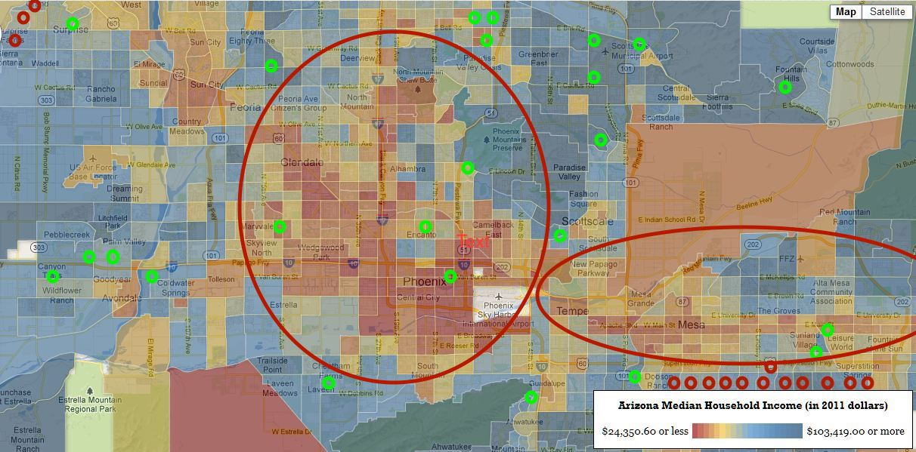

The additional tragedy of the increased segregation of district schools 2010-2021 is the fact that district state revenue has decreased while charter revenue has increased. Districts with more poor students…more special education students…more minority students…and less money – a purposeful Republican plan that assures increased enrollment of White, middle class students in new, well-funded charter schools.

Next: We will look at 10 charter schools that gained over 23,000 students this year.