The Myth of “Quality” Charter Schools in Inner-City Phoenix:
300 square miles of West and South Phoenix had 6 “A” rated and 6 failing charter schools last year… there are 53 “A” district schools in the area

School choice proponents would have you believe that charter schools provide quality education for poor folks needing to escape “failing” public schools in the inner-city. But in Arizona, if you want to attend an “A” rated charter school, you had better live in an affluent suburb of Phoenix. The big charter companies - BASIS, Great Hearts, Legacy Traditional and American Leadership Academy chose to place their schools in affluent neighborhoods because their college prep models simply don’t work in low-income areas. For example, last year Legacy Traditional Phoenix received a “C” rating while Great Hearts Maryvale earned a “B” and BASIS South Phoenix received a “D” rating. American Leadership Academy hasn’t ventured into the inner-city because they know it is better to stick to the areas of town with fewer at-risk, poor, and minority students…a winning business model for these ever-expanding charter corporations.

It is tougher to educate inner-city kids. The proof is there are only six “A” rated charter schools in the 300 square miles of west and south inner-city Phoenix from 15th Avenue to 124th Avenue and Deer Valley Road down to South Mountain. The area includes most of Glendale, Peoria, Tolleson, Cashion, and Laveen. There were as many failing charter schools in the area as “A” rated charter schools, with six charters received “D” or “F” ratings in 2022 in these inner-city neighborhoods.

The failing school category in all of Metro Phoenix is dominated by charter schools – there are 12 failing charters in Phoenix and only 3 district failing schools, none of which are in the 300 square mile area described.

If West and South Phoenix families want a quality school choice… there are 53 district schools in the area that received “A” ratings last year. See the links below to find “A” rated and failing schools throughout Arizona

“A” rated schools “D - F” rated schools
Red= Charter Blue = District Red= Charter Blue = District

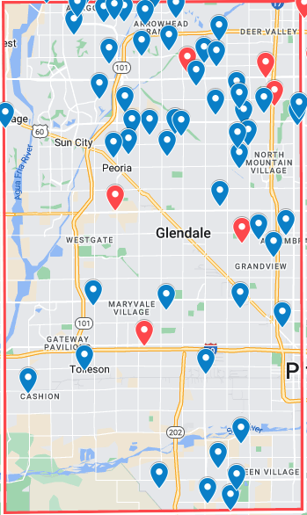
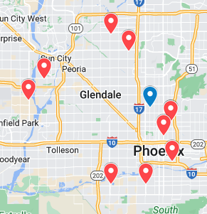

A-F Ratings are at: https://azsbe.az.gov/f-school-letter-grades
https://www.google.com/maps/d/edit?mid=1VpHxUl4WBsuzQ0dnUvktKMnqSzJZDEI&usp=sharing
https://www.google.com/maps/d/edit?mid=1L_91GcZd9NRKoQnkP3Ghs2TBU-qLRwU&usp=sharing

