Getting Rich:
WGRM Pinnacle sent 60% of tax revenue to India last year instead of into children’s education

Public school districts are allowed to carry forward up to 4% of their unspent budget. The average charter holder had 7% of their revenue left after expenses in 2019, a very reasonable cushion.

There are, however, 31 charter owners that made over 20% profit last year. WGRM Pinnacle led the way with two schools that kept 60% of their tax revenue as profit – profit collected by WGRM Inc.

Multi-national corporation WGRM Inc., a for profit company based in India, owns three Pinnacle charter schools that received nearly $7 million in tax funds in 2019 but only spent a total of $2.75 million, sending 60% of their revenue back to India. For-profit charters like WGRM Pinnacle are able to distribute the profits directly to the owners. Below are the profits taken by the largest Pinnacle school, Pinnacle Tempe, totaling $27.8 million since 2011:

Pinnacle Tempe | Revenue | Expenses | Difference | % of Revenue Profit
2010 | $7,620,013 | $5,153,341 | $2,466,672 | 32%
2011 | $9,696,416 | $6,091,147 | $3,605,269 | 37%
2012 | $10,070,838 | $6,133,161 | $3,937,677 | 39%
2013 | $6,133,161 | $5,143,213 | $989,948 | 16%
2014 | $4,896,011 | $2,877,919 | $2,018,092 | 41%
2015 | $3,826,004 | $2,215,542 | $1,610,462 | 42%
2016 | $5,671,435 | $2,672,253 | $2,999,182 | 53%
2017 | $6,860,399 | $3,373,407 | $3,486,992 | 51%
2018 | $6,353,782 | $3,112,338 | $3,241,444 | 51%
2019 | $5,943,641 | $2,458,817 | $3,484,824 | 59%
Total | $67,071,700 | $39,231,138 | $27,840,562 | 42%

The Pinnacle schools are alternative schools providing most of their instruction online, and since alternative schools have not received an A-F grade the last two years, they cannot be closed for poor academic performance. Pinnacle Online falls far below academic standards since they are required to be in a school improvement plan for low test scores:

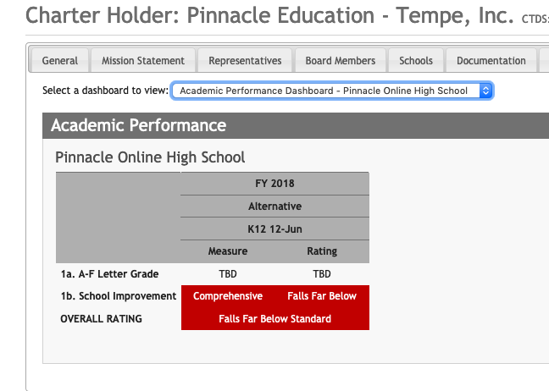

But the Charter Board gives WGRM Pinnacle glowing ratings for their financial performance – all the Board cares about is that charters are profitable business – not how much tax revenue actually makes it to the classroom.

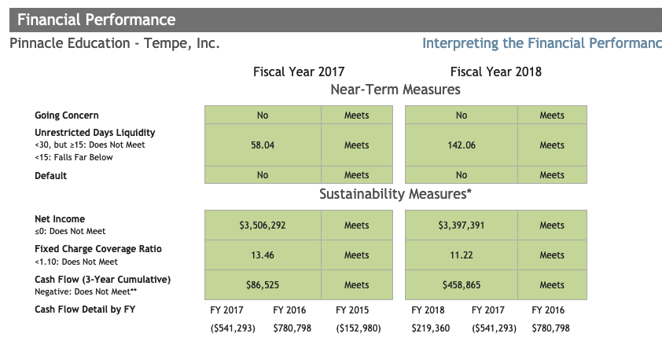

Making $27 million in profit since 2011 makes MGRM Pinnacle the most success small charter company in Arizona…just not successful in providing an education to children.

