February 18, 2021
Public Monies Complaint re: Incito Schools
Arizonans for Charter School Accountability
Jim Hall

In light of the indictment against Incito Schools (CR2021-001131-00) filed by the Attorney General regarding actions taken by the school in 2016, Arizonans for Charter School Accountability would like to point out a disturbing pattern of questionable expenditures and deficiencies in internal controls that are apparent from an examination of audits 2016-2020 and Incito Annual Financial Reports 2014-2020.

1. There is a pattern of deficiencies in internal controls of finances at Incito dating back to 2016.

A summary of deficiencies in internal controls noted in Incito audits is below and the full audit statements are in the Appendix:

2016 – There were multiple misstatements in the school’s accounting records because proper internal controls were not in place.

2017 – Revenue was misstated in the school’s accounting records because proper internal controls were not in place. Payments to Arizona State Retirement System were not made in a timely manner because adequate procedures were not in place

2018 – The school did not retain documentation for 7 of 53 disbursements tested. Supporting documentation was not supplied for point-of-sale credit card transactions totaling $1,229.

2019- The school did not perform comparisons of membership days between its attendance system and ADE. Controls were not in place to identify and correct variances in attendance reporting.

2020- Supporting documentation did not match the disbursements in 5 of 6 disbursements tested. The 5 disbursements consisted of 210 receipts, 5 of which were made using the schools debit card. Inadequate controls allowed the same person to approve purchases, make purchases, and receive purchases.

Based on the current indictment, the lack of internal controls and the consistent misuse of public funds by the directors by failing to provide documentation of purchases warrants investigation.

2. Incito has spent $1.5 million on supplies since 2014, for a school of 300 students.

In light of the continuing problems with internal controls over reimbursements and debit card usage, of particular concern is the sudden increase in expenditures for instructional supplies in 2020 for the school of 300 students, The expenditure of $637/pupil for instructional supplies is the 7th highest of 410 charter holders in the state.

Incito AFR expenditures for instructional supplies 2014-2020
 | 6600 Supplies | 6600 Supplies/pupil
2020 | $210,248 | $637
2019 | $80,801 | $241
2018 | $92,271 | $251
2017 | $36,651 | $121
2016 | $35,953 | $134
2015 | $60,546 | $262
2014 | $76,232 | $431

Administrative spending for supplies at Incito surpasses nearly all other schools in the state. In the last three years Incito has spent an average of over $200,000 for administrative supplies. As a point of comparison, Benjamin Franklin Schools, with four campuses and 2,860, students spent a total of $60,562 on all administrative supplies in 2020.

Incito AFR supply expenditures 2014-2020
Supplies | 1000 Instruction | 2400 School Administration | 2900 Other Administrative Support Services | Total
2020 | $210,248 | $62,705 | $103,396 | $378,995
2019 | $80,801 | $113,123 | $100,355 | $310,274
2018 | $92,271 | $132,933 | $107,594 | $343,056
2017 | $32,725 | $72,624 | $26,320 | $164,707
2016 | $35,953 | $24,139 | $0 | $87,887
2015 | $60,546 | $47,754 | $0 | $108,300
2014 | $76,232 | $23,192 | $0 | $99,424

The school’s history of the directors making undocumented purchases for which they received reimbursements makes the huge supply purchases suspect.

3. Incito has a history of having some of the highest administrative spending in the state.
Incito spent $2,563/pupil on administration in 2020 while the charter state average was $1,665/pupil. Incito has two executive directors, a principal, and an assistant principal for a school of 300 students, causing Incito to spend $50,000 more on administrative salaries than regular instructional salaries in 2020.

Incito AFR expenditures for school administration 2014-2020
 | 2400 School Administration | 2400 School Administration/Pupil
2020 | $845,625 | $2,563
2019 | $794,359 | $2,371
2018 | $930,928 | $2,537
2017 | $717,287 | $2,367
2016 | $518,556 | $1,928
2015 | $495,963 | $2,147
2014 | $316,461 | $1,788

The school’s history of deficiencies in internal controls, especially in disbursements to the directors, makes the exceptionally high administrative spending suspect.

4. There are no IRS 990 submissions for Incito Schools available online.
Incito is the only charter school that we have researched that has no IRS 990 submissions available through the IRS, Guidestar, or Propublica.

Incito’s negative net assets and the extremely high supply and administrative spending are the same red flags that were ignored at the failed Starshine Academy and Bradley Creemos Academy – both of which included significant misuse of public funds by their owners. There needs to be a complete audit of Incito Schools to determine if any of the $1.5 million in supply purchases utilizing public funds were misappropriated.

________________________________________________________________________________________________________________

Appendix follows on pages 4-9

Appendix 1 – 2016 Incito audit documentation of deficiencies
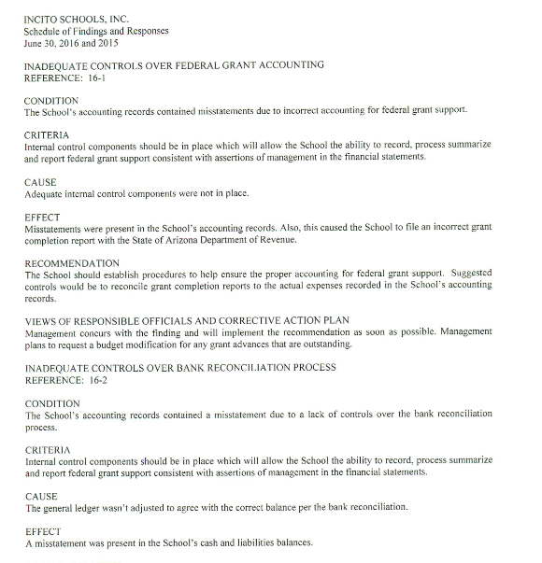

Appendix 2 – 2017 Incito audit documentation of deficiencies

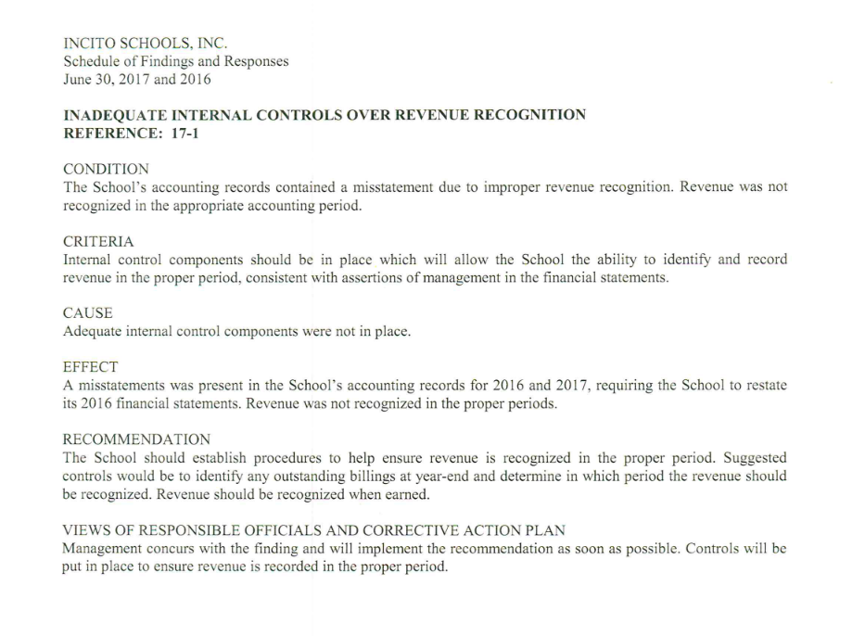

Appendix 3 – 2017 Incito audit documentation of deficiencies

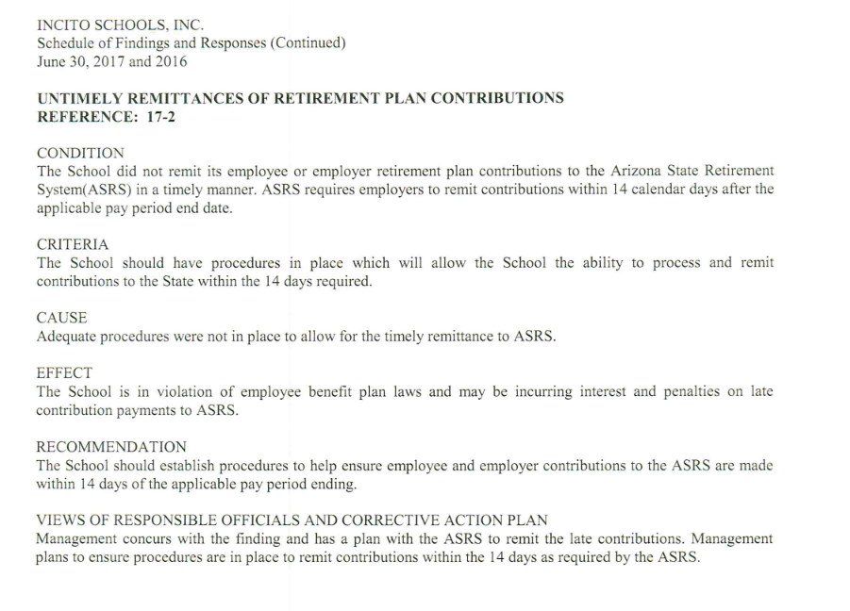

Appendix 4 – 2018 Incito audit documentation of deficiencies

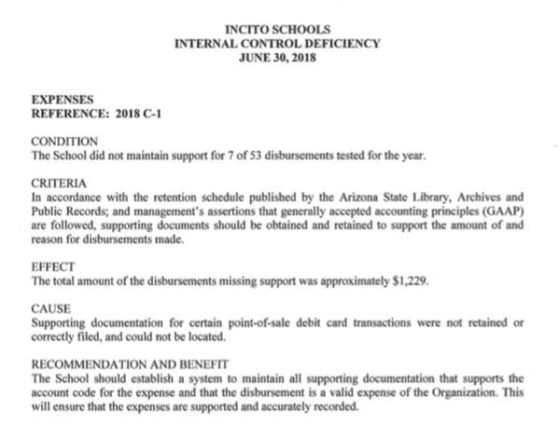

Appendix 5 – 2019 Incito audit documentation of deficiencies

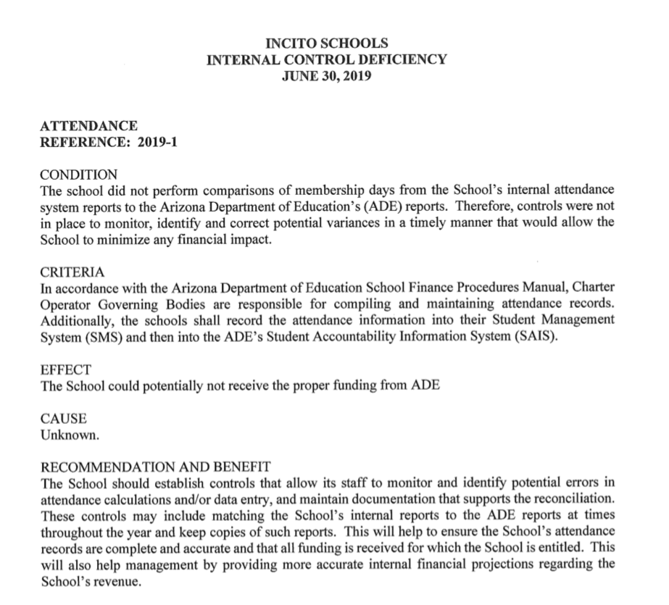

Appendix 6 – 2020 Incito audit documentation of deficiencies

