**The Consequences of Unregulated Charter Schools in Arizona:**

***For-Profit American Virtual Academy Nets $10 Million Profit in 2016 After Siphoning $84 Million from Non-Profit Primavera Online.***

**Jim Hall**

**Arizonans for Charter School Accountability**

**February 27, 2017**

The American Virtual Academy Inc., an educational software company based in Chandler, Arizona, supplied the courseware for the largest non-profit charter online high school in the state, Primareva Online High School, charging over $84 million since 2009 for licensing and support fees. In 2015, the board of Primavera Online voted to relinquish the school’s charter to for-profit American Virtual Academy Inc. without compensation. In 2015-16 the American Virtual Academy recorded a $10 million profit while charging (themselves) $13.4 million for software licenses they owned and created.

This report will examine the unusual transfer of a charter school from a non-profit charter holder to their for-profit software supplier and explore the relationships that drove that decision.

**Primavera Online Charter Renewal July 2016.**

Primavera Online was one of the first computer based, online charter schools in Arizona. Non-profit Primavera Technical Learning Center (PTLC) owned the charter for Primavera Online High School from 2002 until 2015. PTLC assets increased to $44 million (with no debt) over that time period, making them the richest non-profit charter school in Arizona.[1]

Primavera had average revenues of over $30 million and increased their assets an average of $5.6 million a year since 2009. A net gain in 2015 of only $776,400 was due largely to an increase of $1.5 million for license fees and $1.0 million in new “support services” fees from their software supplier, American Virtual Academy. These charges will be discussed at length on page 6. See Table 1

**Table** 1 Primavera Technical Learning Center Revenue, Expenditures and Net Gains 2009-2015

|  |  |  |  |
| --- | --- | --- | --- |
|  | Total Revenue | Total Expenditures | Net gain |
| 2009 | $19,974,999 | $14,685,633 | $5,289,366 |
| 2010 | $23,602,052 | $17,926,279 | $5,675,773 |
| 2011 | $31,087,648 | $22,417,466 | $8,670,182 |
| 2012 | $34,525,323 | $24,674,997 | $9,799,200 |
| 2013 | $33,563,511 | $31,247,922 | $2,315,589 |
| 2014 | $35,856,601 | $28,736,215 | $7,120,386 |
| 2015 | $32,808,038 | $32,031,638 | $776,400 |
| Annual Average | $30,202,596 | $24,531,450 | $5,663,842 |
| Total | $211,418,172 | $171,720,150 | $39,646,896 |

Primavera’s charter contract was up for renewal in July 2016. On May 21, 2015, the Board of PTLC met to discuss the future of the charter school. There apparently was great concern among the PTLC Board regarding the future of Primavera Online, despite its great earnings. The Board minutes reflect their concern:[2]

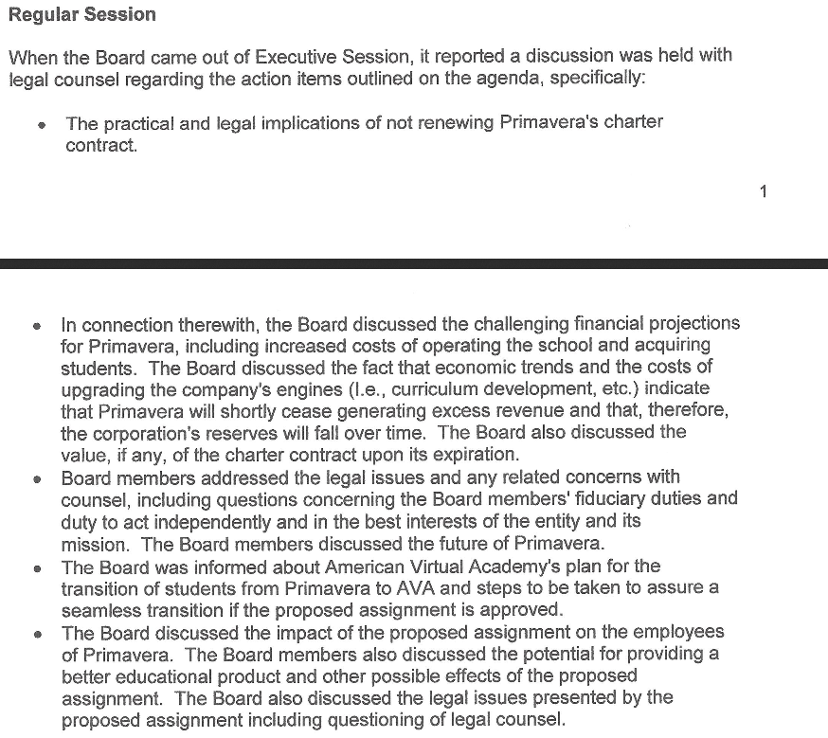

The most prosperous non-profit charter school in Arizona was afraid that *“…economic trends and the cost of upgrading the company’s engines (i.e., curriculum development, etc.) indicate that Primavera will shortly cease generating excess revenues.”*

With this in mind, The PTLC Board, at the same May 21, 2015 meeting, decided to handle the possibility of “not generating excess revenue” in this way:[3]

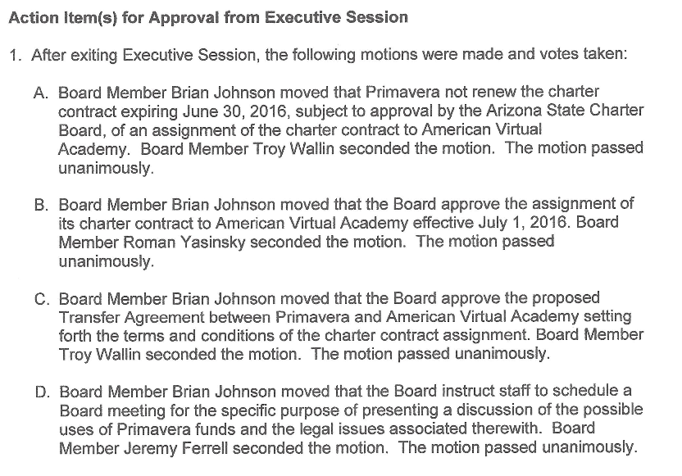

The Board of PTLC voted not to renew its charter contract and instead assigned the charter contract to their for-profit software supplier, American Virtual Academy Inc. (AVA).

PTLC’s only business was the operation of Primavera Online Academy. PTLC basically put itself out of the charter school business after amassing assets of over $44 million. They did not dissolve the non-profit. It still exists – PTLC just isn’t in the charter school business any more. Their $44 million stockpile of cash is still there, as far as we know. [4] Their only source of income now appears to be in real estate leases.

PTLC’s Board approved the purchase of four pieces of real estate the following month, June 25,2015, years after most of purchases were made.[5] One property was purchased on May 29, 2015, a week *after* the Board voted to relinquish the school to AVA. The property is at 2501 N. Arizona Avenue, next door to the Primavera Online Headquarters. The Board agenda states that the property cost $2,525,000 and was to be used to house Primavera support services and provide for future expansion. PTLC had already voted to give its charter for Primavera Online to AVA, so it is odd that they bought real estate to house future school operations.[6] See Table 2.

**Table 2** Property purchases by Primavera Technical Learning Center

|  |  |  |  |  |
| --- | --- | --- | --- | --- |
| Purchase date | November 13 2009 | August 28 2012 | February 3 2014 | May 29 2015 |
| PTLC Property Address | 2471 N. Arizona Avenue Chandler, AZ | 2451 N. Arizona Avenue Chandler, AZ | Southwest corner of Dysart Rd. and Thomas Road Goodyear, AZ | 2501 N Arizona Avenue Chandler AZ |
| Sales Price | $1,900,000 | $750,000 | $1,500,000 | $2,525,000 |
| Intended Use | Present Primavera Online Site | Present Primavera Site | Future West Phoenix PTLC Site | House future Primavera support facilities |

The Board of for-profit American Virtual Academy met on May 22, 2015. There was only one person in attendance – Damian Creamer. Damian Creamer is the sole owner of AVA and its only board member. Creamer made the motion (and seconded it) to accept the transfer contract with PTLC. The motion passed – unanimously. Creamer then voted to retain the entire school board from PTLC to the new AVA owned Primavera Online. Everything at Primavera Online stayed the same, except that Damian Creamer was now the sole owner of a for-profit charter school that generated an average of $5.6 million a year in profits. (See Appendix 2)

The Arizona State Board for Charter Schools granted a new 20-year charter contract for Primavera Online on June 15, 2015 and changed the ownership to the American Virtual Academy Inc. without discussion.[7] PTLC gave up a school that generated an average of over $5.6 million profit a year. What did they get in return? The transfer contract stated:[8]

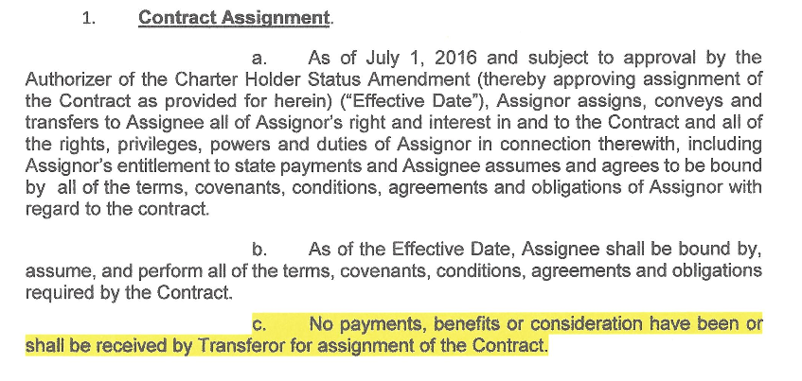

PTLC’s software supplier received sole ownership of a business generating over $30 million in revenue annually and over $5 million in profits every year… for free. The Board of PTLC decided it was in the best interest of the school to give it away to a company solely owned by Damian Creamer.

**Damian Creamer’s relationship with PTLC and AVA**

It turns out the Damian Creamer is also the founder and director of the non-profit Primavera Technical Learning Center. Creamer incorporated PTLC in 2002 and is the paid director of the non-profit, collecting over a million dollars in salary since 2005.[9] His wife and sister also drew over $1 million in salary as officers of the non-profit in that time period.[10] See Table 3.

**Table 3** Salaries of Creamer family officers of PTLC

|  |  |  |  |  |
| --- | --- | --- | --- | --- |
| Year | Damian Creamer | Vanessa Creamer (wife) | Mori Creamer (sister) | Total |
| 2005 | $60,312 | $74,420 |  |  |
| 2006 | $107,615 | $75,917 |  |  |
| 2007 | $108,779 | $71,792 |  |  |
| 2008 | $98,000 | $94,344 |  |  |
| 2009 | $101,031 | $101,766 |  |  |
| 2010 | $98,020 | $98,020 |  |  |
| 2011 | $101,670 | $101,670 |  |  |
| 2012 | $101,253 | $99,309 |  |  |
| 2013 | $100,202 | $102,092 |  |  |
| 2014 | $90,025 |  | $111,037 |  |
| 2015 | $105,972 |  | $197,433 |  |
| Total | $1,072,879 | $819,330 | $308,470 | $2,200,679 |

Damian Creamer’s non-profit corporation, PTLC, gave his for-profit software company, American Virtual Academy, the charter to Primavera Online – for free. The incestuous relationship between Creamer’s non-profit and for-profit companies is just the tip of the iceberg when it come to the self-dealing between firms owned by Creamer.

**Software Licensing and Support Fees**

In seven years between 2009 and 2015, Creamer’s non-profit PTLC diverted $84,896,309 to AVA to pay for “software licensing and support”. This money was strictly for software used by the school. Primavera does not supply computers to students. PTLC spent $2.6 million on supplies and $4.0 million on equipment in addition to the $84.9 million paid to AVA for licensing and support 2009-15. PTLC had to buy additional math software as well, paying $265,250 for a program from Aleks Ed Sys K-12 in 2014 – in addition to the $12.2 million they paid AVA in licensing fees that year. Fees to AVA were not used to buy computers, servers, or other equipment or supplies. The $84 million was only used to develop and improve the courseware used by Primavera Online.[11] See Table 4.

**Table 4** Revenue, Net gains, Fees to AVA, and expenditures for supplies, equipment and real estate 2009-2015

|  |  |  |  |  |  |  |  |
| --- | --- | --- | --- | --- | --- | --- | --- |
|  | Total Revenue | Net gain | Fee to AVA | Total Supplies | Property and equipment | Real Estate Purchases | Equipment Purchases |
| 2009 | $19,974,999 | $5,289,366 | $8,572,555 | $135,586 |  |  |  |
| 2010 | $23,602,052 | $5,675,773 | $10,312,082 | $0 | $3,444,321 | $1,900,000 | $1,544,321 |
| 2011 | $31,087,648 | $8,670,182 | $12,225,808 | $312,613 | $392,434 |  | $392,434 |
| 2012 | $34,525,323 | $9,799,200 | $12,225,808 | $560,269 | $93,151 |  | $93,151 |
| 2013 | $33,563,511 | $2,315,589 | $15,587,876 | $697,106 | $1,207,469 | $750,000 | $457,469 |
| 2014 | $35,856,601 | $7,120,386 | $12,225,808 | $632,821 | $2,783,353 | $1,500,000 | $1,283,353 |
| 2015 | $32,808,038 | $776,400 | $13,746,372 | $304,279 | $2,802,300 | $2,525,000 | $277,300 |
| Total | **$211,418,172** | **$39,646,896** | **$84,896,309** | **$2,642,674** | **$10,723,028** | **$6,675,000** | **$4,048,028** |

**Primavera Online as for-profit American Virtual Academy 2015-16**

Although the agreement signed by the Charter Board stipulated a transfer date of July 1, 2016, AVA took control of the school a year earlier on July 1, 2015.[12] Creamer incorporated a new educational software company, FlipSwitch Inc., on July 16, 2015, and made AVA a subsidiary of the new firm.[13] FlipSwitch Inc. was then contracted by AVA to provide software licensing for $13.4 million with an additional $2.5 million for support services in 2016. Despite almost $16 million diverted to FlipSwitch Inc. AVA made a clear profit of $10 million in 2016. The profits went to ACA’s only stockholder – Damian Creamer. See Table 5.

**Table 5** American Virtual Academy finances - 2016

|  |  |
| --- | --- |
|  | 2016 |
| Total Revenue | $40,680,433 |
| Total Expenditures | $30,533,571 |
| Net profit | $10,136,315 |
| Lease Payment to PTLC | $333,616 |
| Fees to AVA | $13,427,502 |
| Advertising | $3,679,242 |
| AVA support services | $2,531,471 |
| Property and equipment | $381,093.00 |

While the Board of PTLC feared declining revenues, AVA had an increase of $8 million in revenues in 2016. Profits went from $776,400 in 2015 to over $10 million in 2016. It looks like PTLC made a bad decision in giving Primavera away.

Damian Creamer now has a new business. In 2016 FlipSwitch Inc. changed their name to StrongMind and is selling the software created for Primavera around the U.S. Inspire Charter Schools now uses SoundMind software in its virtual charter schools in 20 counties in California.[14] iSucceed Virtual High School in Idaho has also purchased StrongMind.[15]

PTLC is still in the picture though. The real estate PTLC purchased is now providing facilities for AVA and FlipSwitch Inc. and now SoundMind. [16] AVA paid PTLC $333,616 to lease their facilities on 2471, 2451, and 2501 North Arizona Avenue in Chandler, AZ. in 2016.

**Conclusions:**

The reality is this: Damian Creamer built two for-profit software companies, American Virtual Academy and FlipSwitch Inc. with $84 million in licensing fees paid by PTLC from 2009 to 2015. $84 million in tax funds. To put it in perspective, a new Boeing 737 costs $78 million.

A better comparison is Mesa Distance Learning (MDL), an online school in the public Mesa Unified School District. MDL paid $581,000 to develop software for their online program in 1998. Mesa pays only pays for maintenance, improvements and additions to the online courseware they developed. Officials at Mesa Unified School District estimate that it costs about $760,000 a year to update and maintain their online program.  The estimate is based on the salaries for content specialists (developers), administrator, and programmer, and additional stipends paid to online teachers for curriculum development. Mesa Distance Learning offers a complete K-12 curriculum while AVA is only available for grades 6-12. All of the high school semester courses at MDL are designed for 90 hours of instruction. Since AVA is an alternative school, their semester courses provide only 30 hours of instruction. Mesa Distance Learning serves six more grade levels and offers three times the instructional time per semester as AVA.

Mesa Distance Learning is offered by a public district and spends $760,000 a year to maintain its online program. American Virtual Academy is a for-profit corporation and spends *18 times* more to maintain their smaller online offerings - $13.4 million in 2016.

According to Creamer, he began developing his own courseware beginning in 2005.[17] He then charged his non-profit $10-$15 million dollars a year from 2009-2015 to use the software his company developed.

Now Creamer is selling the programs created for Primavera Online through his new company SoundMind. The profits from these sales are unknown because SoundMind is a private company.

There was absolutely no separation between non-profit PTLC and for-profit AVA. The transfer of the Primavera charter to AVA for no compensation demonstrates the collusion between the non-profit PTLC and their related for-profit vendor, AVA. - all for the personal benefit of the owner of both organizations, Damian Creamer.

There is a charade going on in the charter school industry, both in Arizona and around the nation, that allows charter owners like Damian Creamer to control non-profit charter schools to enrich their for-profit subsidiaries. In previous reports we found that Bill Coats used a non-profit be founded (the American Charter Schools Foundation) to buy ten schools owned by Coats’ for-profit company, the Leona Group Inc., for a $25 million profit in 2007. The largest charter company in the U.S., Imagine Schools, uses a non-profit front in Arizona, created by owner Dennis Bakke, to self-deal multiple goods and services from Bakke’s for-profit Imagine Inc.- netting $12 million more on management fees and real estate leases than on classroom instruction each year.[18]

Damian Creamer renewed the charter for Primavera Online for 20 years and moved the charter from his non-profit company to his for-profit company without any discussion of the issues raised in this report by the Arizona Charter Board. The Auditor General is not allowed to monitor charter school operations and the Arizona State Board for Charter Schools gives a wink and a nod to charter owners that defraud Arizona taxpayers out of tens of millions of dollars. It is worthwhile to listen to the transcript of the Primavera renewal presentation on June 15, 2015 to see how little the Charter Board appears to know, or care about the fraud, waste and abuse that permeates many Arizona charter schools.[19] There is no one monitoring these abuses in Arizona.

School choice becomes extremely expensive when corporations are allowed to collect extravagant profits and fees for services public districts can provide at a fraction of the cost. If public Mesa Distance Learning were to *triple* their expenditures for software maintenance and development they would still spend $11 million less annually than AVA. Combine that with AVA’s $10 million profit MDL could not collect as a public district, the annual savings is an astounding $21 million a year. $210 million over 10 years if 4400 students attended a public district online school rather than AVA.

Arizona is 47th. in the nation in spending for public schools and teacher salaries. Every nickel of the $2 million Damian Creamer paid himself and his family as officers of his non-profit, the $84 million he routed into his for-profit software company over seven years, and the obscene $10 million profit he realized in 2016, came out of Arizona’s general fund – and out of the budgets of public schools and taxpayer’s pockets.

**Recommendations:**

* The Internal Revenue Service needs to shut down the self-serving non-profit charter schools that are fronts for for-profit corporations.
* Arizonans need to demand that the Arizona Auditor General monitor charter school spending.
* The Arizona Legislature needs to revise the funding formula for online schools. They cost much less to operate and the savings are going straight to corporate profits.
* The Arizona State Board for Charter Schools needs to step up and sanction charter holders that misuse tax funds for personal gain.

The I.R.S. has strict guidelines for non-profit charter holders when hiring and working with vendors:[20]

* ***For a charter school to establish exemption under IRC 501(c)(3), whether it purchases some or all of the services required to operate, it must establish that it is organized and operated for the benefit of the public and not for the benefit of any private person, such as a service provider.***

Damian Creamer’s acquisition of the most prosperous charter school in Arizona without cost from the non-profit he owned is the most blatant example of a private person benefiting from a non-profit organization imaginable - a $10 million dollar example. Arizonans for Charter School Accountability is filing official complaints with the Internal Revenue Service regarding this misuse of a 501(c)(3) charter school for personal gain.

The following resources are available at azcsa.org:

* Primavera Technical Learning Center I.R.S. 990 returns 2003-2015
* Primavera Technical Learning Center Annual Financial Reports 2002-2016
* Primavera Technical Learning Center Annual Audits 2009-2016

**Appendix**

**Appendix 1** – PTLC Board Meeting Agenda June 25, 2015



Macintosh HD:Users:newowner:Desktop:Feb 20 Ownership change:Agenda-June-25-2015-Board-Meeting.pdf

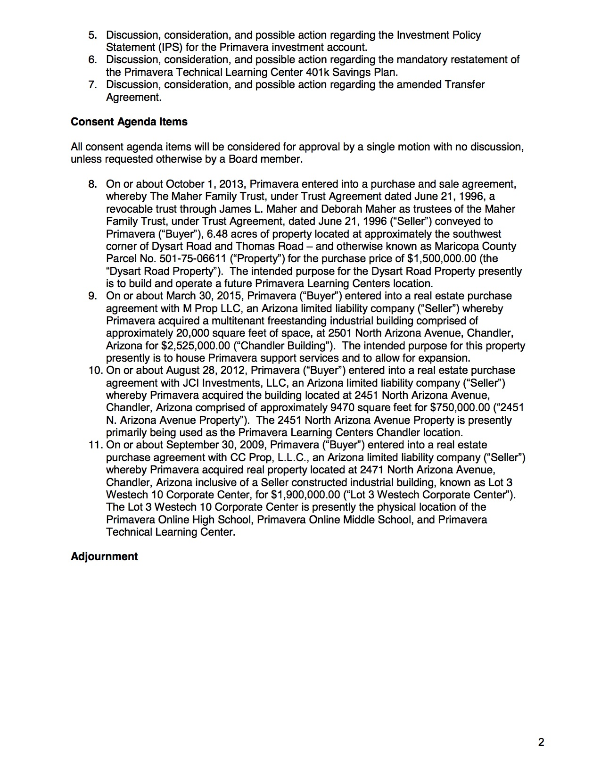

**Appendix 2** - AVA Board Meeting Minutes May 22, 2015

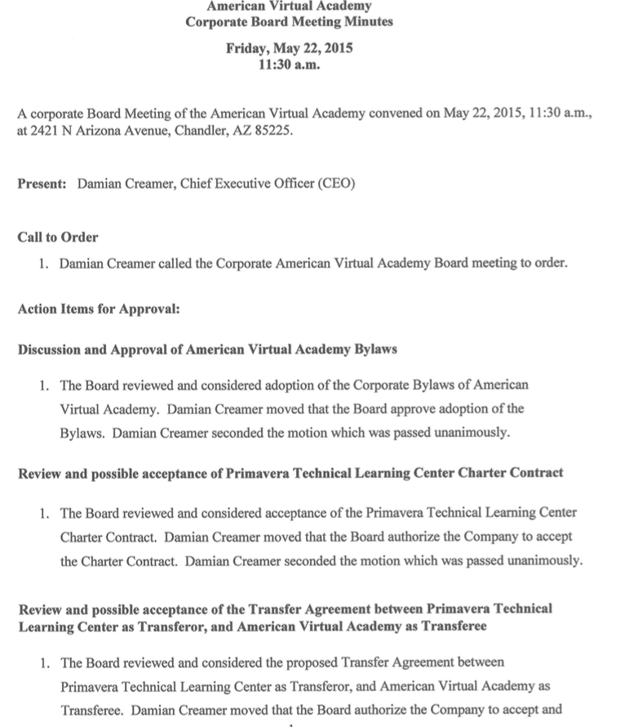

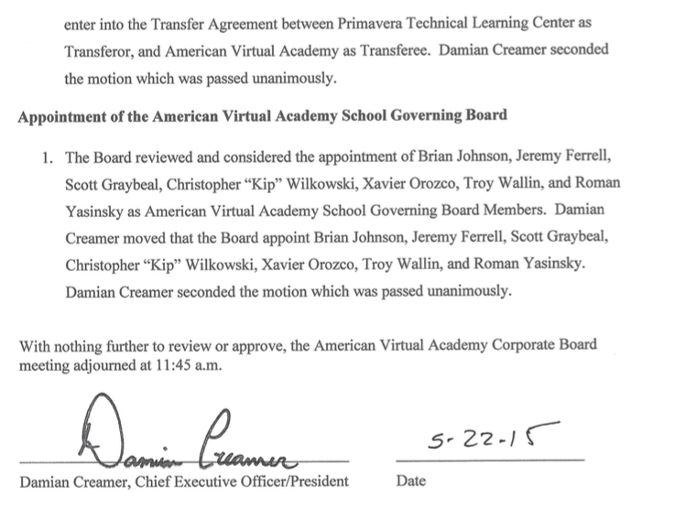

1. (Note: Arizona audit information is only available for PTLC from 2009-2016. 990 tax returns and Annual Financial reports go back to 2002. The time period of data presented in this report will be noted.)
2. The minutes of the PTLC May 21, 2015 meeting are available in the materials submitted by PTLC for the reassignment of the charter at June 15, 2015 ASBSC Board meeting at https://asbcs.az.gov/board-staff-information/meeting-dates-materials/archive
3. The minutes of the PTLC May 21, 2015 meeting are available in the materials submitted by PTLC for the reassignment of the charter at June 15, 2015 ASBSC Board meeting at https://asbcs.az.gov/board-staff-information/meeting-dates-materials/archive
4. PTLC’s 2016 990 tax return is not available yet to determine what income and expenditures were last year.
5. It is possible that the purchase of the properties was not brought to the Board at the time of purchase and legal counsel pointed out the error.
6. See Appendix 1 for the complete PTLC Board agenda for June 25, 2015
7. June 15, 2015 ASBSC Board meeting at https://asbcs.az.gov/board-staff-information/meeting-dates-materials/archive
8. June 15, 2015 ASBSC Board meeting at https://asbcs.az.gov/board-staff-information/meeting-dates-materials/archive
9. Arizona Corporation Commission at http://ecorp.azcc.gov/Details/Corp?corpId=%2009686793
10. Data collected from PTLC IRS 990 returns available at https://www.guidestar.org/PartnerReport.aspx?ein=86-1017522&Partner=Demo
11. “ALEKS is an adaptive, online math program that uses artificial intelligence and open-response questioning to identify precisely what each student knows and doesn't know.” <https://www.aleks.com/k12>
12. The Charter Board has been contacted to determine the official transfer date. They have not responded as of publication.
13. ecorp.azcc.gov/Details/Corp?corpId= 20200192
14. <https://www.strongmind.com/assets/Inspire%20Adds%20StrongMind%20Curriculum.pdf>
15. <http://magicvalley.com/news/local/education/virtual-high-school-enrolling-students/article_aa32f1cf-ea46-5eb4-ac8b-6421fda270db.html>
16. See Table 2
17. Damian Creamer in a statement at the Arizona Charter Board Meeting June 15, 2015 at https://asbcs.az.gov/board-staff-information/meeting-dates-materials/archive
18. Both reports and all supporting data are available at azcsa.org
19. The audio of the June 15, 2015 Charter Board meeting is available at https://asbcs.az.gov/board-staff-information/meeting-dates-materials/archive
20. I.R.S. Guidelines for Charter Schools at https://www.irs.gov/irm/part4/irm_04-076-008.html#d0e619