**Arizona Charter School Classroom Spending 2016 Part 3**

**Case Study:**

***The Leona Group LLC Reaps Millions in Real Estate Profits While Arizona Taxpayers (and Students) Foot the Bill***

**Jim Hall**

**Arizonans for Charter School Accountability**

January 31, 2017

**Background**

Part 1 of *Arizona Charter School Classroom Spending 20*16 (available at azcsa.org) found that less than half of Arizona charter schools spend most of their resources where you would expect - in the classroom. Forty seven percent of all Arizona charters (191 schools) spent more money on regular and special education classroom instruction than on administration and facilities combined. These schools represent both large and small charters utilizing a variety of instructional models – college prep, alternative, special education, arts, etc. Many of the 191 schools have substantial mortgages and have new, modern facilities yet focus their spending on classroom instruction.

Part 2 of this report examined the charter schools that spend the least on classroom instruction – those that spend more on administration alone than in the classroom and those that spend more on just their facilities than in the classroom. The most alarming charter schools in Arizona were also identified – those that spend more on both administration and their facilities than on classroom instruction. Part 2 revealed that the majority of schools that spend the least on classroom instruction are managed by two of the largest for-profit national charter chains in Arizona - Imagine Inc. and the Leona Group LLC. The two companies alone spent $28,000,000 more on management costs and facilities than on children in the classroom.

Part 3 will look at the Leona Group LLC in detail – and explain why the schools they manage for the American Charter Schools Foundation spends less on classroom instruction than any other schools in Arizona.

**Key Findings:**

1. In 2007, Bill Coats, the sole owner of the Leona Group LLC, sold 10 schools owned by Leona to a non-profit foundation he created in 1998, the American Charter Schools Foundation, (ACSF) for $33,890,485 more than their market value.
2. ACSF “leased” the facilities for $6,195,000 to the ten schools in 2016. When Bill Coats owned the schools in 2006, the total leases were less than half that amount - $2,875,034.
3. Bill Coats maintains the same management control over the schools as he had when his company owned the schools but now has set management fees that are not based on student enrollment.
4. ACSF schools have declined in enrollment by 25% since their purchase in 2007.
5. Between 2007 and 2016 overall instruction spending in ACSF schools has declined from $2090/pupil to $1455/pupil while facilities costs increased from $1455/pupil to $2479/pupil.
6. The real estate windfall Bill Coats received in 2007 by selling his schools to his own foundation has caused ACSF to cut classroom spending to among the lowest rates of any school in Arizona - to fund the excessive mortgages.

**Methodology:**

Methodology is discussed in detail in Part 1 available at azcsa.org. Arizonans for Charter School Accountability created a database of all charter expenditures for 2016 as reported on the Annual Financial Reports (AFR) submitted by each charter holder. Each charter school’s spending on regular and special education classroom instruction, administration, and facilities was calculated utilizing the guidelines described on the Auditor General’s Unified System of Financial Records for charter schools that is used to report spending on the AFR. See Part 1 for documentation.

Data were also collected regarding related party spending, leases, outstanding debt, and management contract payments using the annual financial audits each charter holder submits to the Arizona State Board for Charter Schools that can be found at ASBCS online at http://online.asbcs.az.gov/

**Case Study:**

**Why do the American Charter Schools Foundation schools managed by the Leona Group LLC spend**

**so little on classroom instruction?**

In the recently released 2016 Annual Financial report for 2015-16 all ten American Charter Schools Foundation (ACSF) schools, managed by the Leona Group LLC, spent more per pupil on their facilities than in the classroom and nine out of ten ACSF schools spent more per pupil on total administrative costs than in the classroom.[[1]](#footnote-1) See Table 1.

**Table 1** - American Charter Schools Foundation schools expenditures per pupil on instruction, administration, and facilities. Red indicates spending greater than per pupil instruction expenditures

|  |  |  |  |
| --- | --- | --- | --- |
| American Charter Schools Foundation School | Total Instruction 2016/Pupil | Total Administration 2016 /Pupil | Total Plant 2016/Pupil |
| Alta Vista High School | $1,318 | $2,039 | $1,936 |
| Apache Trail High School | $1,843 | $2,583 | $2,201 |
| Crestview College Preparatory | $1,682 | $1,885 | $2,593 |
| Desert Hills High School | $1,262 | $2,337 | $4,264 |
| Estrella High School | $1,524 | $2,297 | $3,299 |
| Peoria Accelerated High School | $1,629 | $1,899 | $1,897 |
| South Pointe High School | $1,076 | $1,963 | $2,714 |
| South Ridge High School | $1,618 | $1,602 | $1,986 |
| Sun Valley High School | $1,776 | $2,164 | $2,148 |
| West Phoenix High School | $1,498 | $2,062 | $2,689 |

The Leona Group also manages the 15 charter schools operated by the Kaizen Education Foundation. In 2016 seven of the Kaizen schools spent more on administration than in the classroom but only three of the fifteen schools had higher costs for facilities than the classroom. See Table 2.

**Table 2** - Kaizen Education Foundation schools spending per pupil on instruction, administration, and facilities. Red indicates spending greater than per pupil instruction expenditures

|  |  |  |  |
| --- | --- | --- | --- |
|  | Total Instruction 2016/Pupil | Total Administration 2016 /Pupil | Total Plant 2016/Pupil |
| Kaizen Discover U | $3,812 | $5,501 | $2,455 |
| Kaizen Advanced U | $2,877 | $1,767 | $1,815 |
| Kaizen El Dorado High School | $1,916 | $2,316 | $1,687 |
| Kaizen Gilbert Arts | $2,648 | $2,038 | $1,962 |
| Kaizen Havasu | $2,210 | $1,813 | $1,611 |
| Kaizen Liberty Arts | $2,127 | $1,743 | $1,980 |
| Kaizen Maya High | $1,707 | $1,864 | $1,194 |
| Kaizen Mission Heights | $1,820 | $1,667 | $1,949 |
| Kaizen Skyview | $1,464 | $2,074 | $3,007 |
| Kaizen South Pointe Jr Hi | $993 | $949 | $729 |
| Kaizen South Pointe El | $3,903 | $3,230 | $2,799 |
| Kaizen Summit | $1,779 | $2,096 | $1,397 |
| Kaizen Tempe Accelerated | $3,125 | $3,920 | $583 |
| Kaizen Vista Grove | $1,840 | $2,017 | $1,268 |
| Kaizen Vista Grove Middle | $238 | $1,716 | $1,276 |
| Total | $1,990 | $1,983 | $1,628 |

Why do the 15 schools chartered by Kaizen have decidedly lower facilities costs than the ACSF schools – both of which are managed by the Leona Group LLC?

An extensive examination of public records was undertaken to determine why administrative and facilities expenditures are so high in the ACSF schools. We found that in 2007 the Leona Group LLC. , a for-profit Arizona company owned solely by Bill Coats, sold ten schools to ACSF, a non-profit foundation that Coats created in 1998 in Michigan, for $72,482,485 - $33, 890,485 more than the market value of the schools. ACSF financed the purchase with a bond granted by the Pima County Industrial Authority, even though the Foundation had never previously owned charter schools or had an annual budget of over $65,000. Bill Coats continued to run all aspects of the schools through the for-profit Leona Group LLC and crafted management contracts requiring a fixed annual dollar amounts from seven schools, regardless of enrollment or income. He also built in a 3% annual management fee increase and an automatic bonus if pre-selected target enrollments were reached.

The Kaizen schools are a different story. The Kaizen Foundation was incorporated in 2008 by former Leona CFO Theodore Frederick, who is now the director of both the ACSF and the Kaizen Education Foundation. Coats transferred the charters of twelve Leona schools he owned to the Kaizen Educational Foundation in 2012, but did not sell any of the property to Kaizen as he did with ACFS. The Kaizen schools are leased from both third party companies and properties owned by Coats. All of the Kaizen schools are managed by the Leona Group LLC for 15% of gross revenues with no built in inflation factor or bonus for increased revenue.

The reason that the ACSF schools spend so much for their facilities compared to the Kaizen schools is because ten Leona Group LLC schools were “bought” by ACSF in 2007 using appraisals valuing them as investment properties, paying Leona up to twice the market value of the schools, providing a profit windfall of 20-30 million dollars. ACSF was left with huge mortgage payments from the purchase of the over-priced facilities. Unfortunately, ACSF enrollment has declined by 25% between 2007 and 2016. See Table 3.

**Table 3** - ASCF 100th Day Average Daily Membership (ADM) 2007 and 2016

|  |  |  |
| --- | --- | --- |
|  | ADM 2006-07 | ADM 2015-16 |
| American Charter Schools Foundation d.b.a. Alta Vista High School | 468 | 460 |
| American Charter Schools Foundation d.b.a. Apache Trail High School | 169 | 135 |
| American Charter Schools Foundation d.b.a. Crestview High School | 269 | 245 |
| American Charter Schools Foundation d.b.a. Desert Hills High School | 508 | 190 |
| American Charter Schools Foundation d.b.a. Estrella High School | 475 | 244 |
| American Charter Schools Foundation d.b.a. Peoria Accelerated High School | 517 | 496 |
| American Charter Schools Foundation d.b.a. South Pointe High School | 634 | 457 |
| American Charter Schools Foundation d.b.a. South Ridge High School | 317 | 437 |
| American Charter Schools Foundation d.b.a. Sun Valley High School | 690 | 490 |
| American Charter Schools Foundation d.b.a. West Phoenix High School | 686 | 390 |
| Totals | 4733 | 3544 |

As every homeowner knows, mortgage payments stay the same, regardless of your income. ACSF still must collect over six million dollars every year leasing the schools (to themselves) to cover the mortgages and maintenance on their buildings. And since seven of the schools operate with fixed rate management fees, management spending does not automatically decrease as income (enrollment) falls.

As a result, facility expenditures have increased by 116% from $1,149 per pupil in 2007 before Coats sold the schools to $2,279 per pupil in 2016. Spending on classroom instruction, including teacher salaries and classroom supplies, has plummeted to an average of $1455 per pupil, the lowest per pupil expenditures in the state. See Table 4.

**Table 4** - Spending on instruction, administration, and facilities before Leona schools were sold in 2007 compared to 2016 ACSF expenditures.

**ACSF Desert Hills High School**

The most glaring example of the devastation caused by high mortgage payments and declining enrollment is ACSF Desert Hills High School in Gilbert, Arizona. Desert Hills’ enrollment fell from 508 students in 2007 to just 190 students in 2016. Last year Desert Hills High schools spent $762 less per pupil on classroom instruction than in 2007, but spent $171 more per pupil on administration and an incredible $2952 more per pupil more on the facilities. Table 5 is a comparison of Desert Hills’s spending in 2007, the year before Coats sold the school, with spending indicated in their Annual Financial Report (AFR) filed October 15, 2016.

**Table 5** – Desert Hills High school expenditures per pupil for Instruction, Administration, and Facilities 2007 and 2016

The other ACSF schools have similar higher facilities costs and lower expenditures on classroom instruction in 2016 than in 2007. See Table 6.

**Table 6** - Comparison of ACSF schools per pupil expenditures on instruction and facilities - 2007 vs. 2016.

|  |  |  |  |  |  |
| --- | --- | --- | --- | --- | --- |
|  | 2007 | Instruction Per Pupil 2007 | Instruction Per Pupil 2016 | Facilities Per Pupil 2007 | Facilities Per Pupil 2016 |
| Alta Vista | 468 | $1,352 | $1,318 | $1,527 | $1,947 |
| Apache | 169 | $2,206 | $1,778 | $1,072 | $2,161 |
| Crestview | 269 | $2,549 | $1,648 | $807 | $2,550 |
| Desert Hills | 508 | $2,024 | $1,205 | $1,312 | $4,112 |
| Estrella | 475 | $1,864 | $1,442 | $969 | $3,164 |
| Peoria | 517 | $1,685 | $1,521 | $1,295 | $1,800 |
| South Pointe | 634 | $1,675 | $1,016 | $1,291 | $2,572 |
| Southridge | 317 | $3,353 | $1,589 | $707 | $1,965 |
| Sun Valley | 690 | $2,005 | $1,620 | $616 | $1,969 |
| West Phoenix | 517 | $2,183 | $1,408 | $1,896 | $2,546 |
| Average |  | $2,090 | $1,455 | $1,149 | $2,479 |

Arizona’s Auditor General would publicly criticize any public district spending so little of their budget on classroom instruction. For example, the Auditor General investigated and sanctioned Window Rock Unified School District in 2014 for allowing classroom spending to fall from 57% of the total budget to 46.5% over an eight-year period.[[2]](#footnote-2)

Desert Hills spent just 12% of their total maintenance and operations budget in 2016 on regular and special education classroom instruction without a word from the Auditor General’s Office.

That is because the Arizona Auditor General monitors the spending of all state agencies except charter schools. Charter legislation only allows the Arizona State Boards for Charter Schools to monitor and regulate charter schools. What does the Charter Board have to say about ACSF Desert Hills High School? The financial report ACSF Desert Hills High School received in its latest evaluation in 2016 from the Charter Board is in Table 7.[[3]](#footnote-3)

**Table 7** - Arizona Charter School Board Financial Performance Review of Desert Hills High School 2016

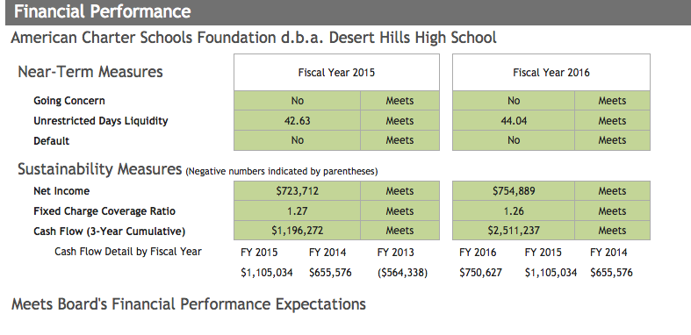

ACSF Desert Hills High School meets all of the Charter Board’s expectations on their Financial Performance Review because the Board only looks at the viability of the charter school as a business – such things as cash flow, liquidity, and net income. The Charter Board does not examine how charter schools expend tax money and have no idea how much money actually reaches children in the classroom. In fact, on March 14, 2016 The Charter Board granted Desert Hills a 20-year extension on their charter stating:

**“Viability of the Organization**

*The Charter Holder meets the Board’s Financial Performance Expectations set forth in the Performance Framework adopted by the Board. Therefore, the Charter Holder was not required to submit a Financial Performance Response.*

**Recommendation**

*Based upon the Charter Holder meeting the Academic Performance Expectations complying with applicable statutory requirements, and the information in the renewal application package, I move to approve the request for charter renewal and grant a renewal contract to American Charter Schools Foundation d.b.a. Desert Hills High School.” [[4]](#footnote-4)*

ACSF Desert Hills High School is apparently a viable business so the Charter Board rewarded Desert Hills with a 20-year extension of their charter, despite the fact that they spend very little on classroom instruction and spend excessive amounts on administration and facilities – perhaps the least spent on classroom instruction in Arizona.

The Internal Revenue Service guidelines for determining the non-profit status of charter holders, like ACSF, states the following:

**4.76.8.8.1  (07-01-2003)  
Charter Schools Exempt Status**

1. ***The primary concern regarding charter schools is whether they are operated for exclusively charitable purposes and do not operate for the benefit of private management companies and service providers.[[5]](#footnote-5)***

It appears that the ACSF is operating its schools for the benefit of Leona Group LLC, owned by Bill Coats. Coats has profited by tens of millions of dollars selling his schools, in essence, to himself and has created lucrative set fee management contracts with automatic increases each year. Classroom spending has been systematically reduced to amoung the lowest percentages of any schools in Arizona – yet it is never reported in the media and the government agency responsible for its oversight determined that ACSF schools meet all required financial requirements.

***There is a problem here.***

The ACSF, The Leona Group LLC and Bill Coats are an example of the waste, fraud, and abuse that plagues Arizona charter schools run by large, for-profit management companies. The purpose of this report is to examine, in detail, the sequence of events, and the lack of oversight along the way, which led to ACSF charter schools spending significantly more money on administration and real estate than on children in the classroom. We will look at Bill Coats and The Leona Group LLC and follow the money trail and loan process that led to a 20-30 million dollar payday for Coats in October 2007, saddling ACSF schools with massive mortgage payments that can only be paid by systematically cutting classroom spending. We will also examine the relationship of ACSF to the Leona Group LLC through management contracts between the two related organizations and will make recommendations to prevent such abuses from continuing in Arizona, the home of the most unregulated charter schools in the United States.

**The Sale of Leona Group LLC Schools to ACSF**

**Bill Coats and the Leona Group**

Dr. William (Bill) Coats was a public schools superintendent in Fort Wayne, Indiana; Anchorage, Alaska; Grosse Pointe, Michigan; and Kalamazoo, Michigan and was a full professor in the College of Education at the University of Michigan.

Bill Coats first became involved in the charter school movement in Michigan by serving as Director of The Michigan Partnership for New Education which was a part of the Michigan New Education led by billionaire mall developer Alfred Taubman.[[6]](#footnote-6) The Partnership for New Education helped win passage of Michigan legislation in 1995 that sanctioned the formation of up to 150 charter schools.[[7]](#footnote-7) In 1997 Coats and Taubman went into business together and the Partnership for New Education became the for-profit Leona Group of Michigan. (See Appendix 1) Tuabman and Coats and opened their first school, the Cesar Chavez Academy, in an inner city neighborhood of Detroit.

Bill Coatscame to Arizona in 1997 and, with the financial backing of Taubman, opened five schools in the Phoenix area. Between 1998 and 2002 Coats bought real estate and built or remodeled 14 sites to become charter schools. Each school was established as a separate business LLC under Coat’s name and was financed by loans from Bank of America. Coats took out additional loans between 2002 and 2006 using eight of the schools as collateral. Each loan listed the Leona Group Michigan as a trustor. The Alfred Taubman Trust is the co-owner of Leona Group Michigan, so Alfred Taubman’s billions stood behind the loans. See Table 8. A list of all of the deeds of trust using the eight schools as collateral is in Appendix 2.

**Table 8** - Leona Group Michigan loans from B of A using Leona schools as collateral.

|  |  |  |  |
| --- | --- | --- | --- |
| Title | Loan | Date | Amount |
|  |  |  |  |
| Peoria | B | 2/8/00 | $1,493,125 |
| Ocotillo | C | 3/15/00 | $1,612,500 |
| Desert Hills | D | 7/30/00 | $1,700,000 |
| Estrella | E | 11/28/00 | $1,575,000 |
| West Phoenix | F | 7/3/01 | $3,000,000 |
| Sun Valley | G | 7/3/01 | $3,000,000 |
| Apache Trails (Pinal) |  | 7/3/01 | $3,000,000 |
| LEONA GROUP AZ | H | 11/30/01 | $4,000,000 |
| Peoria | I | 11/30/01 | $4,000,000 |
| Estrella | J | 11/30/01 | $4,000,000 |
| Sun Valley | K | 11/30/01 | $4,000,000 |
| Ocotillo | L | 11/30/01 | $4,000,000 |
| West Phoenix | M | 11/30/01 | $4,000,000 |
| Desert Hills | N | 11/30/01 | $4,000,000 |
| Alta Vista (Pima) |  | 11/30/01 | $4,000,000 |
| Apache Trails (Pinal) |  | 11/30/01 | $4,000,000 |
|  |  |  |  |
| Total |  |  | $51,380,625 |
|  |  |  |  |
| Revolving Loan |  | 12/19/02 | $3,700,000 |
| Loan A (Revised from 7.5 to 15.0 M 6/30/03) |  | 12/19/02 | $15,000,000 |
| Loan B |  | 12/19/02 | $3,000,000 |
|  |  |  |  |
|  |  |  |  |
| Loan A New |  | 1/17/07 | $20,000,000 |
| Loan B New |  | 1/17/07 | $4,000,000 |

Decca Builders, the general contractor Coats hired to build several schools, reported that Estrella High School and Desert Hills High School cost about 2.5 million to develop. Crestview High School(originally Ocotillo High School) was converted from a roller rink to classroom space for $950,000, according to Decca.[[8]](#footnote-8) There are no sales records or construction contracts available for the schools, but based on statements from Decca Builders and on loan amounts, it appears the schools cost Coats between 2.5 and 4 million dollar each to purchase or build.[[9]](#footnote-9)

By November 2001, Coats had borrowed over 51 million dollars using eight of the schools as collateral. He borrowed an additional 21.7 million dollars in 2002-03 and in January 2006, just ten months before he sold ten schools to his foundation, he borrowed another 24 million dollars. See Table 8 above.

**American Charter Schools Foundation**

In 1998 Bill Coats formed the non-profit American Charter Schools Foundation

(ACSF) in Michigan with Michael Malone the Regional Vice President for Development for Leona. (See Appendix 3) Coats turned over the Foundation on June 29, 2007 to Theodore Frederick, former Chief Financial Officer at Leona, Linda Comer, a former Leona employee, and Matt Proctor, an associate from New Orleans who was instrumental in securing Leona control of several charter schools in post-Katrina New Orleans.[[10]](#footnote-10)

The Foundation received donations of educational materials and parceled them out to various schools, most of which were Leona managed schools in Michigan. The Foundation never had an annual income of over $65,000 and had never owned or managed a charter school.[[11]](#footnote-11) Theodore Fredericks, Director of the Foundation, is the only paid Foundation employee ($124,000/year). His office is at Leona headquarters in North Phoenix. ACSF has six board members:

Matthew Proctor, Director (New Orleans, Louisiana)

Theodore C. Frederick, Director, President and CEO (Phoenix, Arizona)

John Matthews, Vice Chair (Grand Rapids, Michigan)

Linda Comer, Chair (Charlotte, North Carolina)

Gina Conflitti, Treasurer (Scottsdale, Arizona)

Scott McPhail, Secretary (Honolulu, Hawaii)

Meetings are held via teleconference since four of the six board members live outside of Arizona.[[12]](#footnote-12)

**Pima Industrial Authority**

In 2007, Coats began the process to fund the sale of ten Leona schools to ACSF through the Pima Industrial Authority (PIA). Industrial Authorities are government agencies that provide a funding mechanism for non-profits to finance public works projects such as charter schools and prisons. The Pima County Industrial Authority is one of the largest providers of bond funds for charter schools, not just in Pima County, but also around the country.[[13]](#footnote-13) The bonds are sold on the open market as tax-free investments by private financial institutions providing funding at a lower interest rate than conventional financing. The 82 million dollar bond awarded to ACSF was the third largest bond issued to a charter school owner in the U.S. up to that time.[[14]](#footnote-14)

**Application for Bond Funding**

Finding information about the ACSF bond application was challenging. It took 6 months of public records requests to the Pima Industrial Authority’s attorney Michael Slania of Russo, Russo & Slania, including the assistance of Tim Hogan from the Center for Law in the Public Interest, to receive the ACSF loan application and supporting documentation. The application documents were finally received as a portion of a 1771 page packet.[[15]](#footnote-15)

ACSF incorporated in Arizona June 25, 2007 and submitted the bond application on August 9, 2007. ACSF had never owned or managed a school before, yet Slania was unable to produce a financial statement from the Foundation to qualify for the bond. The $82,000,000 loan was the largest bond issue ever authorized by the PIA and it was done without the required financial statement from the Foundation.[[16]](#footnote-16). Slavia noted however, at the Pima County Industrial Authority Board meeting on August 17, 2007, that the Leona Group LLC was guaranteeing the loan - a loan that would pay Leona over $72,000,000. (See Appendix 4)

**Appraisals**

Coats was able to sell the schools to ACSF for an average price of 7.2 million dollars per school, far more than the real estate was worth. The schools were appraised using a value formula appraising them as businesses, not as real estate. This was deemed appropriate by the appraiser because the purchase was to be made by secured, low interest bonds. See Appendix 5. (The complete appraisals are available at azcsa.org)

The appraisals totaled $63,015,000 as reported in the loan application. Buried in the 1771 page loan documents, apparently some of the properties were re-appraised using the actual profit from the schools in the formula. The Leona Group LLC profit amounts used for the calculations were redacted from the documents turned over by the Pima Industrial Authority; apparently to keep Leona profits a secret. See the redacted exhibit below:

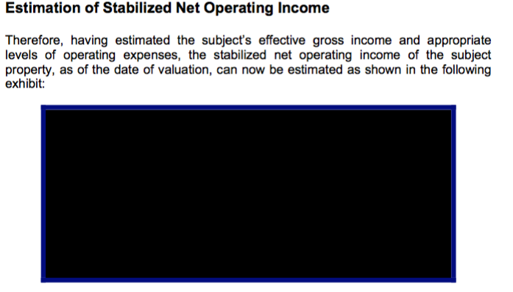

The revision of the property appraisals doubled the investment value of three of the schools and created a total appraisal of $82,656,000. The PIA awarded $82,185,000 to ACSF, including the sales price of the properties. $72,492,485 was used to pay off all of Leona Group LLC loans on the properties at the Bank of America including the 24 million dollar loan Coats acquired that January. See Table 9.

**Table 9** – Appraisals for 10 Leona Group LLC schools from the 2007 bond application submitted by ACSF to the Pima Industrial Authority

|  |  |  |  |  |
| --- | --- | --- | --- | --- |
| School | Market Value | Investment Value | Revised Value\* | Sales Price |
| ACSF Alta Vista HS | $3,045,000.00 | $5,331,000.00 | $11,500,000 | $8,000,000 |
| ACSF Apache Trails HS | $3,535,000.00 | $4,602,000.00 | $4,602,000 | $4,602,000 |
| ACSF Desert Hills | $3,690,000.00 | $5,596,000.00 | $10,925,000 | $7,761,485 |
| ACSF Crestview (Ocotliio) | $4,533,000.00 | $7,178,000.00 | $7,178,000 | $7,178,000 |
| ACSF Estrella HS | $3,440,000.00 | $5,855,000.00 | $5,855,000 | $5,855,000 |
| ACSF Peoria Accelerated HS | $3,920,000.00 | $5,232,000.00 | $10,930,000 | $7,430,000 |
| ACSF South Pointe HS | $4,882,000.00 | $6,825,000.00 | $9,270,000 | $9,270,000 |
| ACSF South Ridge HS | $3,620,000.00 | $6,606,000.00 | $6,606,000 | $6,606,000 |
| ACSF Sun Valley HS | $3,840,000.00 | $6,977,000.00 | $6,977,000 | $6,977,000 |
| ACSF West Phoenix HS | $4,097,000.00 | $8,813,000.00 | $8,813,000 | $8,813,000 |
|  |  |  |  |  |
| **TOTAL** | **$38,602,000** | **$63,015,000** | **$82,656,000** | **$72,492,485** |

**Inaccurate Appraisal- Sun Valley High School**

The most questionable appraisal involved Leona’s Sun Valley High School located at 1043 S. Lindsay in Mesa, Arizona. The school is situated on 3.2 acres and has 12,000 square feet under roof. The school consists of 11 wooden modular classroom buildings built in 1995. The appraiser from KS Appraisals, stated:

“The subject units which have a “modular” design are considered permanent fixtures equal to a stick built facility. It is assumed these structures are permanent fixtures with the Maricopa County Assessor’s office.” (See Appendix 6)

A cursory examination of the Maricopa County Assessor’s records for Sun Valley High School reveal that all of the buildings at Sun Valley are considered “Mobile Homes” and are assessed at significantly lower rates than “stick built” facilities. As a result, the property taxes for Sun Valley in 2006 were about a third of the amount the other Leona schools paid.

Failing to appraise the Sun Valley buildings as mobile homes led to a 7 million dollar appraisal value for Sun Valley High School. Coats received $6,977,000 for 11 “mobile homes” on 3.2 acres in the sale to ACSF. See the description of buildings at Sun Valley listed by the Maricopa County Assessor below: [[17]](#footnote-17)

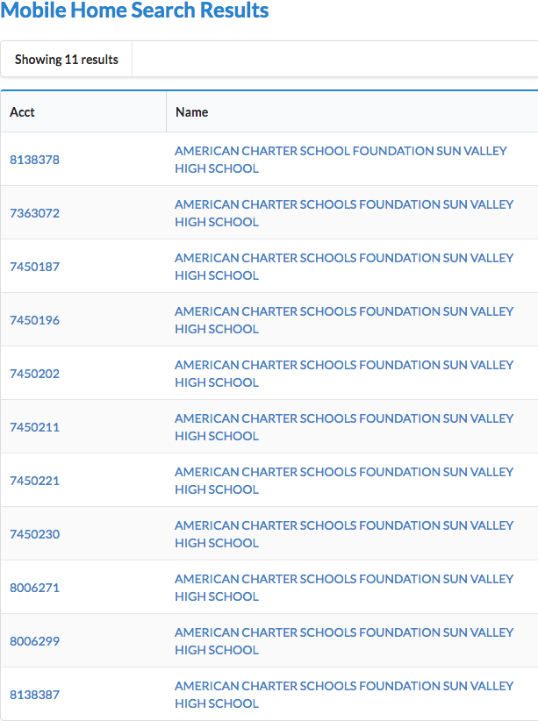

Two of the eleven wooden modular buildings at Sun Valley High School, a school Bill Coats sold to his foundation for nearly $7,000,000, are shown below:

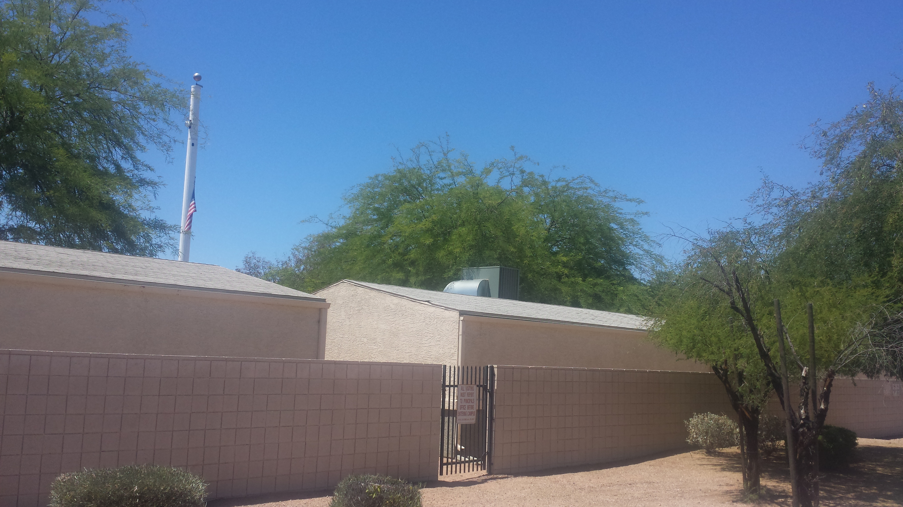

Sun Valley High School

**Purchase of the schools**

The Board of the Pima Industrial Authority granted the bond loan on August 17, 2007 and the Pima County Board of Supervisors approved it on September 18, 2007. The total Bond was $82,185,000 with $72,492,000 earmarked for purchase of the ten schools from Bill Coats. The remainder of the loan went to set up a reserve account for the loan and pay the attorneys and consultants that put the loan package together.

There are no actual purchase documents available for the sale. Instead, 82 million dollars was deposited at Wells Fargo Bank on October 1, 2007 and $72,492,000 was transferred to Bank of America on October 5, 2007 to pay off all of the loans Bill Coats had taken out on the properties since 2000– including the $24,000,000 loan made just 10 months earlier. On October 13, 2007 ACSF signed a ten-year management agreement with the Leona Group LLC and Coats transferred the deeds to the schools to ACSF on October 25th.

**Elimination of property taxes**

When Coats transferred the ten properties to ACSF they were able to forgo paying property taxes on the real estate since the new owners were a non-profit foundation. Leona paid over $324,494 in property taxes in Maricopa County in 2007. [[18]](#footnote-18) Coats avoided paying property taxes in the future by transferring the schools to his foundation.

**School leases double**

Bill Coats charged each of the Leona schools an annual lease payment when they were owned by Leona Group LLC. Those leases totaled $2,875,034 in 2006, the year before he sold the properties.[[19]](#footnote-19) In 2016 the lease payments charged by ACSF to the schools are more than double that amount – even though enrollment has decreased by 25% since 2006. See Table 10.

**Table 10** – ACSF School Leases before sale in 2006 and 2016 lease amounts

|  |  |  |
| --- | --- | --- |
|  | Lease 2006 | Lease 2016 |
| Alta Vista | $415,869 | $670,000 |
| Apache Trail | $31,816 | $185,000 |
| Crestview | $260,298 | $495,000 |
| Desert Hills | $418,080 | $625,000 |
| Estrella | $220,443 | $625,000 |
| Peoria Accelerated | $423,397 | $700,000 |
| South Pointe | $417,610 | $675,000 |
| South Ridge (2007) | $20,617 | $650,000 |
| Sun Valley | $228,286 | $785,000 |
| West | $438,618 | $785,000 |
|  |  |  |
| Total | $2,875,034 | $6,195,000 |

**Lucrative management contracts**

Leona Group LLC charged 15% of gross revenues to manage all aspects of operations for the 15 Kaizen Education Foundation schools. Bill Coats set up a completely different fee structure for the ten schools he sold to ACSF. Seven of the schools had a set fee, with an automatic 3% increase each year built in. A bonus system was also included where Leona would get an additional fee if the school revenue exceeded a prescribed amount. The other three schools have a set $900/pupil management fee.

The management contracts also stated “In addition to the management fee, the borrower (ACSF) will reimburse the manager for all commercially reasonable costs incurred and paid by the manager in providing Educational Services and Administration Services to the Borrower for the Charter School facility.” (See Appendix 7 for a sample management contract from Alta Vista High School listing management fees.)

Table 11 lists the management contract details for each ACSF school.

**Table 11** – Leona Group LLC management contract details

|  |  |  |  |  |  |
| --- | --- | --- | --- | --- | --- |
| School | Base Fee | Annual Increase | Target Revenue | Additional Bonus | Term of Contract |
| Alta Vista | $525,000 | 3% | $4,200,000 | $505,000 | 10 years |
| Apache Trail | $150,000 | 3% | $1,400,000 | $179,000 | 10 years |
| Desert Hills | $450,000 | 3% | $4,400,000 | $536,000 | 10 years |
| Peoria Accelerated | $440,000 | 3% | $4,300,000 | $523,000 | 10 years |
| South Pointe | $525,000 | 3% | $5,200,000 | $624,000 | 10 years |
| Sun Valley | $535,000 | 3% | $5,300,000 | $636,000 | 10 years |
| West Phoenix | $550,000 | 3% | $5,400,000 | $654,000 | 10 years |
|  |  |  |  |  |  |
| Estrella | $900/pupil |  |  |  | 5 years |
| Ocotillo | $900/pupil |  |  |  | 5 years |
| Southridge | $900/pupil |  |  |  | 5 years |

With set management fees that do not decrease as enrollment declines, Leona is able to keep the schools financially solvent by adjusting the amount they charge in for management. The fees that are forgiven become revenue for the school, making their operations appear more solvent. See Table 12.

**Table 12** – ACSF management expenses 2007 - 2016

|  |  |  |
| --- | --- | --- |
| Year | Management Fee | Amount Forgiven |
| Aug-Oct7 2007 | $1,220,563 | $479,415 |
| 2007-08 | $1,746,563 | 0 |
| 2008-9 | $4,186,949 | $1,313,244 |
| 2009-10 | $4,260,563 | 0 |
| 2010-11 | $4,375,197 | $681,700 |
| 2011-12 | $4,560,465 | $2,955,613 |
| 2012-13 | $4,720,930 | $752,494 |
| 2013-14 | $3,912,801 | $1,240,614 |
| 2014-15 | $3,721,341 | 0 |
| 2015-16 | $3,549,007 | 0 |

**Bond Pressures**

In March 2013 the Fitch Bond Rating Service downgraded the ACSF bonds from BBB to BB because of the weak financial profile of the ten ACSF schools caused by declining enrollment. A BB rating made the bonds speculative, or “junk” bonds.

*“WEAK FINANCIAL PROFILE: The downgrade to 'BB' primarily reflects a history of break-even to slightly negative operations and a very limited financial cushion. The downgrade also reflects a high debt burden and adequate, albeit limited, coverage of transaction maximum annual debt service (TMADS). Under Fitch's updated charter school rating criteria, ACSF's financial profile demonstrates characteristics consistent with a speculative grade rating.*

*ENROLLMENT ISSUES PERSIST: Aggregate enrollment at the schools rebounded in fall 2012 following three consecutive years of declines. However, enrollment declines persisted at several schools. The inability to correct these issues over a total of four enrollment cycles is an additional credit concern.”[[20]](#footnote-20)*

Leona implemented cost controls to strengthen the schools financial profile by slashing instructional expenses but Leona still collected “bonuses” prescribed in their management agreements for increased enrollments at certain schools, even though the actual enrollment declined during the course of the year. The bonuses contributed to ACSF poor financial performance in 2013:

*“The CMO has been able to implement cost controls, especially in salaries which are its largest expense item. Instructional expense dropped 10.5% in fiscal 2009 and then increased just 1.1% in 2010. Budgetary data provided by the CMO indicates a 15% reduction in total salaries in the current year, with additional cuts planned for fiscal 2012 to absorb state funding reductions. Leona Group also deferred approximately one-fifth of its total management fee for the ACSF schools this fiscal year, and is contractually obligated to continue deferrals as long as they are needed to ensure all cash flow obligations of the schools, including debt service, are fully met. The fiscal 2012 ACSF school budgets include a similar deferral. Management fees have historically accounted for 10 -15% of overall operating expenses. Bonus payments at certain schools based on enrollment improvements in fall 2012 despite the fact that the enrollment levels eroded during the course of the year. This resulted in weaker than anticipated financial performance.”[[21]](#footnote-21)*

**The Leona niche:**

Nine of the ten ACSF schools are alternative schools that were designed to serve at-risk students and students who had fallen behind in credits to graduate from high school. Alternative schools have far fewer expectations for academic success; in fact only 11 of 140 alternative schools in Arizona were failing in 2014.[[22]](#footnote-22) Alternative schools operate on a shorten day and 144 day calendar rather than the 180 days required by traditional schools. Public high schools, eager to improve test scores and graduation rates, welcomed charter alternative schools like Leona’s to take poor performing students off their rosters. Seven years after the Leona schools opened, total enrollment was over 4000 students.

**Alternative charter schools are much less expensive to run than comprehensive public schools**

The nine alternative schools owned by ACSF are significantly less expensive to operate than traditional comprehensive public high schools. The ACSF schools offer a bare-bones credit recovery program that relies heavily on computer instruction and offers few of the services a traditional high school would offer.

A good way to demonstrate the difference is to compare two Arizona high schools that have similar enrollments – ACSF Sun Valley High School (537 students) and Santa Rita High School (526 students) in the Tucson Unified School District.

ACSF Sun Valley High School has fifteen teachers listed on their staff roster posted on their website at: <http://www.sunvalleymesa.com/school-leader--staff.html>

|  |  |
| --- | --- |
| **Sun Valley High School**  Joe Procopio Principal  [Garth Engle](http://www.sunvalleymesa.com/engle.html), Assistant Principal [email](mailto:garth.engle@leonagroup.com) [Sarah Coleman](http://www.sunvalleymesa.com/slack.html), Assistant Principal, Curriculum Coach [email](mailto:sarah.coleman@leonagroup.com) [Shawn Coats](http://www.sunvalleymesa.com/coats.html)Assistant Principal of Vocational Education [email](mailto:shawn.coats@leonagroup.com)  **Office Staff**  [Stephanie Hernandez](http://www.sunvalleymesa.com/hernandez.html), Office Manager [email](mailto:stephanie.hernandez@leonagroup.com) [Roxanne Brooks](http://www.sunvalleymesa.com/brooks.html), Administrative Assistant [email](mailto:roxanne.brooks@leonagroup.com)  [DeeLynn Southwick](http://www.sunvalleymesa.com/southwick.html), Administrative Assistant [email](mailto:deelynn.southwick@leonagroup.com) [Silvia Navarro](http://www.sunvalleymesa.com/navarro.html), Student Services [email](mailto:silvia.navarro@leonagroup.com)  **Specialist Support**  [Marilyn Brimacombe](http://www.sunvalleymesa.com/brimacombe.html) Special Education Coordinator [email](mailto:marilyn.brimacombe@leonagroup.com) [Tracy Inorio](http://www.sunvalleymesa.com/tracy-inorio.html) College and Career Advisor | **Teaching Staff**  [Mandi Bolinger,](http://www.sunvalleymesa.com/bolinger.html) Economics, History [email](mailto:mandi.bolinger@leonagroup.com) Collin Burrell, Mathematics email [Claire Candler](http://www.sunvalleymesa.com/candler.html), Government [email](mailto:claire.candler@leonagroup.com)  [Stephen Curran](http://www.sunvalleymesa.com/uploads/4/3/9/7/4397552/curran_stephen.bmp), Mathematics [email](mailto:stephen.curren@leonagroup.com) [Stephanie Darley](http://www.sunvalleymesa.com/darley.html), Mathematics [email](mailto:stephanie.darley@leonagroup.com) [Michelle Ebersole](http://www.sunvalleymesa.com/ebersole.html), English [email ​](mailto:michelle.ebersole@leonagroup.com)Brittnee Felix, Mathematics [email](mailto:brittnee.felix@leonagroup.com) [Telleny Gilliam,](http://www.sunvalleymesa.com/gilliam.html) U.S. History [email](mailto:telleny.gilliam@leonagroup.com) [Dannielle Jensen](http://www.sunvalleymesa.com/jensen.html), Biology [email](mailto:dannielle.jensen@leonagroup.com) [Heather LaCourt](http://www.sunvalleymesa.com/lacourt.html), English [email](mailto:heather.lacourt@leonagroup.com)   [Kathy Mead](http://www.sunvalleymesa.com/uploads/4/3/9/7/4397552/2010_2011_ccat_ii.pdf" \t "_blank), Nursing [email](mailto:kathy.mead@leonagroup.com) [Matthew O'Brien](http://www.sunvalleymesa.com/obrien.html), Science, fitness training [email](mailto:matthew.obrien@leonagroup.com) Crista Procopio, English [email](mailto:crista.procopio@leonagroup.com) Sarah Hoyt, English [email](mailto:sarah.hoyt@leonagroup.com) [Jonathan Zinger](http://www.sunvalleymesa.com/zinger.html), Computer Based Education [email](mailto:jon.zinger@leonagroup.com) |

Santa Rita High School in Tucson, Arizona has 36 teachers. Santa Rita offers French, Spanish, drama, art, choir, guitar, psychology, culinary arts, and special education programs. They have a nurse, a librarian, and a social worker. ACSF Sun Valley offers none of these programs. See the 2016 staff roster from Santa Rita High School’s website from <http://edweb.tusd1.org/SantaRita/Documents/Teachers%20Phones%20Emails%2015-16.pdf> below:

****

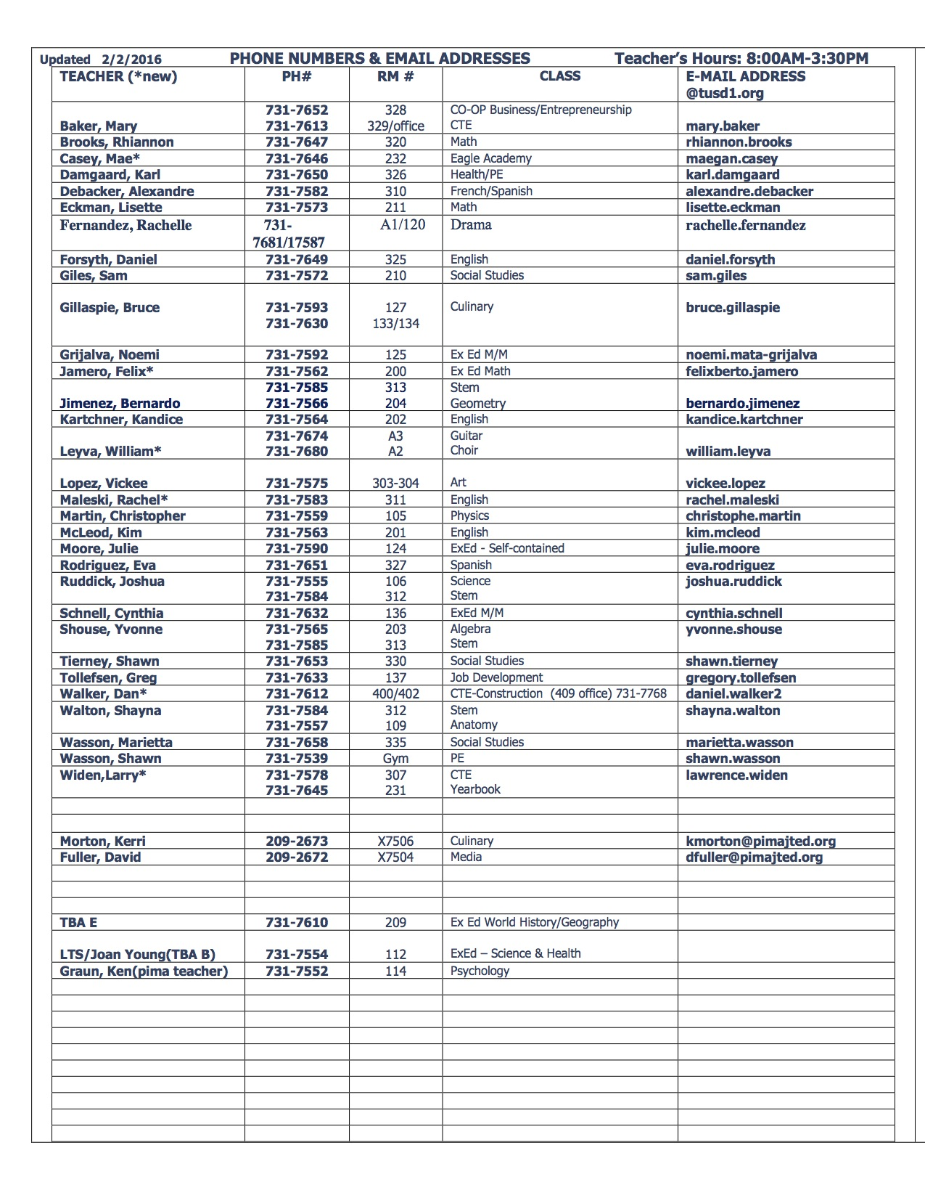

Charter high schools in Arizona receive $2000 per pupil more in state funding than public districts, to cover the costs of capitol purchases and facilities, since charters do not have access to bonds approved by local taxpayers.[[23]](#footnote-23) Sun Valley receives $2000 more per pupil than Santa Rita High School in basic state aid yet has less than half the programs and staff.

**Conclusions:**

It is not a coincidence that Bill Coats came to Arizona in partnership with A. Alfred Taubman, a real estate billionaire. Through Taubman, Coats was able to secure stable financing to create a charter school empire of 14 schools by 2002 and then leveraged them to eventually control 25 schools in Arizona and 60 schools total in five states by 2016. At the height of the real estate bubble in 2007, he concocted the scheme to sell ten of his schools to his own foundation for double their actual market value. Financial institutions eagerly provided 82 million dollars in funding, even though the foundation receiving the funds provided no financial statements. Coats then established lucrative management contracts with the schools so he could retain complete control over school operations.

The ACSF schools have lost a significant number of students since 2007, severely decreasing revenue. But the schools must come up with $6,000,000 every year just to pay the mortgages created by the school purchases from Leona Group LLC in 2007. ACSF has been forced to cut classroom spending to the lowest levels in Arizona…to fund mortgages paying for Bill Coats’ real estate windfall.

The Arizona State Board for Charter Schools sees nothing wrong with this. In fact they find ACSF to have an exemplary financial track record. The Auditor General and the Arizona Department of Education have no comment – because they do not track charter school expenditures.

The lack of transparency for all aspects of charter school operations, the ability to skirt procurement laws, and the autonomy with which private for-profit charter management companies like Leona Group LLC are allowed to operate, contributes to a culture where profits take precedence over quality education and sound fiscal responsibility for the use of public funds.

The use of non-profit status by charter companies is a shell game that skirts income taxes and local property taxes while allowing charters to hide all activities from the public by allowing for-profit management companies to completely control the schools – management companies that the charter holders own.

We pay a huge price for the deregulation of public education, whether through charter schools or vouchers, when we don’t demand complete transparency for how precious tax dollars are being expended.

The Arizona Auditor General must begin to monitor charter spending and the Charter Board needs to make charter schools just as accountable for the use of tax funds as public districts are. The I.R.S. should investigate the non-profit American Charter Schools Foundation to determine if their operation is really geared toward the public good or if it is a vehicle for Leona Group LLC profits.

**Recommendations:**

1. Legislation is necessary to require the Arizona Auditor Generals Office to monitor charter school classroom spending just as they do for public districts.
2. The Arizona State Board for Charter Schools should consider all aspects of charter spending as part of their annual financial evaluation of charter holders.
3. Affiliated companies servicing charter schools need to provide financial records documenting profits and expenses.
4. The relationship between non-profit charter holders and management companies owned by charter holders needs to be investigated by the Internal Revenue Service.
5. The practice of leasing facilities from an affiliated company needs to be investigated.
6. Charter schools should be required to follow state procurement laws so all transactions are made public, including all purchases from related parties.
7. The loan process for the Pima Industrial Authority needs to be more transparent.

**Appendix 1** –Articles of Organization for the Leona Group Michigan 1996

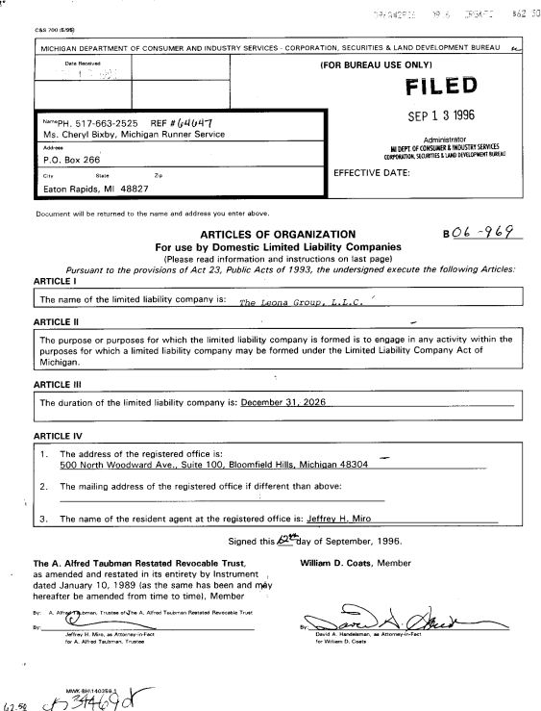

**Appendix 2** – Deeds of Trust from Bank of America using Leona Group schools sold to ACSF as collateral

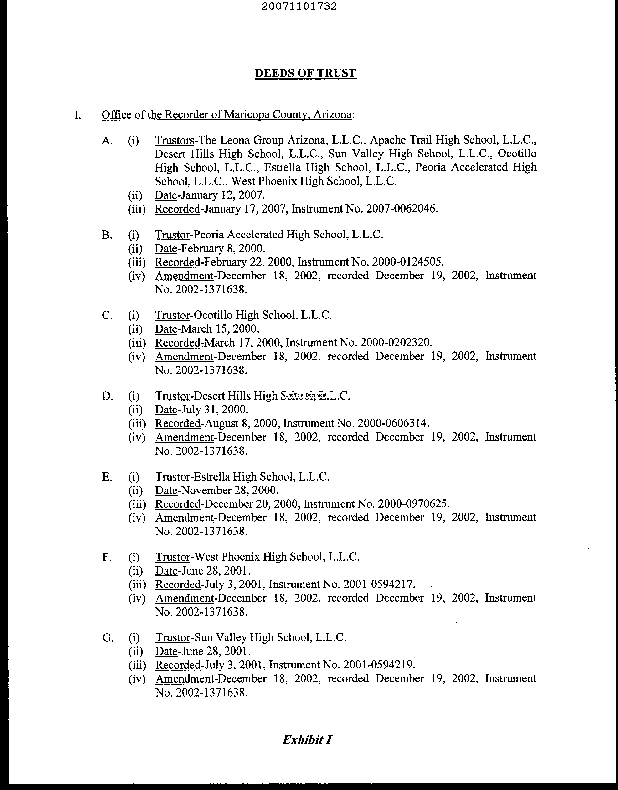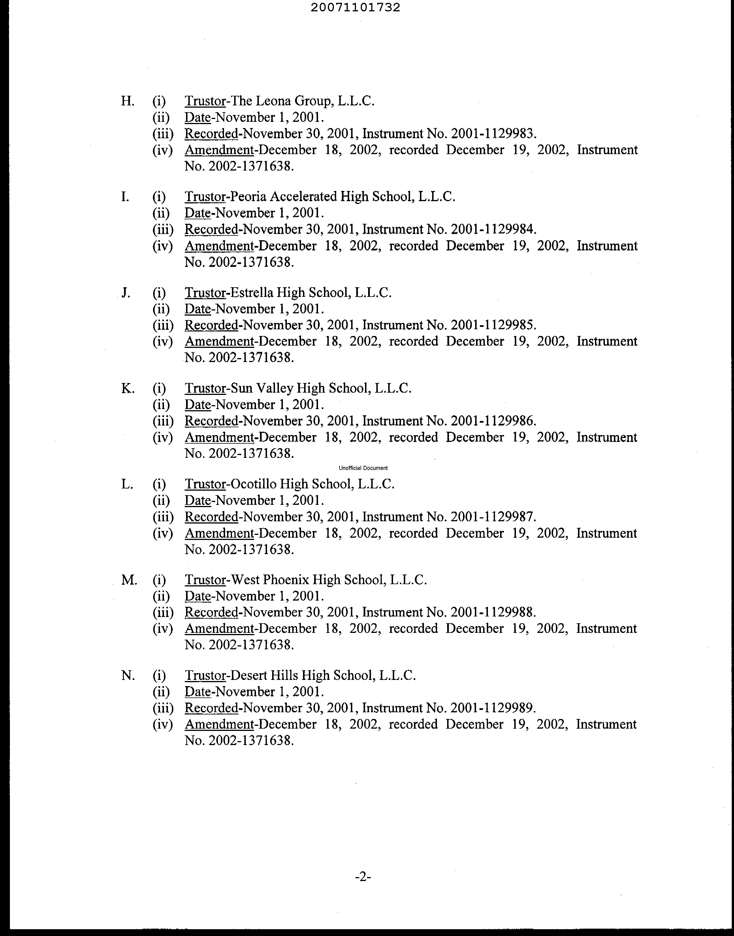

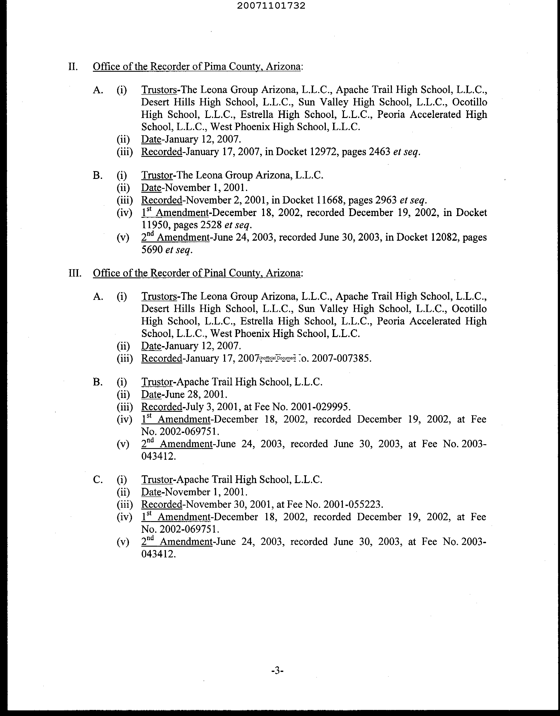 **Appendix 3 -** ACSF Michigan LLC listing William Coats and Michael Malone as sole members

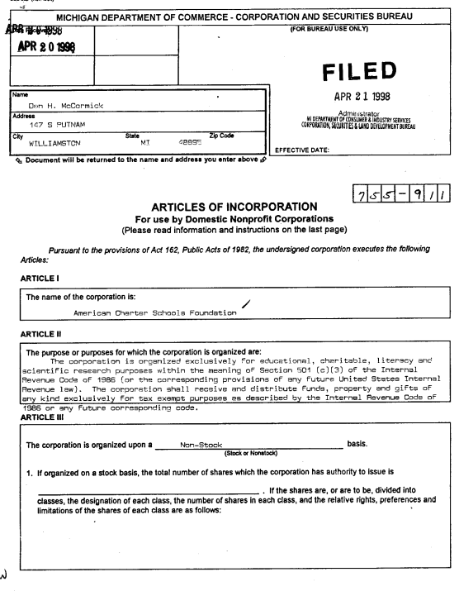

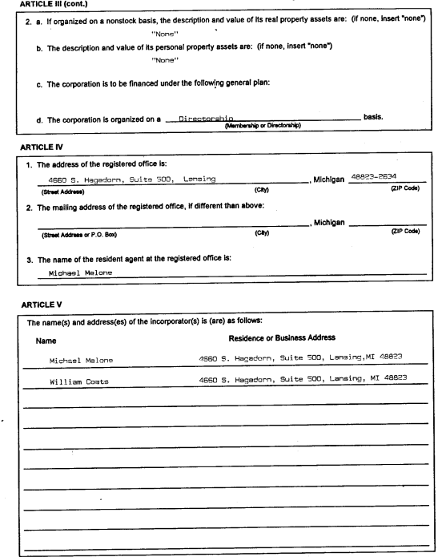

**Appendix 4** – Leona loan guarantee statement at IDA meeting August 17, 2007. Page 363 ACSF Loan Documents available at azcsa.org

**MINUTES OF THE REGULAR MEETING OF THE BOARD OF DIRECTORS OF THE INDUSTRIAL DEVELOPMENT AUTHORITY OF THE COUNTY OF PIMA**

**AUGUST 17, 2007**

…….“The Vice President announced that the next item of new business was Educational Revenue Bonds (American Charter School Foundation Project) Series 2007. Mr. Slania stated that American Charter School Foundation Project is a Michigan entity, but all the schools to be financed are in Arizona. ***With one borrower, all the schools will be cross-collateralized. RBC, the underwriter, anticipates that this management group called Leona is also providing a guarantee.*** Mr. Russo stated that because Leona is also in other states, there are multiple schools in multiple states, this Borrower may actually come back to the Authority for other financings. General discussion ensued regarding the financing. Board Member Valenzuela moved for the approval of final Resolution authorizing and approving the issue of Education Revenue Bonds (American Charter School Foundation Project) Series 2007 in an amount not to exceed $100,000,000. Board Member Collins seconded the Motion. “

**Appendix 5** – Appraisal definition of investment valuation . All appraisals are available at azcsa.org

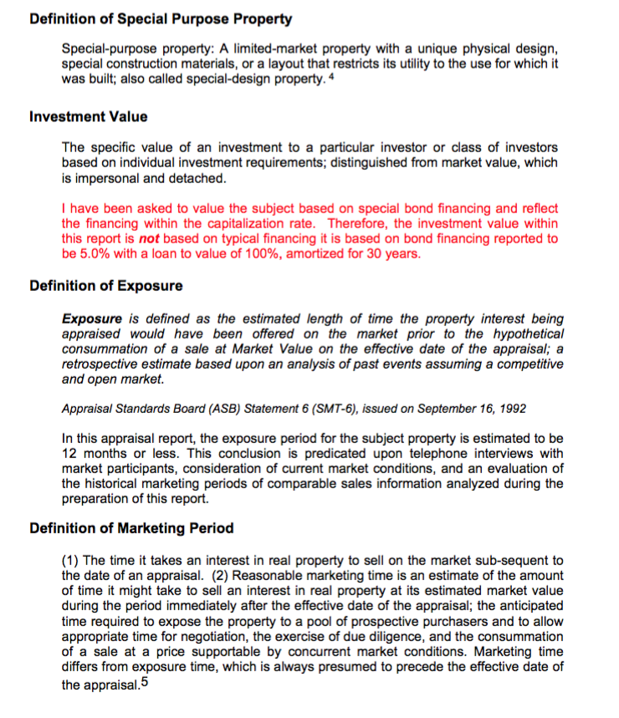

**Appendix 6** – Sun Valley High School appraisal as “stick built”. All appraisals are available at azcsa.org.

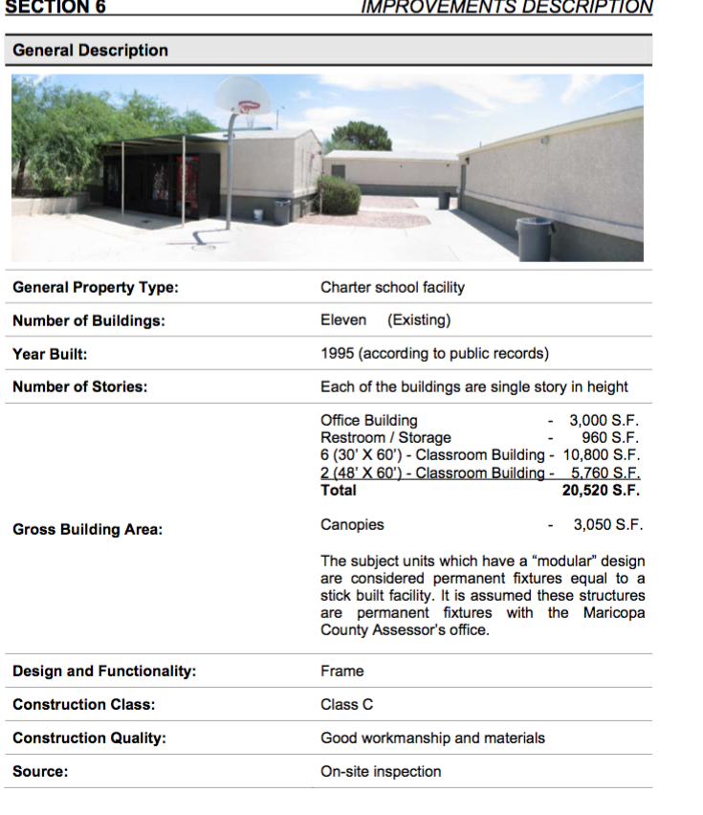

**Appendix 7 –** Sample management fee agreement for Alta Vista High School p. 1568 ACSF Loan Documents available at azcsa.org

12. Consideration for Services. (Alta Vista High School)

12.1 Management Fee. For the Term of this Agreement (including the Term as extended pursuant to Section **9.2),** ACSF will pay LAM an annual fee of Four Hundred Twenty Five Thousand Dollars ($425,000) for the Initial School Year ("Management Fee"), payable in monthly installments, provided that the parties acknowledge that the Management Fee will be equitably prorated during the short Initial School Year. The Management Fee for each subsequent School Year shall be adjusted upwards as of the first day of each School Year (the "Adjustment Date") by an amount equal to three (3%) percent of the Management Fee provided herein for the immediately preceding School Ycar ("Adjusted Management Fee"). By way of example the Adjusted Management Fee for the (i) second School Year during the Term will be Four Hundred Thirty Nine Thousand Eight Hundred Seventy Five Dollars ($439,875) and (ii) third School Year during the Term will be Four Hundred Fifty Five Thousand Two Hundred Seventy One Dollars ($455,27 1).

12.2 One-Time Incentive Award. If the gross revenues of the Charter School shall exceed Five Million Four Hundred Thousand Dollars ($4,200,000) in any School Year during the Term, LAM shall be paid an incentive award equal to the amount that Six Hundred Fifty Four Thousand Dollars ($505,000) exceeds the Adjusted Management Fee for that School Year (the "Incentive Award") and the Adjusted Management Fee for the next School Year of the Term shall be increased by the amount of the Incentive Award.

12.3 Reasonable Compensation. The Management Fee under this agreement is reasonable compensation for services rendered. LAM’s compensation for services under this Agreement will not be based, in whole or in part, on a share of net surplus or profits from the operation of the Charter School.

12.4 Payment of Costs. In addition to the Management Fee, ACSF will reimburse LAM for all commercially reasonable costs incurred and paid by LAM in providing Educational Services and Administrative Services to ACSF for the Charter Schools.

1. 2016 Annual Financial Reports for all charter and public districts are available at : http://www.ade.az.gov/schoolfinance/forms/leaquery/submittedfiles.aspx [↑](#footnote-ref-1)
2. See - https://www.azauditor.gov/sites/default/files/Window\_Rock\_USD\_Report.pdf [↑](#footnote-ref-2)
3. See - ASBCS online at http://online.asbcs.az.gov/ [↑](#footnote-ref-3)
4. ACSF submits one consolidated audit covering all ten schools so all ten schools meet all financial requirements set by the Charter Board. See - https://asbcs.az.gov/sites/default/files/ACSF%20-%20Desert%20Hills%20High%20School%20Renewal.pdf [↑](#footnote-ref-4)
5. See: *Revised Charter School Reference Guide at http://mycharterlaw.com/pdf/IRS\_Update\_Revised\_Charter\_School\_Reference\_Guide\_102607.pdf* [↑](#footnote-ref-5)
6. Alfred Taubman was estimated by Forbes to be worth 3.1 billion dollars and was on the Forbes Richest 400 Americans list for over two decades. [↑](#footnote-ref-6)
7. http://www.edweek.org/ew/articles/1995/12/06/14mich2.h15.html [↑](#footnote-ref-7)
8. See http://www.bizjournals.com/phoenix/stories/2002/01/21/story8.html [↑](#footnote-ref-8)
9. Leona Group LLC is a for-profit company and state procurement laws documenting contracts and sales do not apply. [↑](#footnote-ref-9)
10. See http://www.frilot.com/articledetail.asp?tid=30 [↑](#footnote-ref-10)
11. See page 11 of ACSF 2006 IRS 990 form at: https://www.guidestar.org/FinDocuments/2006/383/463/2006-383463353-0360651c-9.pdf [↑](#footnote-ref-11)
12. See ACSF website at http://www.acsfoundation.org/our-board.html [↑](#footnote-ref-12)
13. See https://arizonadailyindependent.com/2016/04/04/industrial-development-authority-industrious-everywhere-but-pima-county/ [↑](#footnote-ref-13)
14. See *The Complete History of Charter Bond Issuance* at http://www.highmarkschools.com/wp-content/uploads/2016/05/LISC-1998-2010-Charter-School-Bond-History-Vol-I.pdf [↑](#footnote-ref-14)
15. The entire application document is available at azcsa.org [↑](#footnote-ref-15)
16. See http://www.pimaida.com/bond-issues/ [↑](#footnote-ref-16)
17. See http://mcassessor.maricopa.gov/mcs.php?q=sun%20valley%20high%20school [↑](#footnote-ref-17)
18. Property tax payments for 2006 are listed for each property in the individual appraisals available at azcsa.org [↑](#footnote-ref-18)
19. Lease amounts are listed in the Annual Audits submitted to the Charter Board available at: http://online.asbcs.az.gov/ [↑](#footnote-ref-19)
20. See -http://www.businesswire.com/news/home/20130308005957/en/Fitch-Downgrades-American-Charter-Schools-Foundation-MI [↑](#footnote-ref-20)
21. See - http://www.businesswire.com/news/home/20130308005957/en/Fitch-Downgrades-American-Charter-Schools-Foundation-MI [↑](#footnote-ref-21)
22. See A-F ratings for alternative schools at: http://www.azed.gov/accountability/state-accountability/ [↑](#footnote-ref-22)
23. A.R.S. 15-185.B.4 [↑](#footnote-ref-23)