Getting Rich: 31 Charter holders had over 20% profit margin in 2019
Charter Owner Steven Durand

Public school districts are allowed to carry forward up to 4% of their unspent budget. The average charter holder had 7% of their revenue left after expenses in 2019, a very reasonable cushion.

There are, however, 31 charter owners that made over 20% profit last year.

Steven Durand’s non-profit Educational Options Foundation school received $4.6 million in tax revenue but he only spent $2.3 million in 2019 – keeping 51% of the money the state paid him to educate children. Durand also owns Kestrel Schools (44% profit margin) and James Sandoval Prep (27% profit margin). And, you guessed it - Durand’s schools are alternative schools using online instruction.

Just the one Durand Educational Options School has generated $14.7 million in increased net assets since 2011:

Educational Options | Expenditures | Revenue | Gain | Gain % of Revenue
2011 | $480,434 | $561,549 | $81,115 | 14%
2012 | $391,801 | $551,938 | $160,137 | 29%
2013 | $1,069,462 | $2,077,236 | $1,007,774 | 49%
2014 | $1,507,473 | $2,948,692 | $1,441,219 | 49%
2015 | $1,817,361 | $3,604,424 | $1,787,063 | 50%
2016 | $1,990,360 | $3,994,611 | $2,004,251 | 50%
2017 | $2,301,975 | $5,445,660 | $3,143,685 | 58%
2018 | $2,340,977 | $5,120,329 | $2,779,352 | 54%
2019 | $2,275,338 | $4,642,811 | $2,367,473 | 51%
Totals | $14,175,181 | $28,947,250 | $14,772,069 | 51%

Twenty-six of the high earning charters are non-profits like Educational Options that merely add profits to the net assets of the company. You might wonder what the point is of a non-profit hoarding money?

First is a hefty salary for the owner paid by the non-profit. Steven Durand took home $243,933 in salary and benefits in 2017 (from the latest non-profit 990 tax return available).

Secondly, the non-profit is able to buy equipment, materials, and real estate with their assets. Steven Durand bought this $1.35 million house on 6710 E Calle Legos as a “school” site in 2017...using the assets of the non-profit Educational Options Foundation.

6710 W. Calle Legos – Backyard “playground” for Durand’s new “school”
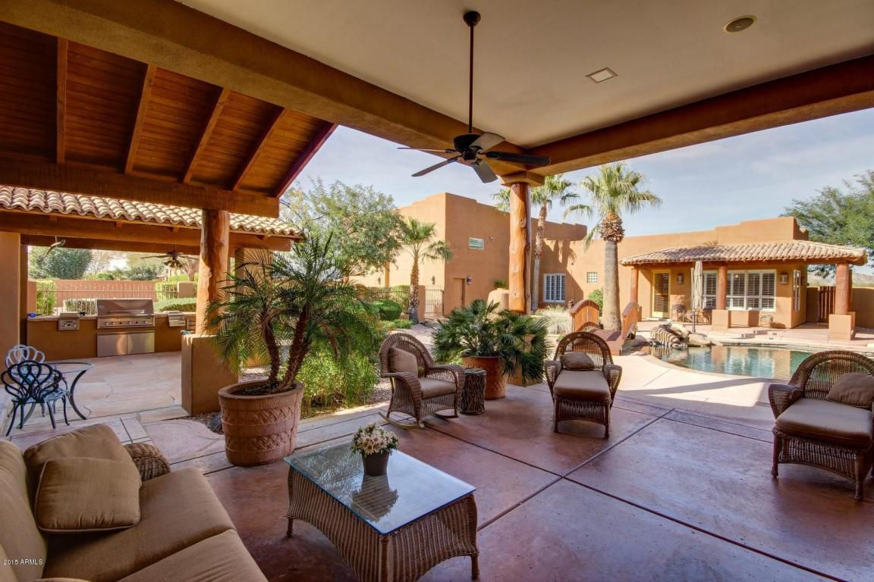

The next year, Durand bought a second “school” site right next door at 6790 W. Calle Legos for $954,000

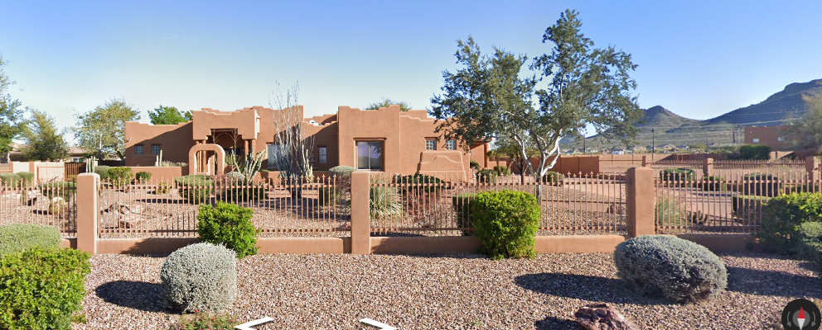

Please look at the photos of the real estate charter owners are purchasing by refusing to spend tax funds on the most at-risk students in the state. Then read this article on AZ Central about school districts that are unable to fix leaking roofs because of a lack of funding.
https://www.azcentral.com/story/news/local/arizona-education/2019/11/20/rain-damages-some-arizona-classrooms-lacking-funds-repairs/4250177002/

The pot that should be funding public district school repairs is the same pot that is buying luxury homes for charter owners like Steven Durand.

