BASIS Schools Fall On Hard Times
Excessive management fees and rapid national expansion leads to $ 26 million deficit in 2016

Jim Hall
Arizonans for Charter School Accountability

As the BASIS empire has grown, so have the management fees paid to BASIS Educational Group Inc., owned by Michael Block. BASIS ed. describes management fees as “…upper management salaries and related benefits, technology support, accounting, student enrollment and reporting, and new school development services.” (2015 BASIS Consolidated Audit, p. 18 found at: http://online.asbcs.az.gov/dms/browse/561)
Between 2012 and 2015 BASIS ed. administrative costs were some of the highest in Arizona, taking in over one third as much in management fees as in all school salaries and benefits: (from BASIS Annual Audits 2012-2016 found at http://online.asbcs.az.gov/dms/browse/561)
 | Leased Employee Salaries | Management Fees | Management Percentage
2012 | $14,544,995 | $5,229,593 | 36.0%
1013 | $21,173,748 | $8,339,475 | 39.4%
2014 | $30,439,295 | $11,459,735 | 37.6%
2015 | $44,304,951 | $15,589,133 | 35.2%
2016 | $61,512,302 | $12,015,390 | 19.5%

In a 2015 study by the Grand Canyon Institute and Arizonans for Charter School Accountability, BASIS schools spent an average of $2291/pupil on administration in while the average public district spent just $628/pupil. http://grandcanyoninstitute.org/higher-administration-charges-of-arizona-charter-schools-cost-taxpayers-128-million-a-year/

BASIS General Administrative costs alone amounted to nearly $12 million for 8,730 students, while the six largest public school districts combined served a quarter million students for less than $10 million in General Administrative costs. (From the 2016 Annual Financial Reports for each district and BASIS) http://www.ade.az.gov/schoolfinance/forms/leaquery/submittedfiles.aspx
Charter School or School District |  | Enrollment October 1, 2014 | General Admin
Tucson Unified School District |  | 49,012 | $2,774,083
Roosevelt Elementary School District 66 |  | 9,614 | $1,920,856
Mesa Unified School District #4 |  | 64,532 | $1,450,539
Phoenix Union High School District #210 |  | 26,814 | $1,401,457
Paradise Valley Unified School District |  | 32,732 | $1,185,208
Chandler Unified |  | 42,664 | $1,161,728
Total |  | 225,368 | $9,893,871
BASIS Schools |  | 8,730 | $11,668,824

This lavish spending on upper administrative salaries, rapid Arizona expansion, and building the national BASIS brand came to an end last year when BASIS ed. dramatically reduced management fees to only 19.5% of school salaries, compared to 35.2% the previous year. If BASIS had reduced management fees in 2015 to the lower 2016 level, BASIS Schools would have saved $7 million - $7 million in profits that went to Michael Block.

Why did Brock take such a hit? Exorbitant management fees and rising debt for new facilities left BASIS Schools with a $13.2 million deficit in net assets in 2015. Even with the drastic reduction in management fees in 2016, the total BASIS deficit soared to $22.9 million in 2016.

The BASIS schools in Washington DC have over $1 million in net assets and the Texas schools are in the black $2.5 million. The Arizona BASIS schools, however, show deficits of over $26 million last year. (2016 Annual Audit)

The Arizona State Board for Charter Schools has sited BASIS for not meeting financial expectations in 2014 and 2015: http://online.asbcs.az.gov/charterholders/view/560/basis-schools-inc#performance-tab

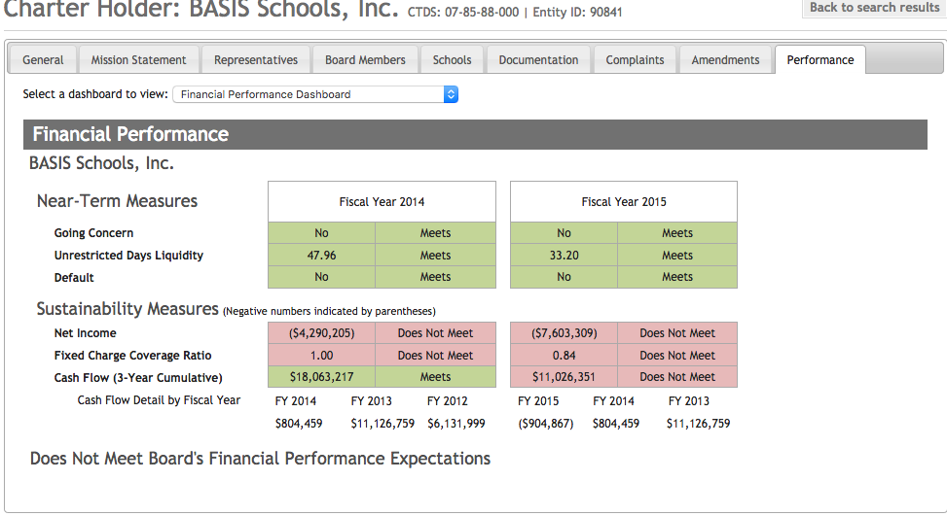

Lavish facilities and huge profits have greatly benefited the bottom line of BASIS ed. and Michael Brock but have left non-profit BASIS Schools in trouble with the Charter Board.

BASIS parents gave BASIS Schools over $11 million in extra curricular fees and contributions last year. (2016 Annual Audit) They should be outraged.

