ASU Prep is the Worst Run Charter Organization in Arizona
Their CEO made $560,000 and top executives made $1.5 million in 2018 … with just 3,000 students and schools with “C” and “D” ratings

Summary:
ASU Prep is the worst run charter organization in Arizona – by far. ASU Prep has an enrollment of 3,000 students and had a “C” and a “D” school in 2019. The CEO of ASU Prep, Beatriz Rendon, was paid $304,000 in 2018 by non-profit ASU Prep and drew an additional $260,000 from ASU as Vice President of Strategic Initiatives (over $564,000 total) - making her the highest paid K-12 public school official in Arizona history. Total ASU Prep executive salaries in 2018 were $1,549,617. On top of that, ASU Prep has an additional district office staff of 33 people including a Talent Specialist, a Director of Student Well Being, and a Communications and Relations Director who oversees a Marketing and Communications Manager. ASU Prep spent $4,929/pupil for administration in 2019 while the average charter spent $1,600/pupil and districts averaged about $800/pupil for administrative costs.

The extravagant pay and unnessesary personnel are possible because ASU dumped $16 million in 2019 into ASU Prep, giving ASU Prep an astounding $15,700/pupil to spend, nearly double what the average charter has available. A big chunk of that is paying for the highest K-12 administrative salaries in Arizona.

As a comparison, Safford Unified District in a small town in eastern Arizona also has about 3,000 students. Safford Unified has more free and reduced lunch students than ASU Prep and a similar minority population- yet Safford had all “A” and “B” rated schools in 2019. Safford Unified spent $832/pupil for administration and has a district office with a staff of 12, including the superintendent who made less than $140,000 last year.

ASU Prep is not regulated by the Arizona State Board for Charter Schools - it is authorized solely by Arizona State University, which provides absolutely no oversight we can find. In fact ASU appears to be using its charter schools to funnel money to pay exorbitant salaries to ASU personnel, and provide great PR for the “Innovation” University, rather than addressing why they have “C” and “D” rated schools.

University “lab schools” have historically been a place where professors could experiment with new educational strategies in real classroom settings – to ultimately improve classroom instruction in public schools. ASU Prep is the opposite. They have shown that having nearly $16,000/pupil does nothing to increase student achievement…especially when most of it is going into the pockets of ASU employees.

Data:
Existing ASU Prep Schools 2016-2019
The six ASU Prep schools that have been in existence since 2016 have seen a huge increase in funding and expenditures 2016-2019. The schools had over $4,000/pupil in additional revenue in 2019 than in 2016 with $2,400 per pupil going into administrative expenditures while classroom instruction increased by $1,100/pupil.

Existing ASU Prep Schools 2016-2019 per ADM
 | ASU Preparatory Academy - Phoenix Elementary | ASU Preparatory Academy - Phoenix Middle School | ASU Preparatory Academy - Polytechnic Middle School | ASU Preparatory Academy - Phoenix High School | ASU Preparatory Academy - Polytechnic High School | ASU Preparatory Academy - Polytechnic Elementary | Totals
2016 M&O/ADM | $10,421 | $8,426 | $7,562 | $10,730 | $9,280 | $9,130 | $9,371
2019 M&O/ADM | $13,967 | $11,776 | $11,486 | $15,453 | $15,202 | $12,664 | $13,452
2016 Revenue/ADM | $10,813 | $9,515 | $9,550 | $10,176 | $9,344 | $10,580 | $10,050
2019 Revenue/ADM | $14,400 | $11,869 | $12,370 | $15,724 | $15,975 | $13,185 | $13,931
2016 Admin/ADM | $1,360 | $1,235 | $1,381 | $1,216 | $1,436 | $1,229 | $1,296
2019 Admin/ADM | $3,860 | $3,313 | $3,461 | $3,534 | $3,669 | $3,878 | $3,617
2016 Instruction/ADM | $3,898 | $3,040 | $3,060 | $4,636 | $4,690 | $3,650 | $3,832
2019 Instruction/ADM | $4,635 | $3,455 | $4,622 | $6,716 | $5,290 | $5,133 | $4,996

Local Revenue skyrockets in 2018 and 2019 through University contributions
In 2016 ASU Prep had similar local revenue in the form of activity fees and donations similar to Great Hearts and BASIS- about $1,600/pupil. Total revenue in 2016 was $10,000/pupil - near the average for charter schools.

In 2018 local revenue, in the form of fees and donations, tripled to $4,600/pupil and total revenue increased to $13,598/pupil. In 2019 local revenue went up another $1,100/pupil to $6,739/pupil and total revenue increased to $15,760/pupil – over 50% more than was available in 2016.

ASU Prep Local and Total Revenue 2016-2019
 | Local Revenue | Local/ADM | Total Revenue | Revenue/ADM
2016 | $3,241,163 | $1,618 | $20,130,751 | $10,050
2017 | $4,926,811 | $2,324 | $22,349,072 | $10,542
2018 | $12,559,519 | $4,609 | $37,053,480 | $13,598
2019 | $21,281,378 | $6,739 | $49,771,242 | $15,760
The increase in local revenue came straight from the University. In 2016 ASU provided ASU Prep $1.5 million in in kind contributions and services – subsidizing some facilities rentals and providing ASU staff to assist the charter. In 2018 ASU suddenly contributed $6 million in cash to the charter and in 2019 ASU contributed over $13 million in cash with a total subsidy of $16,705,662, over $5,000/pupil.

ASU Contributions 2016-2019
 | Oct. 1 Enrollment | ASU In Kind +Services | ASU Cash Donation | Total ASU Contribution | ASU Contributions/pupil
2016 | 2,003 | $1,594,217 | $0 | $1,594,217 | $796
2017 | 2,120 | $1,874,178 | $0 | $1,874,178 | $884
2018 | 2,725 | $2,789,291 | $6,000,000 | $8,789,291 | $3,225
2019 | 3,158 | $3,388,006 | $13,317,656 | $16,705,662 | $5,290

Revenue increases 2016-2019 go mostly to administrative costs
The infusion of over $ 5,000/pupil into ASU Prep by the University between 2016 and 2019 has gone mostly to paying exorbitant administrative costs, not classroom instruction. Regular and special education instruction in creased by 20% 2016-2019 while total administrative spending more than tripled.

Instruction and Administration Per Pupil 2016-2019
 | October Enrollment | Regular and Special Education Instruction | Instruction/pupil | Total Administration | Administration/Pupil
2016 | 2,003 | $8,394,730 | $4,191 | $2,595,542 | $1,296
2017 | 2,120 | $9,255,687 | $4,366 | $3,652,045 | $1,723
2018 | 2,725 | $12,274,146 | $4,504 | $11,238,340 | $4,124
2019 | 3,158 | $16,431,232 | $5,203 | $14,514,725 | $4,596

ASU Prep apparently tries to hide the increase in district office spending by reporting this spending as school administration costs on annual financial reports. School administrative spending suddenly tripled in 2019.

ASU Prep Executive pay
According to IRS 990 tax returns, the salaries paid ASU executives tripled 2014-2018, topping $1.5 million in 2018. CEO Beatriz Rendon’s salary increased from $95,406 in 2016 to $304,193 in 2018. Ms. Reddon also drew a $260,000 salary in 2018 from ASU as Vice President of Strategic Initiatives, making her total compensation $564,193.

IRS 990 disclosures of ASU Prep executive salaries 2014-2019
Name | Title | 2014 | 2015 | 2016 | 2017 | 2018
Beatriz Rendon | CEO | $95,406 | $119,649 | $252,637 | $296,741 | $304,193
Deborah Gonzales | CAO | $175,322 | $161,178 | $167,667 | $201,632 | $208,506
Marcie Rodriguez | Ex Bus Off | $54,814 | $99,905 | $114,383 | $122,976 | $135,400
Arthur Lebowitz | Director | $103,800 | $105,123 | $108,417 | $136,269
David Lujan | Ed Director | $138,700
Steven Benton | CFO |  |  |  |  | $135,400
RobertTodd Jones | Sr Global BD |  |  |  |  | $225,118
Wendy Oliver | Senior Learn |  |  |  |  | $182,750
Corey Woods | COO |  |  |  |  | $182,000
Cecilia Lopez | Senior Officer |  |  |  |  | $176,250
Total |  | $568,042 | $485,855 | $643,104 | $757,618 | $1,549,617

The “District Office” at ASU Prep is housed in three separate facilities. The ASU Prep executives are in offices at the Fulton Center in downtown Tempe. Business and HR functions are housed at University Center in Tempe and Operations and IT are at ASU’s Palo Verde West. Beyond the executives, there are 33 employees at the ASU Prep “Network Offices” (District Office) that add millions to ASU Prep’s administrative expenses.

Central administration at ASU Prep includes directors, officers, managers, coordinators, and specialists for things a public district has never heard of, such as an Executive Director of Student Well Being, a Talent Specialist, or Student Services Project Administration Support Manager. There are two full time public relations
positions and four human relations people. Central administration spending at ASU Prep in 2019 was $ 9 million…for a school district of 3,000 students

Annual Financial Reports 2016-2019: Administrative spending
 | General Administration | School Administration | Central Administration | Other Administration | Total Administration | Admin/Pupil
2016 | $541,903 | $886,296 | $1,167,343 | $0 | $2,595,542 | $1,296
2017 | $768,045 | $1,028,372 | $1,855,628 | $0 | $3,652,045 | $1,723
2018 | $3,315,725 | $1,650,325 | $6,272,290 | $0 | $11,238,340 | $4,124
2019 | $0 | $5,041,543 | $9,038,562 | $434,620 | $14,514,725 | $4,596

ASU Prep District Office staff 2019
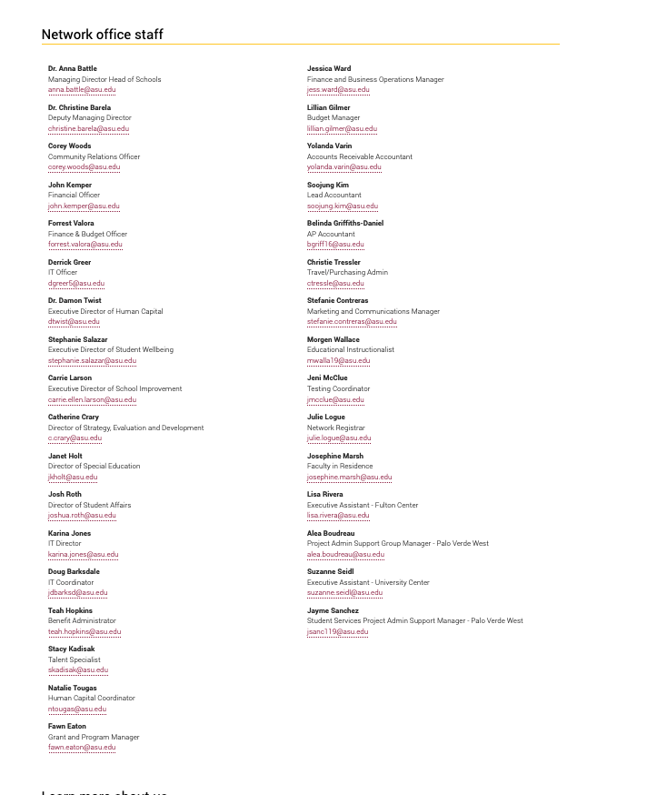

Public district comparison with ASU Prep
As a comparison, Safford Unified District, serving a small town in eastern Arizona, also has about 3,000 students. Safford Unified has more free and reduced lunch students than ASU Prep (57% vs. 49%) and has a similar minority population- yet Safford had all “A” and “B” rated schools in 2019. Safford Unified spent $832/pupil for administration and has a district office with a staff of 12, including the superintendent who made less than $140,000 last year. Safford Unified spent $1,147, 430 for all general and central administration in 2019. ASU Prep spent $9 million.

Safford Unified District Office Staff 2019
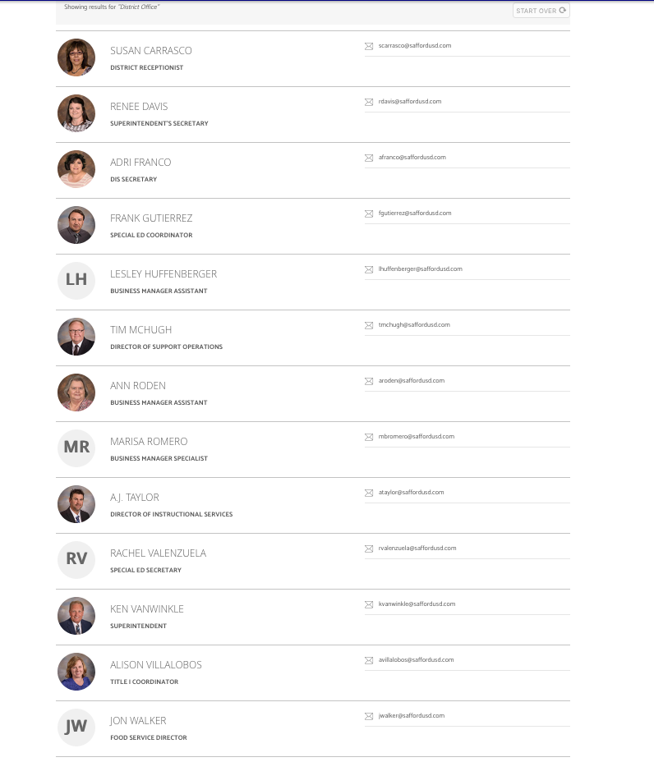

Safford Unified spent 67% more on special education than ASU Prep and had a total of $17,767,801 in revenue in 2019 while ASU Prep had $49,771,242 to spend. (To add injury to insult, Safford Unified tax payers paid 20% more in property taxes to support their schools than a rich district like Scottsdale Unified because tax rates depend on commercial property valuations, which Safford has little of).

ASU Prep Safford Unified Revenue and Expenditures 2019
 | ASU Prep | Safford
Enrollment | 3,100 | 3,028
Regular Instruction | $15,686,793 | $9,344,989
Special Education Instruction | $744,439 | $1,243,874
General Administration |  | $324,556
School Administration | $5,041,543 | $1,320,349
Central Administration | $9,038,562 | $711,453
Total Administration | $14,080,105 | $2,356,358
Total M&O | $45,595,114 | $21,228,258
Local Revenue | $21,281,378 | $4,264,271
State Revenue | $26,222,630 | $12,286,571
Federal Revenue | $2,267,234 | $1,216,959
Total Revenue | $49,771,242 | $17,767,801

2019 Tax Rates
Tax Rate | Safford Unified | Scottsdale Unified
Primary | $4.08 | 2.74
Secondary | $0.61 | 1.13
Total | $4.69 | $3.87

Comparison with Mesa Unified
Mesa Unified has been in the news recently regarding administrative bonus pay and concerns over the superintendent’s salary. Mesa Unified has 62,000 students and their superintendent, Ember Conley, made $294,481 last year. Mesa Unified executive salaries topped $2.6 million this year, according the AZ Central. ASU Prep, enrollment 3,000 students, had a superintendent making $560,000 and executive salaries of $1.5 million in 2018.

Effect of ASU Prep Digital
ASU donated $4,598,048 to ASU Digital in 2019, apparently in an effort to get that enterprise off the ground. The over contribution to ASU Digital, compared to the other ASU Prep schools, did not greatly effect overall revenue and expenditures.
ASU Prep vs. ASU Digital spending/ADM 2019
 | ASU Prep Per ADM | W/O Digital Per ADM
Regular Instruction | $5,060 | $5,037
Total Expenditures | $14,708 | $13,760
Local Revenue | $6,865 | $5,943
Total Revenue | $16,055 | $15,214

Citations for all data in the summary are included in the Data sections that follow
All ASU Prep Annual Financial Reports are at: http://www.ade.az.gov/Budget/EntitySelection.asp
ASU Prep annual audits are not available on the school, or University websites. See ProPublica at: https://projects.propublica.org/nonprofits/organizations/260664313
https://projects.propublica.org/nonprofits/organizations/260664313
https://www.azcentral.com/pages/interactives/news/local/arizona-data/arizona-government-salary-database/
https://asuprep.asu.edu/contact
https://asuprep.asu.edu/contact
https://asuprep.asu.edu/contact
October 1, 2018 Enrollment Report at: https://www.azed.gov/accountability-research/data/
Superintendents Annual Report 2019 Volume 2 at: https://www.azed.gov/superintendent/superintendents-annual-report/

