ASU Prep Charter Schools Are Completely Controlled Without Oversight by One Person:
Anna Battle Has Sole Control Over $34 Million in Tax Funds

The corporate bylaws of ASU Prep indicate that one person, Anna Battle, makes all business and educational decisions for the $40 million ($34 million state revenue) charter chain, including setting curriculum, hiring all employees and determining all staff salaries. Dr. Battle has had no supervision from the ASU Prep Board, in fact the Board does little except set their own meeting calendar and approve budgets as required by law. Anna Battle appears to be the most powerful executive, not just in Arizona education, but of any non-profit corporation in Arizona.

The corporate board of ASU Prep merged with the school board in 2013. Arizona statutes require charter school boards to set the policies of the school, while the corporate board makes the operational decisions for the corporation.

The ASU Prep Board does neither. Board meeting minutes from July 2013 to February 2021 reveal that the Board has dealt primarily with the board meetings calendar and the required school budgets every year. The Board has only approved six school policies in seven years and has not hired any employees, including the Prep CEO. No purchases were approved, no salaries were set, and no curriculum or instructional programs were discussed 2013-2021. ASU donated $13 million to ASU Prep in 2019 but the Board never discussed it. ASU halted donations in 2020, requiring classroom expenditures to be cut in half in 2020. Board minutes show no evidence that the Board was even aware of the reduction in teachers in 2020 from 310 to 172 - while enrollment increased.

So, who runs ASU Prep? The ASU Prep corporate bylaws reveal that all business and educational operations are under the sole authority of the “Senior Official”, the principal executive officer of the corporation. The Senior Official develops all curriculum and assessments, hires all employees and sets all salaries:

Section 7. The Senior Official. The Senior Official, or such other title as the Board may designate from time to time, shall be the principal executive officer of the Corporation and shall serve at the pleasure of the Board. The Senior Officer shall, subject to the oversight of the Board, supervise and control all of the business and affairs of the Corporation including, but not limited to the development and implementation of curriculum, assessments, and teacher evaluation and development. The Senior Official has the authority, subject to the rules as may be prescribed by the Board, to appoint such agents and employees of the corporation as he or she shall deem necessary, and prescribe powers, duties, and compensation, and to delegate authority to them. Such agents and employees shall hold office at the discretion of the Senior Official. In general, the Senior Official shall perform all of the duties incident to that office, and other such duties as may be prescribed by the Board from time to time.

The Senior Official’s selection, retention, and termination must be approved by the University President.

The current Senior Officer is Anna Battle. She was hired by ASU Prep in July 2018 as the chief leadership development officer, after serving as an assistant superintendent in the Tempe Union High School District. On August 12, 2019 the ASU Prep Board voted to make her the Senior Official of the corporation, giving her a seat on the Board. The Board did not, however, discuss her compensation. Each IRS 990 submission made by ASU Prep disclosed that CEO compensation is approved by the Board, but the Board has never discussed any employee’s salary since 2013. Based on the bylaws, Dr. Battle must have set her own salary.

While Dr. Battle’s salary is unknown, she has supposedly hired ASU Vice President Julie Young to be the Managing Director of ASU Prep (while Battle’s title is Head of Schools). Julie Young was paid $300,000 in 2020 by the University to manage ASU Prep. Battle also hired ASU Vice President Amy McGrath to be the Chief Operations Officer for ASU Prep Digital. ASU paid McGrath $275,000 in 2020. By contrast, the superintendent of Mesa Unified (enrollment 59,000) made $236,000 in 2020. ASU Prep’s total enrollment in 2020 was 3,800 students.
Both Young and McGrath work at ASU’s Educational Outreach Division that is headed by Senior Vice President James Rund. Dr. Rund is one of five members of the ASU Prep Board and is also the President’s designee as the ASU’s charter authorization director with the authority to make all of ASU’s decisions regarding the charter schools.
There are no policies to guide Anna Battle in her overreaching control of ASU Prep. Public records requests for ASU Prep policies and procedures resulted in the disclosure of only four documents related to the approval, amendment, and termination of a charter contract. Based on the ASU Prep bylaws, Dr. Battle has complete control of $34 million in state funds to spend as she alone sees fit, with no policies in place to guide her and with no apparent oversight from the Board or ASU.
It is highly unlikely of course that Anna Battle is making all of the business and educational decisions for ASU Prep and it is far more likely that the University, through VP James Rund and the Educational Outreach division, is running the charter schools – without transparency or regulation from either the ASU Prep Board or the University.
But maybe Anna Battle is in sole dictatorial control of the charter schools. Either way, $34 million in tax dollars are being appropriated without transparency and oversight, making the possibility of fraud and misuse of public funds a real possibility
Appendix 1 – Policies approved by ASU Prep Board 2013-2021
- July 9, 2013 - Board voted to merge corporate Board with school governing board
- July 2013 to September 25, 2018 – Board only approves calendars and budgets. No policies approved
- September 25, 2018 – Special education policy approved that added names of new schools. Policy not included in minutes
- Feb12, 2019 – Approved graduation credit requirements
- June 25, 2019 – Approved lottery admission policy
- July 8, 2019 – Approved purchasing policy (adding a purchasing from sex offender clause)
- August 12, 2000 – Approved mitigation plan and continuity of pay policy

Appendix 2 – ASU 2019 audit: University donations

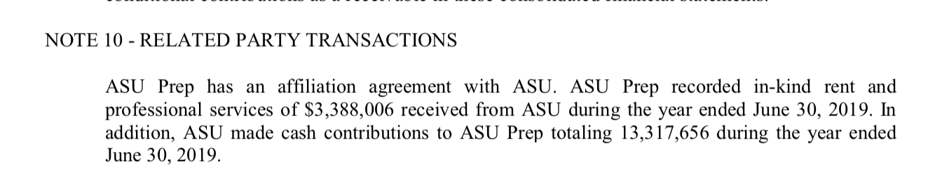

https://asuprep.asu.edu/sites/default/files/13_07_09_meeting_minutes_approved_0.pdf
ASU Prep Board minutes are at: https://asuprep.asu.edu/governance
See Appendix 1
See Appendix 2
ASU Prep Annual Financial Reports at: http://www.ade.az.gov/Budget/EntitySelection.asp
https://asusponsor.asu.edu/sites/default/files/second_amended_and_restated_bylaws_for_asu_prep_-_signed.docx.pdf
ASU Prep 990 submissions at: https://projects.propublica.org/nonprofits/organizations/260664313
ASU salaries at: https://www.statepress.com/article/2017/04/spinvestigative-salary-database
Superintendent’s salaries from Superintendent’s Annual Report 2020 at: https://www.azed.gov/finance/reports

