Charter School Prop 301 Funds Are In Complete Disarray:
Money targeted for teacher raises is an open checkbook for charter owners without oversight by the Charter Board

Jim Hall
Arizonans for Charter School Accountability
July 1, 2018

Prop 301 funds are a key component in the quest to increase teacher salaries in Arizona. The Arizona State Board for Charter Schools (Charter Board) has provided absolutely no accountability for the expenditure of Prop 301 funds by charter owners, allowing over 100 of the 417 charter holders to misuse Prop 301 funds and an additional 72 to fail to report how they expended the funds.

Without supervision from the Charter Board, the $75 million in Prop 301 funds given to charter schools is up for grabs. Charter schools bought bus passes, leased classrooms, paid administrators, and purchased health insurance with Prop 301 funds instead of increasing teacher salaries in 2017. They have left $34 million in Prop 301 funds unspent over the years to prop up their bottom lines.

ARS 15-977 spells out very specific rules for the expenditure of Prop 301 Classroom Site Funds (CSF). CSF must be distributed by districts and charters through a strict formula – 20% for Base Salary, 40% for Performance Compensation, and 40% for Other M&O uses to benefit classroom instruction. Other expenses includes class size reduction, additional teacher compensation, test preparation, teacher training, dropout prevention programs, and paying premiums for teacher liability insurance.

Public school districts generally spend all of the “Other” 301 funds to increase teacher’s salaries, spending over 90% of all 301 funds directly on teacher salaries and related benefits. ARS 15-977 C. provides detailed rules for how district teachers can qualify to receive additional performance money through rigorous evaluations, test scores, parent surveys, etc. 70% of district teachers have to approve a 301 plan before the district board can submit it to the state. Public districts must also submit a 301 Narrative every year describing in detail how funds were utilized.

Legislators purposely excluded charters from all of the rules required of districts to create a 301 plan. Charter schools do not have to inform teachers how they will receive 301 funds or to utilize evaluations or test scores to qualify for performance compensation. Charter administrators can basically dole out 301 funds in any way they wish. For example, teachers at Heritage Elementary Charter report that there was no explanation about how 301 raises were distributed and salary increases were only given to teachers that returned the following year, regardless of performance. This may be a widespread practice. Charters only have to set up budget categories reflecting the proper percentages for Base, Performance, and Other M&O spending and submit an annual narrative describing in detail how funds were utilized to insure that funds were properly spent.

The majority of charter holders are following the law. 265 charter owners (64%) used 60% or more of Prop 301 funds in 2017 to increase teacher pay, as the law requires. But only 164 charter schools (39%) expended over 90% of CSF funds for teacher salaries - the spending level of all public districts. (See Appendix 1, p.6 and Appendix 2, p.16)

The Charter Board has not examined charter 301 Narratives for years, allowing many charter owners to treat Prop 301 funds as an open checkbook to grow their businesses. 179 charter holders are simply not following state laws - apparently with the Charter Board’s blessing.

For example:
- 72 charters violated state law (ARS 15-977. H) by failing to submit a 301 Narrative in 2017 - an offense that could lead to the revocation of their charters. Two of the largest charter companies in Arizona did not submit the required narrative – the American Leadership Academy and all Edkey schools. Edkey did not submit the Narratives in 2016 as well without any question from the Charter Board. (See Appendix 3, p. 20)
- The 23 Great Hearts Academies submitted 301 Narratives that did not account for Base Pay and Performance Compensation, the only charter owners making this “mistake” - an err Great Hearts has made every year undetected since 2013. (See Appendix 4, p. 21 for an example)
- 61 Charters did not account for all expenditures reported on their Annual Financial Report (AFR) on the 301 Narrative. (See Appendix 5, p.21)
- 45 charters reported spending more on the Narrative than actually expended according to their AFR (See Appendix 6, 23)
- 58 charters did not spend Base and Performance funds for Teacher salary increases as required by law. American Virtual Academy spent $181,000 earmarked for teacher salaries on “Other” expenses. See Appendix 7, p.25)
- While not illegal, charters have accumulated over $34 million in unspent 301 funds that are added to their net assets. Online charters are given the same 301 funds as traditional schools, even though they have few teachers. Five online charters are sitting on $8.8 million in unspent 301 funds, adding to their net worth but doing nothing for Arizona teachers. (See Appendix 8, p.27)

Examples of inappropriate use of CSF

1. Using Prop 301 Classroom Site Funds to buy bus passes and pay administrators:
Career Success Charter School spent nothing on 301 teacher compensation in 2017 but spent $131,627 on “Dropout Prevention” defined in their Narrative as:

“Bus passes for retention and costs of teachers and administrators who developed and implemented a dropout program to concentrate on students who are at risk of dropping out.”
ARS 15-977 N. states : “Monies distributed from the classroom site fund for class size reduction, assessment intervention and dropout prevention programs shall only be used for instructional purposes in the instruction function as defined in the uniform system of financial records, except that monies shall not be used for school-sponsored athletics. “
Bus passes for students are not an instructional expense and administrators are expressly forbidden to receive CSF monies.

Career Success has been misusing 301 funds for years - their 2013 301 Narrative described expenditures for Dropout Prevention as:

“Bus passes for retention and a portion of Principal's wages to concentrate on dropout prevention by counseling students.”

The Charter Board never questioned paying 301 Funds to a principal. They never read the Narratives.

2. Using CSF to rent classroom space (from a related party):
The next two examples involve Compass High School. Compass has been illegally spending Prop 301 funds since 2012 without interference from the Charter Board.

Compass High School spent $91,806 for teacher compensation but also spent $76,096 for Dropout Prevention in 2017 defined in their Narrative as:
“Like all Schools we strive to affect the dropout rate every day. After 16 years of alternative education we have found that three things are crucial to saving a student from becoming a dropout; early identification, allocated space for either remediation or advisement/counseling and concerted effort by staff to make connections/relationships with these young adults to motivate them to complete their education. Specifically, the 301 monies spent for Dropout Prevention was spent to provide the space for the above items to be possible.”

The Compass High School’s 2012 301 Narrative regarding their Dropout Prevention program stated:

“Computers were purchased so that students could work independantly on their skills. Space was rented and provided for students to use AIMS based curriculum for better preparation.”

Compass High School leases all facilities from a member of the corporate board.
As state previously, dropout prevention funds can only be used for instructional purposes. Leasing facilities is not an instructional function.
3. Supplanting funds:
ARS 15-977 A. states “…Teacher compensation increases based on performance or teacher base salary increases distributed pursuant to this subsection shall supplement, and not supplant, teacher compensation monies from any other sources”

Compass High School spent $63,899 for Teacher liability insurance in 2017, explained in their 301 Narrative:

“As a school that uses alternative methods such as hands-on and project based learning to educate a large at-risk, FRL, and IEP student population, we have found that we must hire experienced and motivated teachers to tackle this difficult task. To attract these teachers it is important that we offer, as part of our hiring package, an excellent health insurance plan. These monies spent for Teacher Liability Insurance Premiums reflect this commitment to our teachers and staff.”

Compass High School, a for-profit company, paid nearly all teacher and instructional aide benefits, including health insurance, out of funds intended for teacher liability insurance. Compass only paid $4,000 for all benefits for over $1 million in teacher salaries in 2017 – the rest came from Prop 301 funds. Rather than supplementing Instruction benefits, Compass supplanted or replaced benefit costs with Prop 301 funds. Compass profited by $63,000 rather than utilizing additional funds for teacher salaries. This is a clear violation of the law. Compass has been doing this since 2015.

The Charter Board relies on a compliance questionnaire in the annual audit submitted by each charter owner to verify that Prop 301 funds are spent appropriately. This is the 301 compliance questionnaire submitted by Compass High School in 2017:

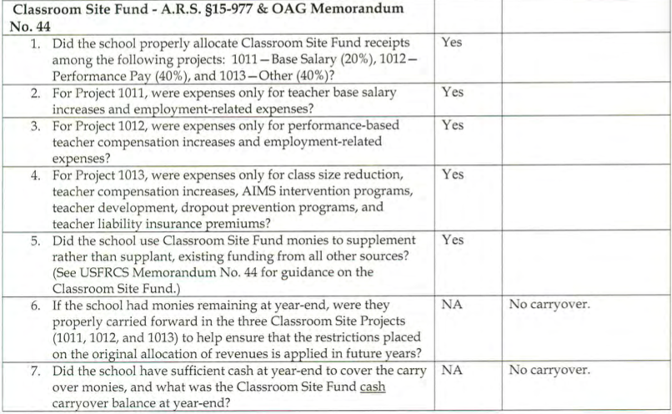

Every charter that failed to submit the 301 Narrative, and every charter that spent funds inappropriately had straight “Yes” answers on their 301 compliance questionnaires as well. The Charter Board sees “Yes” and their oversight is complete. The auditors hired by the charters are complicit in hiding just how the owners are spending Classroom Site Funds. The veracity of the entire audit process now becomes questionable.

Charter misuse of Prop 301 funds is widespread
It is impossible to catalog all the abuses associated with Prop 301 funds because so many charters failed to submit the required 301 Narratives or submitted wildly inconsistent spending numbers between their Annual Financial Reports and the 301 Narrative.

The teacher pay increases passed by the legislature this year will require charter owners to report the average teacher salaries for 2017-18 and the increase given teachers for the 2018-19 school year to verify that additional funds are actually going to raise teacher salaries. Based on the mess that surrounds charter expenditures of 301 funds, it unlikely that there will be a remotely accurate accounting of where the new funds earmarked for teacher salaries will actually be spent.

Charters are required by law to submit four financial documents – a budget, an annual financial report, an audit, and the 301 Narrative. We collected all of the charter data on 301 expenditures from their annual financial reports and the 301 Narratives in about 20 hours - opening each file and cutting and pasting the data. The Arizona Department of Education could provide the information to the Charter Board in less than an hour. The Charter Board has never bothered to verify if charter owners even submit the 301 Narrative, let alone read them. They see “Yes” on the compliance questionnaire and turn a blind eye to any potential abuse.

The Arizona State Board for Charter Schools has been unwilling to provide the audit and compliance oversight necessary to assure that charter owners are responsibly spending public funds. The Arizona Attorney General must demand that the Charter Board monitor charter schools’ expenditure of state funds or over turn over that responsibility to the Auditor General’s Office, like every other state agency.

There needs to be a complete audit of charter Prop 301 expenditures for each of the charters that failed to submit the Narrative and those that reported inappropriate or inconsistent expenditures.

Appendix 1

Charter Holders spending 60% or more of 301 funds for teacher Compensation
Charter Holder | CFS Narrative Teacher Compensation Increases | Total AFR Base+Performance Expenditures | Compensation ≥ than 60% of 301 AFR Expenditures
A Center for Creative Education | $31,426 | $22,557 | $8,869
Academy of Building Industries, Inc. | $76,450 | $52,550 | $23,900
Academy of Mathematics and Science South, Inc. | $137,108 | $58,375 | $78,733
Academy of Mathematics and Science, Inc. | $124,564 | $59,632 | $64,932
Academy of Mathematics and Science, Inc. | $148,551 | $61,960 | $86,591
Academy with Community Partners Inc. | $76,120 | $45,609 | $30,511
Accelerated Learning Center, Inc. | $130,304 | $73,970 | $56,334
Acclaim Charter School | $93,907 | $93,907 | $0
Acorn Montessori Charter School | $163,743 | $94,571 | $69,172
AIBT Non-Profit Charter High School - Phoenix | $33,118 | $33,121 | -$3
Akimel O Otham Pee Posh Charter School, Inc. | $4,948 | $2,905 | $2,043
Akimel O'Otham Pee Posh Charter School, Inc. | $64,863 | $31,726 | $33,137
All Aboard Charter School | $48,048 | $28,829 | $19,219
American Basic Schools LLC | $237,754 | $199,687 | $38,067
American Charter Schools Foundation d.b.a. Apache Trail High School | $66,539 | $44,130 | $22,409
American Charter Schools Foundation d.b.a. Crestview College Preparatory High Sc | $81,006 | $65,819 | $15,187
American Charter Schools Foundation d.b.a. Desert Hills High School | $72,685 | $52,158 | $20,527
American Charter Schools Foundation d.b.a. Estrella High School | $81,564 | $70,441 | $11,123
American Charter Schools Foundation d.b.a. Peoria Accelerated High School | $203,382 | $132,345 | $71,037
American Charter Schools Foundation d.b.a. South Ridge High School | $233,238 | $116,017 | $117,221
American Charter Schools Foundation d.b.a. Sun Valley High School | $227,571 | $129,812 | $97,759
American Charter Schools Foundation d.b.a. West Phoenix High School | $154,092 | $111,980 | $42,112
Aprender Tucson | $101,440 | $60,864 | $40,576
Arizona Academy of Science And Technology, Inc. | $19,599 | $14,301 | $5,298
Arizona Agribusiness & Equine Center, Inc. Prescott Valley | $91,387 | $91,387 | $0
Arizona Autism Charter Schools, Inc. | $66,305 | $39,783 | $26,522
Arizona Community Development Corporation | $746,931 | $457,954 | $288,977
Arizona Connections Academy Charter School, Inc. | $500,961 | $500,961 | $0
Arizona Language Preparatory | $10,953 | $10,953 | $0
Arizona Montessori Charter School at Anthem | $77,719 | $77,719 | $0
Arizona School For The Arts | $222,744 | $222,743 | $1
ASU Preparatory Academy - Casa Grande | $18,801 | $6,268 | $12,533
ASU Preparatory Academy Phoenix Elementary | $154,969 | $93,377 | $61,592
ASU Preparatory Academy Phoenix High School | $192,379 | $115,033 | $77,346
ASU Preparatory Academy Phoenix Middle School | $136,209 | $73,610 | $62,599
ASU Preparatory Academy Polytech Elementary | $142,808 | $84,086 | $58,722
ASU Preparatory Academy Polytech High School | $117,787 | $70,900 | $46,887
ASU Preparatory Academy Polytech Middle School | $134,667 | $81,687 | $52,980
Avondale Learning dba Precision Academy | $42,627 | $23,075 | $19,552
AZ Compass Schools, Inc. | $65,203 | $24,701 | $40,502
Az-Tec High School | $80,089 | $33,129 | $46,960
Ball Charter Schools (Dobson) | $170,779 | $111,377 | $59,402
Ball Charter Schools (Hearn) | $209,955 | $136,927 | $73,028
Ball Charter Schools (Val Vista) | $119,850 | $78,163 | $41,687
BASIS Schools, Inc. Ahwatukee | $308,302 | $184,981 | $123,321
BASIS Schools, Inc. Chandler | $374,513 | $224,708 | $149,805
BASIS Schools, Inc. Chandler Primary | $177,311 | $106,387 | $70,924
BASIS Schools, Inc. Chandler Primary North | $198,147 | $118,888 | $79,259
BASIS Schools, Inc. Flagstaff | $286,342 | $171,805 | $114,537
BASIS Schools, Inc. Goodyear | $83,991 | $50,395 | $33,596
BASIS Schools, Inc. Goodyear Primary | $217,643 | $130,586 | $87,057
BASIS Schools, Inc. Mesa | $282,378 | $169,427 | $112,951
BASIS Schools, Inc. Oro Valley | $264,176 | $158,506 | $105,670
BASIS Schools, Inc. OV Primary | $268,252 | $160,951 | $107,301
BASIS Schools, Inc. Peoria | $321,361 | $192,817 | $128,544
BASIS Schools, Inc. Phoenix | $344,624 | $206,775 | $137,849
BASIS Schools, Inc. Prescott | $304,095 | $182,457 | $121,638
BASIS Schools, Inc. Scottsdale | $445,488 | $267,293 | $178,195
BASIS Schools, Inc. Scottsdale Primary | $198,389 | $119,033 | $79,356
BASIS Schools, Inc. Tucson | $276,993 | $166,196 | $110,797
BASIS Schools, Inc. Tucson North | $441,016 | $264,610 | $176,406
BASIS Schools, Inc.Phoenix Central | $306,929 | $184,158 | $122,771
Benchmark School, Inc. | $171,433 | $102,860 | $68,573
Benjamin Franklin Charter School | $1,250,733 | $750,440 | $500,293
Blueprint Education | $190,365 | $79,213 | $111,152
Bright Beginnings School, Inc. | $162,329 | $118,246 | $44,083
Calibre Academy | $164,506 | $73,035 | $91,471
Cambridge Academy East, Inc | $73,947 | $61,422 | $12,525
Camino Montessori | $19,228 | $18,498 | $730
Canyon Rose Academy, Inc. | $103,004 | $103,003 | $1
Career Development, Inc. | $15,696 | $15,696 | $0
Carpe Diem Collegiate High School | $83,079 | $37,388 | $45,691
CASA Academy | $68,439 | $41,064 | $27,375
Center for Academic Success, Inc. | $449,062 | $288,759 | $160,303
Challenger Basic School, Inc. | $77,280 | $77,280 | $0
CITY Center for Collaborative Learning | $148,518 | $85,259 | $63,259
Collaborative Pathways, Inc. | $45,925 | $41,470 | $4,455
Compass Points International, Inc | $107,777 | $73,159 | $34,618
Concordia Charter School, Inc. | $40,080 | $40,043 | $37
Cornerstone Charter School,Inc | $63,934 | $63,934 | $0
Country Gardens Charter Schools | $114,195 | $114,195 | $0
Create Academy | $44,471 | $18,475 | $25,996
Daisy Education Corporation dba Paragon Science Academy | $199,636 | $119,782 | $79,854
Daisy Education Corporation dba Sonoran Science Academy | $290,997 | $174,598 | $116,399
Daisy Education Corporation dba Sonoran Science Academy - Phoenix | $139,900 | $83,940 | $55,960
Daisy Education Corporation dba. Sonoran Science Academy Davis Monthan | $107,185 | $64,311 | $42,874
Daisy Education Corporation dba. Sonoran Science Academy Peoria | $131,482 | $78,889 | $52,593
Deer Valley Charter Schools, Inc. | $36,377 | $21,844 | $14,533
Desert Heights Charter Schools | $54,610 | $54,610 | $0
Desert Rose Academy,Inc. | $61,227 | $61,227 | $0
Desert Sky Community School, Inc. | $24,943 | $15,950 | $8,993
Destiny School, Inc. | $100,664 | $100,664 | $0
Discovery Plus Academy | $38,738 | $28,350 | $10,388
E-Institute Charter Schools, Inc. | $209,044 | $90,074 | $118,970
EAGLE College Prep Harmony, LLC | $93,248 | $43,625 | $49,623
EAGLE College Prep Maryvale, LLC | $89,627 | $46,463 | $43,164
EAGLE South Mountain Charter, Inc. | $60,168 | $35,655 | $24,513
East Valley Academy | $5,875 | $3,525 | $2,350
Edge School, Inc., The | $89,337 | $82,245 | $7,092
Educational Options Foundation | $55,737 | $55,737 | $0
EduPreneurship, Inc. | $28,162 | $15,686 | $12,476
Eduprize Schools, LLC | $1,306,512 | $783,907 | $522,605
Espiritu Community Development Corp. | $158,703 | $95,222 | $63,481
Espiritu Community Development Corp. | $203,242 | $121,945 | $81,297
Espiritu Schools | $20,040 | $12,024 | $8,016
Estrella Educational Foundation | $7,205 | $7,207 | -$2
Excalibur Charter Schools, Inc. | $127,169 | $77,116 | $50,053
Fit Kids, Inc. dba Champion Schools | $674,883 | $331,149 | $343,734
Flagstaff Arts And Leadership Academy | $153,183 | $100,105 | $53,078
Flagstaff Junior Academy | $62,962 | $62,962 | $0
Flagstaff Montessori, L.L.C. | $79,434 | $47,661 | $31,773
Foothills Academy | $154,444 | $88,363 | $66,081
Fountain Hills Charter School | $39,986 | $23,392 | $16,594
Freedom Academy, Inc. | $193,077 | $139,803 | $53,274
Friendly House, Inc. | $115,350 | $115,350 | $0
GAR, LLC dba Student Choice High School | $145,903 | $145,903 | $0
Griffin Foundation, Inc. The | $77,675 | $77,673 | $2
Ha:san Educational Services | $55,054 | $33,692 | $21,362
Happy Valley East | $125,770 | $122,094 | $3,676
Happy Valley School, Inc. | $173,744 | $149,364 | $24,380
Haven Montessori Children's House, Inc. | $38,413 | $23,048 | $15,365
Heritage Elementary School | $359,044 | $222,710 | $136,334
Highland Free School | $12,929 | $9,320 | $3,609
Horizon Community Learning Center, Inc. | $183,295 | $183,295 | $0
Horizon Community Learning Center, Inc. | $175,210 | $175,210 | $0
Humanities and Sciences Academy of the United States, Inc. | $64,112 | $64,112 | $0
Imagine Camelback Middle, Inc. | $57,663 | $46,069 | $11,594
Imagine Charter Elementary at Camelback, Inc. | $57,663 | $46,069 | $11,594
Imagine Charter Elementary at Desert West, Inc. | $143,836 | $117,543 | $26,293
Imagine Coolidge Elementary, Inc. | $180,026 | $83,566 | $96,460
Imagine Prep Coolidge, Inc. | $70,251 | $50,153 | $20,098
Institute for Transformative Education, Inc. | $41,445 | $41,444 | $1
Integrity Education Incorporated | $13,287 | $13,287 | $0
International Commerce Secondary Schools, Inc. | $129,433 | $129,433 | $0
James Madison Preparatory School | $99,235 | $59,541 | $39,694
James Sandoval Preparatory High School | $13,665 | $13,665 | $0
Kaizen Education Foundation dba Advance U | $8,962 | $5,599 | $3,363
Kaizen Education Foundation dba Discover U Elementary School | $48,108 | $47,658 | $450
Kaizen Education Foundation dba El Dorado High School | $153,885 | $106,741 | $47,144
Kaizen Education Foundation dba Gilbert Arts Academy | $47,369 | $37,538 | $9,831
Kaizen Education Foundation dba Havasu Preparatory Academy | $83,219 | $64,642 | $18,577
Kaizen Education Foundation dba Liberty Arts Academy | $54,487 | $53,055 | $1,432
Kaizen Education Foundation dba Maya High School | $134,416 | $111,476 | $22,940
Kaizen Education Foundation dba Mission Heights Preparatory High School | $125,055 | $87,475 | $37,580
Kaizen Education Foundation dba Skyview High School | $56,753 | $46,269 | $10,484
Kaizen Education Foundation dba South Pointe Elementary School | $75,509 | $67,236 | $8,273
Kaizen Education Foundation dba South Pointe Junior High School | $35,895 | $34,182 | $1,713
Kaizen Education Foundation dba Summit High School | $160,880 | $91,790 | $69,090
Kaizen Education Foundation dba Tempe Accelerated High School | $27,341 | $14,877 | $12,464
Kaizen Education Foundation dba Vista Grove Preparatory Academy Middle School | $40,731 | $13,873 | $26,858
Kestrel Schools, Inc. | $7,000 | $5,708 | $1,292
Keystone Montessori Charter School, Inc. | $75,556 | $62,891 | $12,665
Khalsa Family Services | $71,068 | $71,068 | $0
Khalsa Montessori Elementary Schools | $52,806 | $28,636 | $24,170
Kingman Academy Of Learning | $491,166 | $376,899 | $114,267
La Tierra Community School, Inc | $27,912 | $27,912 | $0
LEAD Charter Schools | $217,580 | $217,580 | $0
LEAD Charter Schools dba Leading Edge Academy Queen Creek | $103,435 | $95,772 | $7,663
Leading Edge Academy Maricopa | $174,853 | $174,853 | $0
Legacy Education Group | $24,330 | $24,330 | $0
Legacy Traditional Charter School | $517,186 | $348,160 | $169,026
Legacy Traditional Charter School - Laveen Village | $345,142 | $208,567 | $136,575
Legacy Traditional Charter School - Maricopa | $542,709 | $371,763 | $170,946
Legacy Traditional Charter Schools - Casa Grande | $559,383 | $390,201 | $169,182
Legacy Traditional School - Avondale | $513,560 | $326,639 | $186,921
Legacy Traditional School - Chandler | $553,602 | $348,059 | $205,543
Legacy Traditional School - Gilbert | $420,763 | $255,787 | $164,976
Legacy Traditional School - Glendale | $337,853 | $202,712 | $135,141
Legacy Traditional School - North Chandler | $170,677 | $102,406 | $68,271
Legacy Traditional School - Northwest Tucson | $573,135 | $390,722 | $182,413
Legacy Traditional School - Peoria | $86,280 | $51,768 | $34,512
Legacy Traditional School - Surprise | $485,990 | $291,594 | $194,396
Leman Academy of Excellence, Inc. | $267,354 | $129,535 | $137,819
Liberty High School | $18,825 | $15,309 | $3,516
Liberty Traditional Charter School | $200,683 | $120,795 | $79,888
Lifelong Learning Research Institute, Inc. | $3,962 | $2,242 | $1,720
Lifelong Learning Research Institute, Inc. | $34,463 | $14,882 | $19,581
Little Lamb Community School | $142,426 | $106,524 | $35,902
Madison Highland Prep | $119,438 | $105,450 | $13,988
Masada Charter School, Inc. | $218,358 | $131,015 | $87,343
Math and Science Success Academy, Inc. | $137,405 | $61,757 | $75,648
Metropolitan Arts Institute, Inc. | $114,604 | $75,196 | $39,408
Mexicayotl Academy, Inc. | $92,252 | $81,446 | $10,806
Midtown Primary School | $51,799 | $31,687 | $20,112
Mingus Springs Charter School | $53,588 | $51,152 | $2,436
Mohave Accelerated Learning Center | $118,033 | $74,967 | $43,066
Montessori Day Public Schools Chartered, Inc. | $145,411 | $66,585 | $78,826
Montessori House, Inc. | $28,722 | $18,163 | $10,559
Montessori Schoolhouse of Tucson, Inc. | $41,735 | $25,041 | $16,694
Mountain Oak Charter School, Inc. | $34,863 | $34,863 | $0
Mountain Rose Academy, Inc. | $94,128 | $94,128 | $0
Mountain School, Inc. | $46,666 | $46,666 | $0
New Horizon School for the Performing Arts | $55,028 | $25,247 | $29,781
New World Educational Center | $94,207 | $60,632 | $33,575
Noah Webster Schools - Mesa | $206,557 | $206,557 | $0
Noah Webster Schools-Pima | $64,619 | $64,619 | $0
North Star Charter School, Inc. | $50,983 | $50,983 | $0
Ombudsman Educational Services, Ltd.,a subsidiary of Educational Services of Ame | $270,518 | $270,518 | $0
Omega Alpha Academy | $128,539 | $118,989 | $9,550
P.L.C. Charter Schools | $244,580 | $244,579 | $1
PACE Preparatory Academy, Inc. | $64,646 | $34,034 | $30,612
Painted Desert Demonstration Projects, Inc. | $24,998 | $14,612 | $10,386
Painted Pony Ranch Charter School | $38,777 | $38,777 | $0
Pan-American Elementary Charter | $234,321 | $103,872 | $130,449
Paragon Management, Inc. | $601,453 | $505,255 | $96,198
Park View School, Inc. | $96,200 | $59,000 | $37,200
Patagonia Montessori Elementary School | $14,474 | $8,685 | $5,789
PEAK School Inc., The | $73,510 | $44,106 | $29,404
Pensar Academy | $23,375 | $21,225 | $2,150
Phoenix Advantage Charter School, Inc. | $113,461 | $54,451 | $59,010
Phoenix Collegiate Academy Elementary, LLC | $62,185 | $37,311 | $24,874
Phoenix Collegiate Academy High LLC | $70,843 | $42,506 | $28,337
Phoenix Collegiate Academy, Inc. | $66,214 | $44,005 | $22,209
Phoenix Education Management, LLC, | $267,095 | $149,731 | $117,364
Phoenix School of Academic Excellence The | $47,058 | $45,586 | $1,472
Pillar Charter School | $22,766 | $14,691 | $8,075
Pima County | $19,366 | $19,366 | $0
Pima Prevention Partnership | $16,498 | $16,231 | $267
Pima Prevention Partnership dba Pima Partnership Academy | $14,692 | $14,682 | $10
Pima Prevention Partnership dba Pima Partnership School, The | $58,207 | $28,207 | $30,000
Pima Rose Academy, Inc. | $126,362 | $126,362 | $0
Pine Forest Education Association, Inc. | $119,020 | $92,704 | $26,316
PLC Arts Academy at Scottsdale, Inc. | $25,945 | $25,945 | $0
Pointe Educational Services | $519,680 | $348,680 | $171,000
Portable Practical Educational Preparation, Inc. (PPEP, Inc.) | $1,335,060 | $996,639 | $338,421
Premier Charter High School | $111,846 | $66,604 | $45,242
Prescott Valley Charter School | $74,109 | $74,109 | $0
Reid Traditional Schools' Painted Rock Academy Inc. | $138,794 | $138,794 | $0
Reid Traditional Schools' Valley Academy, Inc. | $158,865 | $158,865 | $0
RSD Charter School, Inc. | $41,670 | $41,670 | $0
Salt River Pima-Maricopa Community Schools | $150,174 | $150,174 | $0
Scottsdale Country Day School | $25,742 | $25,742 | $0
Sedona Charter School, Inc. | $69,376 | $41,261 | $28,115
Self Development Academy-Phoenix | $79,921 | $79,921 | $0
Self Development Charter School | $112,825 | $112,825 | $0
Skyline Gila River Schools, LLC | $62,962 | $17,173 | $45,789
Skyline Schools, Inc. | $65,106 | $26,320 | $38,786
Skyview School, Inc. | $90,599 | $52,656 | $37,943
Sonoran Desert School | $11,960 | $7,000 | $4,960
Sonoran Science Academy - Broadway | $127,112 | $76,267 | $50,845
South Phoenix Academy Inc. | $78,480 | $38,359 | $40,121
South Valley Academy, Inc. | $92,035 | $43,678 | $48,357
Southern Arizona Community Academy, Inc. | $31,468 | $31,467 | $1
StarShine Academy | $46,056 | $46,056 | $0
STEP UP Schools, Inc. | $40,667 | $24,400 | $16,267
Stepping Stones Academy | $83,178 | $53,680 | $29,498
StrengthBuilding Partners | $20,480 | $10,180 | $10,300
Success School | $199,638 | $199,638 | $0
SySTEM Schools | $34,816 | $11,605 | $23,211
Tempe Preparatory Academy | $212,406 | $124,551 | $87,855
The Farm at Mission Montessori Academy | $15,640 | $7,425 | $8,215
The Grande Innovation Academy | $160,060 | $90,372 | $69,688
The Paideia Academies, Inc | $239,363 | $140,853 | $98,510
The Shelby School | $15,790 | $9,474 | $6,316
Triumphant Learning Center | $25,025 | $25,025 | $0
Tucson Country Day School, Inc. | $192,058 | $115,299 | $76,759
Tucson International Academy, Inc. | $145,304 | $145,303 | $1
Tucson Youth Development/ACE Charter High School | $9,760 | $9,760 | $0
Vector School District, Inc. | $64,106 | $18,411 | $45,695
Villa Montessori Charter School | $195,670 | $116,357 | $79,313
Vision Charter School, Inc. | $12,423 | $12,423 | $0
Vista Charter School | $15,756 | $2,950 | $12,806
Vista College Preparatory, Inc. | $99,500 | $59,700 | $39,800
West Valley Arts and Technology Academy, Inc. | $91,985 | $91,985 | $0
Yuma Private Industry Council, Inc. | $29,417 | $29,417 | $0

Appendix 2

Charters spending over 90% of 301 funds on Teacher Compensation
Enrollment October 1, 2016 | Charter Holder | CFS Narrative Teacher Compensation Increases | CFS Narrative Total Expenses | Teacher Comp % of Total Narrative Expenses
121 | Academy of Building Industries, Inc. | $76,450 | $76,450 | 100%
505 | Academy of Mathematics and Science South, Inc. | $137,108 | $137,108 | 100%
419 | Academy of Mathematics and Science, Inc. | $148,551 | $148,551 | 100%
585 | Academy of Mathematics and Science, Inc. | $124,564 | $124,564 | 100%
128 | Academy with Community Partners Inc | $76,120 | $76,120 | 100%
183 | Accelerated Learning Center, Inc. | $130,304 | $130,304 | 100%
452 | Acorn Montessori Charter School | $163,743 | $166,915 | 98%
17 | Akimel O Otham Pee Posh Charter School, Inc. | $4,948 | $4,948 | 100%
117 | Akimel O'Otham Pee Posh Charter School, Inc. | $64,863 | $64,863 | 100%
116 | All Aboard Charter School | $48,048 | $48,048 | 100%
232 | Aprender Tucson | $101,440 | $101,440 | 100%
151 | Arizona Autism Charter Schools, Inc. | $66,305 | $66,305 | 100%
1999 | Arizona Community Development Corporation | $746,931 | $746,931 | 100%
235 | ASU Preparatory Academy Polytech High School | $117,787 | $117,787 | 100%
368 | ASU Preparatory Academy Polytech Elementary | $142,808 | $142,808 | 100%
358 | ASU Preparatory Academy Phoenix Middle School | $136,209 | $136,209 | 100%
300 | ASU Preparatory Academy Polytech Middle School | $134,667 | $134,667 | 100%
389 | ASU Preparatory Academy Phoenix Elementary | $154,969 | $154,969 | 100%
408 | ASU Preparatory Academy Phoenix High School | $192,379 | $192,379 | 100%
62 | ASU Preparatory Academy - Casa Grande | $18,801 | $18,801 | 100%
98 | Avondale Learning dba Precision Academy | $42,627 | $42,627 | 100%
156 | AZ Compass Schools, Inc. | $65,203 | $65,203 | 100%
96 | Az-Tec High School | $80,089 | $80,496 | 99%
478 | Ball Charter Schools (Dobson) | $170,779 | $185,627 | 92%
626 | Ball Charter Schools (Hearn) | $209,955 | $228,212 | 92%
336 | Ball Charter Schools (Val Vista) | $119,850 | $130,272 | 92%
804 | BASIS Schools, Inc. Tucson | $276,993 | $276,993 | 100%
1081 | BASIS Schools, Inc. Scottsdale | $445,488 | $445,488 | 100%
571 | BASIS Schools, Inc. Oro Valley | $264,176 | $264,176 | 100%
722 | BASIS Schools, Inc. Peoria | $321,361 | $321,361 | 100%
897 | BASIS Schools, Inc. Chandler | $374,513 | $374,513 | 100%
634 | BASIS Schools, Inc. Flagstaff | $286,342 | $286,342 | 100%
781 | BASIS Schools, Inc. Phoenix | $344,624 | $344,624 | 100%
1063 | BASIS Schools, Inc. Tucson North | $441,016 | $441,016 | 100%
648 | BASIS Schools, Inc. Mesa | $282,378 | $282,378 | 100%
756 | BASIS Schools, Inc. Ahwatukee | $308,302 | $308,302 | 100%
762 | BASIS Schools, Inc. OV Primary | $268,252 | $268,252 | 100%
786 | BASIS Schools, Inc. Prescott | $304,095 | $304,095 | 100%
880 | BASIS Schools, Inc.Phoenix Central | $306,929 | $306,929 | 100%
522 | BASIS Schools, Inc. Chandler Primary North | $198,147 | $198,147 | 100%
530 | BASIS Schools, Inc. Scottsdale Primary | $198,389 | $198,389 | 100%
441 | BASIS Schools, Inc. Chandler Primary | $177,311 | $177,311 | 100%
589 | BASIS Schools, Inc. Goodyear Primary | $217,643 | $217,643 | 100%
186 | BASIS Schools, Inc. Goodyear | $83,991 | $83,991 | 100%
426 | Benchmark School, Inc. | $171,433 | $171,433 | 100%
3084 | Benjamin Franklin Charter School | $1,250,733 | $1,250,733 | 100%
352 | Blueprint Education | $190,365 | $190,365 | 100%
654 | Bradley Academy of Excellence, Inc. | $86,840 | $86,840 | 100%
262 | Bright Beginnings School, Inc. | $162,329 | $162,329 | 100%
580 | Calibre Academy | $164,506 | $164,506 | 100%
329 | Cambridge Academy East, Inc | $73,947 | $74,547 | 99%
202 | Carpe Diem Collegiate High School | $83,079 | $83,079 | 100%
180 | CASA Academy | $68,439 | $68,439 | 100%
1180 | Center for Academic Success, Inc. | $449,062 | $479,892 | 94%
326 | CITY Center for Collaborative Learning | $148,518 | $148,518 | 100%
180 | Compass Points International, Inc | $107,777 | $107,777 | 100%
110 | Create Academy | $44,471 | $44,471 | 100%
476 | Daisy Education Corporation dba Paragon Science Academy | $199,636 | $199,636 | 100%
696 | Daisy Education Corporation dba Sonoran Science Academy | $290,997 | $290,997 | 100%
330 | Daisy Education Corporation dba Sonoran Science Academy - Phoenix | $139,900 | $139,900 | 100%
219 | Daisy Education Corporation dba. Sonoran Science Academy Davis Monthan | $107,185 | $107,185 | 100%
333 | Daisy Education Corporation dba. Sonoran Science Academy Peoria | $131,482 | $131,482 | 100%
18 | Deer Valley Charter Schools, Inc. | $36,377 | $36,377 | 100%
813 | Desert Heights Charter Schools | $54,610 | $54,610 | 100%
66 | Desert Sky Community School, Inc. | $24,943 | $24,943 | 100%
840 | E-Institute Charter Schools, Inc. | $209,044 | $209,044 | 100%
319 | EAGLE College Prep Harmony, LLC | $93,248 | $93,248 | 100%
280 | EAGLE College Prep Maryvale, LLC | $89,627 | $89,627 | 100%
634 | East Mesa Charter Elementary School, Inc. | $119,353 | $128,165 | 93%
12 | East Valley Academy | $5,875 | $5,875 | 100%
73 | EduPreneurship, Inc. | $28,162 | $28,162 | 100%
3528 | Eduprize Schools, LLC | $1,306,512 | $1,306,512 | 100%
336 | Espiritu Community Development Corp. | $158,703 | $158,703 | 100%
532 | Espiritu Community Development Corp. | $203,242 | $203,242 | 100%
39 | Espiritu Schools | $20,040 | $20,040 | 100%
25 | Estrella Educational Foundation | $7,205 | $7,205 | 100%
300 | Excalibur Charter Schools, Inc. | $127,169 | $127,169 | 100%
1118 | Fit Kids, Inc. dba Champion Schools | $674,883 | $674,883 | 100%
311 | Flagstaff Arts And Leadership Academy | $153,183 | $160,693 | 95%
192 | Flagstaff Montessori, L.L.C. | $79,434 | $79,434 | 100%
328 | Foothills Academy | $154,444 | $154,444 | 100%
84 | Fountain Hills Charter School | $39,986 | $39,986 | 100%
491 | Freedom Academy, Inc. | $193,077 | $193,077 | 100%
102 | Ha:san Educational Services | $55,054 | $55,054 | 100%
84 | Haven Montessori Children's House, Inc. | $38,413 | $38,413 | 100%
934 | Heritage Elementary School | $359,044 | $359,044 | 100%
45 | Highland Free School | $12,929 | $12,929 | 100%
166 | Imagine Camelback Middle, Inc. | $57,663 | $60,513 | 95%
380 | Imagine Charter Elementary at Camelback, Inc. | $57,663 | $60,513 | 95%
793 | Imagine Charter Elementary at Desert West, Inc. | $143,836 | $153,465 | 94%
653 | Imagine Coolidge Elementary, Inc. | $180,026 | $187,374 | 96%
379 | Imagine Desert West Middle, Inc. | $143,163 | $154,169 | 93%
382 | Imagine Middle at Surprise, Inc. | $84,238 | $92,114 | 91%
606 | Imagine Prep Coolidge, Inc. | $70,251 | $78,451 | 90%
185 | James Madison Preparatory School | $99,235 | $99,235 | 100%
138 | Khalsa Montessori Elementary Schools | $52,806 | $52,806 | 100%
1347 | Kingman Academy Of Learning | $491,166 | $491,166 | 100%
319 | LEAD Charter Schools dba Leading Edge Academy Queen Creek | $103,435 | $103,435 | 100%
673 | Leading Edge Academy Maricopa | $174,853 | $174,853 | 100%
1092 | Legacy Traditional Charter School | $517,186 | $517,186 | 100%
938 | Legacy Traditional Charter School - Laveen Village | $345,142 | $345,142 | 100%
1183 | Legacy Traditional Charter School - Maricopa | $542,709 | $542,709 | 100%
1177 | Legacy Traditional Charter Schools - Casa Grande | $559,383 | $559,383 | 100%
1300 | Legacy Traditional School - Avondale | $513,560 | $513,560 | 100%
1195 | Legacy Traditional School - Chandler | $553,602 | $553,602 | 100%
1148 | Legacy Traditional School - Gilbert | $420,763 | $420,763 | 100%
951 | Legacy Traditional School - Glendale | $337,853 | $337,853 | 100%
444 | Legacy Traditional School - North Chandler | $170,677 | $170,677 | 100%
1257 | Legacy Traditional School - Northwest Tucson | $573,135 | $573,135 | 100%
212 | Legacy Traditional School - Peoria | $86,280 | $86,280 | 100%
1349 | Legacy Traditional School - Surprise | $485,990 | $485,990 | 100%
976 | Leman Academy of Excellence, Inc. | $267,354 | $267,354 | 100%
533 | Liberty Traditional Charter School | $200,683 | $200,683 | 100%
12 | Lifelong Learning Research Institute, Inc. | $3,962 | $3,962 | 100%
31 | Lifelong Learning Research Institute, Inc. | $34,463 | $34,463 | 100%
262 | Little Lamb Community School | $142,426 | $142,426 | 100%
368 | Madison Highland Prep | $119,438 | $119,438 | 100%
521 | Masada Charter School, Inc. | $218,358 | $218,358 | 100%
470 | Math and Science Success Academy, Inc. | $137,405 | $137,405 | 100%
255 | Metropolitan Arts Institute, Inc. | $114,604 | $114,604 | 100%
116 | Midtown Primary School | $51,799 | $51,799 | 100%
478 | Mohave Accelerated Learning Center | $118,033 | $118,033 | 100%
294 | Montessori Day Public Schools Chartered, Inc. | $145,411 | $145,411 | 100%
48 | Montessori House, Inc. | $28,722 | $28,722 | 100%
92 | Montessori Schoolhouse of Tucson, Inc. | $41,735 | $41,735 | 100%
165 | New Horizon School for the Performing Arts | $55,028 | $55,028 | 100%
63 | New School for the Arts Middle School | $12,036 | $12,036 | 100%
202 | New World Educational Center | $94,207 | $94,207 | 100%
366 | Omega Alpha Academy | $128,539 | $128,539 | 100%
107 | PACE Preparatory Academy, Inc. | $64,646 | $64,646 | 100%
114 | Painted Desert Demonstration Projects, Inc. | $24,998 | $24,998 | 100%
168 | Park View School, Inc. | $96,200 | $96,200 | 100%
33 | Patagonia Montessori Elementary School | $14,474 | $14,474 | 100%
172 | PEAK School Inc., The | $73,510 | $73,510 | 100%
354 | Phoenix Advantage Charter School, Inc. | $113,461 | $113,461 | 100%
180 | Phoenix Collegiate Academy Elementary, LLC | $62,185 | $62,185 | 100%
161 | Phoenix Collegiate Academy High LLC | $70,843 | $70,843 | 100%
180 | Phoenix Collegiate Academy, Inc. | $66,214 | $66,214 | 100%
726 | Phoenix Education Management, LLC, | $267,095 | $276,968 | 96%
51 | Pillar Charter School | $22,766 | $22,766 | 100%
1362 | Pointe Educational Services | $519,680 | $519,680 | 100%
265 | Salt River Pima-Maricopa Community Schools | $150,174 | $150,174 | 100%
144 | Sedona Charter School, Inc. | $69,376 | $69,376 | 100%
69 | Shonto Governing Board of Education, Inc. | $25,938 | $28,902 | 90%
144 | Skyline Gila River Schools, LLC | $62,962 | $62,962 | 100%
137 | Skyline Schools, Inc. | $65,106 | $65,106 | 100%
228 | Skyview School, Inc. | $90,599 | $90,599 | 100%
41 | Sonoran Desert School | $11,960 | $11,960 | 100%
355 | Sonoran Science Academy - Broadway | $127,112 | $127,112 | 100%
305 | South Phoenix Academy Inc. | $78,480 | $78,480 | 100%
236 | South Valley Academy, Inc. | $92,035 | $92,035 | 100%
92 | STEP UP Schools, Inc. | $40,667 | $40,667 | 100%
207 | Stepping Stones Academy | $83,178 | $89,467 | 93%
117 | SySTEM Schools | $34,816 | $34,816 | 100%
442 | Tempe Preparatory Academy | $212,406 | $212,406 | 100%
43 | The Farm at Mission Montessori Academy | $15,640 | $15,640 | 100%
447 | The Grande Innovation Academy | $160,060 | $160,060 | 100%
697 | The Paideia Academies, Inc | $239,363 | $239,363 | 100%
35 | The Shelby School | $15,790 | $15,790 | 100%
699 | Tucson Country Day School, Inc. | $192,058 | $192,058 | 100%
205 | Vector School District, Inc. | $64,106 | $64,106 | 100%
493 | Villa Montessori Charter School | $195,670 | $195,670 | 100%
15 | Vista Charter School | $15,756 | $15,756 | 100%
239 | Vista College Preparatory, Inc. | $99,500 | $99,500 | 100%

Appendix 3

Charter Holders Not Submitting 301 Narratives 2017
Charter Holder Not Submitting 301 Narrative 2017 | Charter Holder Not Submitting 301 Narrative 2017
Academy Del Sol, Inc. | Harvest Power Community Development Group, Inc.
Allen-Cochran Enterprises, Inc. | Heritage Academy Laveen, Inc.
American Heritage Academy | Heritage Academy Queen Creek, Inc.
American Leadership Academy, Inc. | Heritage Academy, Inc.
Arizona Call-a-Teen Youth Resources, Inc. | Hirsch Academy A Challenge Foundation
Blue Adobe Project | Imagine Avondale Elementary, Inc.
CAFA, Inc. dba Learning Foundation and Performing Arts Alta Mesa | Imagine Avondale Middle, Inc.
CAFA, Inc. dba Learning Foundation and Performing Arts Gilbert | Incito Schools
CAFA, Inc. dba Learning Foundation Performing Arts School | Innovative Humanities Education Corporation
Camelback Education, Inc | Life Skills Center of Arizona, Inc.
Candeo Schools, Inc. | Maricopa County Community College District dba Gateway Early College High School
Challenge School, Inc. | Mary Ellen Halvorson Educational Foundation. dba: Tri-City Prep High School
Cochise Community Development Corporation | MCCCD on behalf of Phoenix College Preparatory Academy
CPLC Community Schools dba Hiaki High School | Milestones Charter School
CPLC Community Schools dba Toltecalli High School | Morrison Education Group, Inc.
Crown Charter School, Inc | Painted Desert Montessori, LLC
Desert Star Academy | Paramount Education Studies Inc
Desert Star Community School, Inc. | Pathways In Education-Arizona, Inc.
Edkey, Inc. - Arizona Conservatory for Arts and Academics | Pinnacle Education-Casa Grande, Inc.
Edkey, Inc. - Pathfinder Academy | Pinnacle Education-Kino, Inc.
Edkey, Inc. - Redwood Academy | Pinnacle Education-Tempe, Inc.
Edkey, Inc. - Sequoia Charter School | Pinnacle Education-WMCB, Inc.
Edkey, Inc. - Sequoia Choice Schools | Pioneer Preparatory School
Edkey, Inc. - Sequoia Pathway Academy | Rising Schools, Inc.
Edkey, Inc. - Sequoia Ranch School | San Tan Montessori School, Inc.
Edkey, Inc. - Sequoia School for the Deaf and Hard of Hearing | Southgate Academy, Inc.
Edkey, Inc. - Sequoia Village School | Southwest Leadership Academy
Employ-Ability Unlimited, Inc. | Telesis Center for Learning, Inc.
Empower College Prep | The Odyssey Preparatory Academy, Inc.
Ethos Academy - A Challenge Foundation Academy | Tucson Preparatory School
Florence Crittenton Services of Arizona, Inc. | Twenty First Century Charter School, Inc. Bennett Academy
Franklin Phonetic Primary School, Inc. | West Gilbert Charter Elementary School, Inc.
Franklin Phonetic Primary School, Inc. | West Gilbert Charter Middle School, Inc.
Gem Charter School, Inc. | Western School of Science and Technology, Inc.
Genesis Program, Inc. | Young Scholars Academy Charter School Corp.
Graysmark Schools Corporation
Great Expectations Academy

Appendix 4

Example of Greats Hearts incomplete 301 Narrative 2017

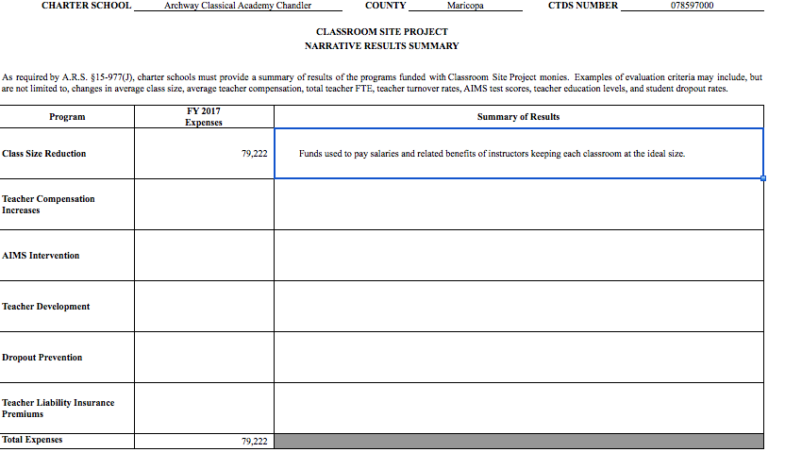

Appendix 5

Charters AFR 301 spending more than reported on the 301 Narrative
Charter Holder | CFS Narrative Total Expenses | Total 301 expenses AFR | Difference
Scottsdale Preparatory Academy | $144,893 | $374,239 | $229,346
Career Success Schools | $131,702 | $350,642 | $218,940
Cholla Academy | $18,402 | $208,219 | $189,817
Veritas Preparatory Academy | $121,773 | $302,779 | $181,006
Anthem Preparatory Academy | $125,146 | $303,110 | $177,964
Trivium Preparatory Academy | $107,132 | $280,962 | $173,830
East Mesa Charter Elementary School, Inc. | $128,165 | $296,709 | $168,544
Chandler Preparatory Academy | $125,132 | $288,948 | $163,816
Imagine Desert West Middle, Inc. | $154,169 | $315,568 | $161,399
Arete Preparatory Academy | $92,931 | $244,097 | $151,166
Archway Classical Academy Glendale | $80,774 | $222,257 | $141,483
Archway Classical Academy Veritas | $80,180 | $206,575 | $126,395
Archway Classical Academy Cicero | $77,059 | $202,876 | $125,817
Archway Classical Academy Chandler | $79,222 | $202,482 | $123,260
Archway Classical Academy North Phoenix | $74,941 | $196,761 | $121,820
Archway Classical Academy Arete | $78,927 | $198,370 | $119,443
Montessori Education Centre Charter School | $72,950 | $192,112 | $119,162
Glendale Preparatory Academy | $95,518 | $214,477 | $118,959
Maryvale Preparatory Academy | $69,659 | $181,109 | $111,450
Rosefield Charter Elementary School, Inc. | $117,318 | $227,987 | $110,669
Archway Classical Academy Lincoln | $77,979 | $187,143 | $109,164
Cicero Preparatory Academy | $71,683 | $180,515 | $108,832
Pathfinder Charter School Foundation | $70,655 | $179,254 | $108,599
Bradley Academy of Excellence, Inc. | $86,840 | $194,604 | $107,764
Archway Classical Academy Trivium West | $82,178 | $186,820 | $104,642
North Phoenix Preparatory Academy | $71,480 | $175,719 | $104,239
Ridgeline Academy, Inc. | $215,879 | $315,815 | $99,936
Imagine Middle at Surprise, Inc. | $92,114 | $188,967 | $96,853
Imagine Elementary at Tempe, Inc. | $10,112 | $106,928 | $96,816
Archway Classical Academy Scottsdale | $59,940 | $154,409 | $94,469
Archway Classical Academy Trivium East | $69,464 | $156,246 | $86,782
Bell Canyon Charter School, Inc | $56,190 | $138,795 | $82,605
Valley of the Sun Waldorf Education Association, dba Desert Marigold School | $55,297 | $134,775 | $79,478
Boys & Girls Clubs of the East Valley dba Mesa Arts Academy | $24,386 | $101,610 | $77,224
Imagine Prep Surprise, Inc. | $76,273 | $147,309 | $71,036
Lincoln Preparatory Academy | $49,568 | $109,344 | $59,776
Imagine Prep Superstition, Inc. | $51,089 | $106,940 | $55,851
New School For The Arts | $37,291 | $92,408 | $55,117
George Gervin Youth Center, Inc. | $45,682 | $100,000 | $54,318
Teleos Preparatory Academy | $32,234 | $85,402 | $53,168
Imagine Prep Coolidge, Inc. | $78,451 | $128,604 | $50,153
Cortez Park Charter Middle School, Inc. | $44,311 | $82,132 | $37,821
PAS Charter, Inc., dba Intelli-School | $63,012 | $94,561 | $31,549
Imagine Superstition Middle, Inc. | $24,967 | $55,731 | $30,764
Imagine Middle at East Mesa, Inc. | $25,212 | $49,962 | $24,750
SC Jensen Corporation, Inc. dba Intelli-School | $21,599 | $45,387 | $23,788
Montessori Academy, Inc. | $43,997 | $66,347 | $22,350
Flagstaff Junior Academy | $71,574 | $90,553 | $18,979
New School for the Arts Middle School | $12,036 | $30,188 | $18,152
Sage Academy, Inc. | $36,795 | $53,833 | $17,038
Intelli-School, Inc. | $24,953 | $41,539 | $16,586
Portable Practical Educational Preparation, Inc. (PPEP, Inc.) | $294,032 | $304,786 | $10,754
StarShine Academy | $71,450 | $76,760 | $5,310
Estrella Educational Foundation | $7,205 | $12,012 | $4,807
Career Development, Inc. | $21,443 | $26,204 | $4,761
Phoenix Education Management, LLC, | $276,968 | $280,842 | $3,874
Blueprint Education | $190,365 | $193,259 | $2,894
Mohave Accelerated Learning Center | $118,033 | $120,151 | $2,118
Open Doors Community School, Inc. | $74,498 | $75,230 | $732
Presidio School | $183,094 | $183,803 | $709
CITY Center for Collaborative Learning | $148,518 | $148,913 | $395

Appendix 6

Charters Reporting less expenditures on the 301 Narrative than expenses reported on the AFR
Charter Holder | CFS Narrative Total Expenses | Total 301 expenses AFR | Difference
Concordia Charter School, Inc. | $62,056 | $62,019 | -$37
Pima Prevention Partnership | $61,837 | $61,570 | -$267
Success School | $333,031 | $332,730 | -$301
Happy Valley East | $204,298 | $203,490 | -$808
Fountain Hills Charter School | $39,986 | $38,987 | -$999
Kestrel Schools, Inc. | $14,724 | $13,583 | -$1,141
Camino Montessori | $32,797 | $29,385 | -$3,412
Liberty High School | $46,614 | $43,098 | -$3,516
Happy Valley School, Inc. | $257,272 | $248,940 | -$8,332
Legacy Traditional Charter School | $517,186 | $508,551 | -$8,635
Mexicayotl Academy, Inc. | $104,602 | $93,795 | -$10,807
Mountain School, Inc. | $120,425 | $107,936 | -$12,489
Create Academy | $44,471 | $31,011 | -$13,460
Humanities and Sciences Academy of the United States, Inc. | $124,321 | $110,343 | -$13,978
Kaizen Education Foundation dba South Pointe Elementary School | $128,689 | $112,060 | -$16,629
American Charter Schools Foundation d.b.a. Alta Vista High School | $228,628 | $208,918 | -$19,710
American Charter Schools Foundation d.b.a. South Pointe High School | $223,811 | $198,513 | -$25,298
Kaizen Education Foundation dba Gilbert Arts Academy | $90,797 | $62,564 | -$28,233
Legacy Traditional School - Chandler | $553,602 | $523,127 | -$30,475
Montessori Day Public Schools Chartered, Inc. | $145,411 | $110,975 | -$34,436
Kaizen Education Foundation dba Liberty Arts Academy | $123,174 | $88,425 | -$34,749
American Charter Schools Foundation d.b.a. Crestview College Preparatory High Sc | $146,492 | $109,698 | -$36,794
Compass High School, Inc. | $235,076 | $197,300 | -$37,776
American Charter Schools Foundation d.b.a. Estrella High School | $157,166 | $117,402 | -$39,764
Kaizen Education Foundation dba Vista Grove Preparatory Academy Middle School | $65,523 | $23,121 | -$42,402
Kaizen Education Foundation dba South Pointe Junior High School | $102,833 | $56,970 | -$45,863
Kaizen Education Foundation dba Vista Grove Preparatory Academy Elementary | $156,777 | $110,032 | -$46,745
Academy of Tucson, Inc. | $371,863 | $322,242 | -$49,621
Kaizen Education Foundation dba Skyview High School | $127,894 | $77,115 | -$50,779
Kaizen Education Foundation dba Tempe Accelerated High School | $76,834 | $24,795 | -$52,039
Pan-American Elementary Charter | $271,325 | $212,401 | -$58,924
Kaizen Education Foundation dba Discover U Elementary School | $139,257 | $79,430 | -$59,827
American Charter Schools Foundation d.b.a. Apache Trail High School | $139,173 | $73,550 | -$65,623
Kaizen Education Foundation dba Havasu Preparatory Academy | $173,426 | $107,737 | -$65,689
Kaizen Education Foundation dba Advance U | $76,665 | $9,332 | -$67,333
Kaizen Education Foundation dba Maya High School | $258,532 | $185,793 | -$72,739
Kaizen Education Foundation dba Mission Heights Preparatory High School | $221,859 | $145,791 | -$76,068
American Charter Schools Foundation d.b.a. Desert Hills High School | $200,639 | $86,930 | -$113,709
American Charter Schools Foundation d.b.a. Peoria Accelerated High School | $334,364 | $220,576 | -$113,788
Fit Kids, Inc. dba Champion Schools | $674,883 | $560,445 | -$114,438
American Charter Schools Foundation d.b.a. West Phoenix High School | $308,093 | $186,633 | -$121,460
Kaizen Education Foundation dba Summit High School | $277,810 | $152,983 | -$124,827
Kaizen Education Foundation dba El Dorado High School | $328,993 | $177,902 | -$151,091
American Charter Schools Foundation d.b.a. South Ridge High School | $395,164 | $193,362 | -$201,802
American Charter Schools Foundation d.b.a. Sun Valley High School | $427,630 | $216,353 | -$211,277

Appendix 7

Charters spending Base funds and Teacher Compensation funds for Other uses
Charter Holder | CFS Narrative Teacher Compensation Increases | Total AFR Base+Performance Expenditures | Money not spent on Teacher Compensation Increases
Academy Of Excellence, Inc. | $20,477 | $24,977 | -$4,500
Academy of Tucson, Inc. | $118,946 | $207,179 | -$88,233
Accelerated Elementary and Secondary Schools | $6,157 | $53,132 | -$46,975
American Charter Schools Foundation d.b.a. Alta Vista High School | $116,241 | $125,351 | -$9,110
American Charter Schools Foundation d.b.a. South Pointe High School | $108,276 | $119,107 | -$10,831
American Virtual Academy | $1,004,111 | $1,185,250 | -$181,139
Arizona Agribusiness & Equine Center, Inc. Paradise Valley | $123,062 | $133,093 | -$10,031
Arizona Agribusiness & Equine Center, Inc. Red Mountain | $74,385 | $75,385 | -$1,000
Arizona Agribusiness & Equine Center, Inc. SMCC | $136,510 | $146,339 | -$9,829
Arizona Agribusiness & Equine Center, Inc. Estrella | $128,303 | $137,722 | -$9,419
Bell Canyon Charter School, Inc | $47,214 | $82,605 | -$35,391
Boys & Girls Clubs of the East Valley dba Mesa Arts Academy |  | $60,966 | -$60,966
Bradley Academy of Excellence, Inc. | $86,840 | $107,964 | -$21,124
Career Success Schools |  | $218,939 | -$218,939
Cholla Academy | $7,429 | $124,291 | -$116,862
Compass High School, Inc. | $91,806 | $118,380 | -$26,574
Cortez Park Charter Middle School, Inc. | $37,530 | $37,821 | -$291
Desert Springs Academy | $12,226 | $18,340 | -$6,114
East Mesa Charter Elementary School, Inc. | $119,353 | $168,544 | -$49,191
Eastpointe High School, Inc. | $136,575 | $141,034 | -$4,459
Ed Ahead | $12,000 | $17,724 | -$5,724
Educational Impact, Inc. | $15,307 | $45,918 | -$30,611
George Gervin Youth Center, Inc. | $8,867 | $60,000 | -$51,133
Hermosa Montessori Charter School | $43,573 | $54,372 | -$10,799
Imagine Desert West Middle, Inc. | $143,163 | $161,399 | -$18,236
Imagine Elementary at Tempe, Inc. | $3,628 | $64,157 | -$60,529
Imagine Middle at East Mesa, Inc. | $20,984 | $24,750 | -$3,766
Imagine Middle at Surprise, Inc. | $84,238 | $105,352 | -$21,114
Imagine Prep Superstition, Inc. | $42,176 | $55,851 | -$13,675
Imagine Prep Surprise, Inc. | $64,969 | $87,188 | -$22,219
Imagine Superstition Middle, Inc. | $20,155 | $30,764 | -$10,609
Intelli-School, Inc. | $8,318 | $24,904 | -$16,586
Juniper Tree Academy | $100,000 | $117,520 | -$17,520
Kaizen Education Foundation dba Vista Grove Preparatory Academy Elementary | $54,853 | $66,019 | -$11,166
Mohave Accelerated Elementary School, Inc. | $71,826 | $104,392 | -$32,566
Montessori Academy, Inc. | $14,724 | $51,623 | -$36,899
Montessori Education Centre Charter School | $33,052 | $119,162 | -$86,110
New School For The Arts |  | $55,117 | -$55,117
New School for the Arts Middle School | $12,036 | $18,152 | -$6,116
Northland Preparatory Academy | $152,848 | $184,400 | -$31,552
Nosotros, Inc | $107,209 | $133,462 | -$26,253
Open Doors Community School, Inc. | $45,375 | $46,107 | -$732
PAS Charter, Inc., dba Intelli-School | $21,004 | $52,553 | -$31,549
Pathfinder Charter School Foundation | $62,407 | $108,599 | -$46,192
Portable Practical Educational Preparation, Inc. (PPEP, Inc.) | $214,653 | $225,406 | -$10,753
Presidio School | $109,572 | $110,282 | -$710
Research Based Education Corporation | $9,693 | $27,264 | -$17,571
Ridgeline Academy, Inc. | $44,653 | $144,589 | -$99,936
Rosefield Charter Elementary School, Inc. | $103,130 | $110,669 | -$7,539
Sage Academy, Inc. | $0 | $29,303 | -$29,303
Santa Cruz Valley Opportunities in Education, Inc. | $4,483 | $13,450 | -$8,967
Satori, Inc. | $30,883 | $34,855 | -$3,972
SC Jensen Corporation, Inc. dba Intelli-School | $7,200 | $30,988 | -$23,788
Shonto Governing Board of Education, Inc. | $25,938 | $26,052 | -$114
The Charter Foundation, Inc. | $59,495 | $131,137 | -$71,642
Valley of the Sun Waldorf Education Association, dba Desert Marigold School |  | $79,478 | -$79,478
Victory High School, Inc. | $1,698 | $4,690 | -$2,992
Great Hearts Incomplete Narratives
Anthem Preparatory Academy |  | $177,964 | -$177,964
Archway Classical Academy Arete |  | $119,443 | -$119,443
Archway Classical Academy Chandler |  | $123,260 | -$123,260
Archway Classical Academy Cicero |  | $125,817 | -$125,817
Archway Classical Academy Glendale |  | $141,483 | -$141,483
Archway Classical Academy Lincoln |  | $109,164 | -$109,164
Archway Classical Academy North Phoenix |  | $121,820 | -$121,820
Archway Classical Academy Scottsdale |  | $94,469 | -$94,469
Archway Classical Academy Trivium East |  | $86,782 | -$86,782
Archway Classical Academy Trivium West |  | $104,642 | -$104,642
Archway Classical Academy Veritas |  | $126,395 | -$126,395
Arete Preparatory Academy |  | $151,166 | -$151,166
Chandler Preparatory Academy |  | $163,816 | -$163,816
Cicero Preparatory Academy |  | $108,832 | -$108,832
Lincoln Preparatory Academy |  | $59,776 | -$59,776
North Phoenix Preparatory Academy |  | $104,239 | -$104,239
Maryvale Preparatory Academy |  | $111,450 | -$111,450
Scottsdale Preparatory Academy |  | $229,346 | -$229,346
Teleos Preparatory Academy |  | $53,168 | -$53,168
Trivium Preparatory Academy |  | $173,830 | -$173,830
Veritas Preparatory Academy |  | $181,006 | -$181,006
Glendale Preparatory Academy |  | $118,959 | -$118,959

Appendix 8

Charters > $200,000 unspent 301 funds
Charter Holder | Total 301 Balance
Portable Practical Educational Preparation, Inc. (PPEP, Inc.) | $2,977,669
American Virtual Academy | $2,877,065
Pinnacle Education-Tempe, Inc. | $1,219,038
E-Institute Charter Schools, Inc. | $854,777
Educational Options Foundation | $818,356
Kingman Academy Of Learning | $580,564
Salt River Pima-Maricopa Community Schools | $511,186
Ombudsman Educational Services, Ltd.,a subsidiary of Educational Services of Ame | $494,531
Desert Heights Charter Schools | $466,986
Center for Academic Success, Inc. | $453,224
Skyline Schools, Inc. | $436,161
Calibre Academy | $415,745
Rosefield Charter Elementary School, Inc. | $399,910
LEAD Charter Schools | $391,750
Imagine Charter Elementary at Desert West, Inc. | $362,790
Pan-American Elementary Charter | $357,851
Paragon Management, Inc. | $330,908
Az-Tec High School | $325,860
South Phoenix Academy Inc. | $316,310
P.L.C. Charter Schools | $288,620
Maricopa County Community College District dba Gateway Early College High School | $282,920
AIBT Non-Profit Charter High School - Phoenix | $276,070
Arizona Agribusiness & Equine Center, Inc. SMCC | $271,544
Pioneer Preparatory School | $261,900
Imagine Coolidge Elementary, Inc. | $261,739
Pima Prevention Partnership dba Pima Partnership School, The | $260,137
Bradley Academy of Excellence, Inc. | $245,313
Intelli-School, Inc. | $240,258
Tucson Youth Development/ACE Charter High School | $238,586
Imagine Prep Coolidge, Inc. | $237,062
Leading Edge Academy Maricopa | $235,141
Employ-Ability Unlimited, Inc. | $234,015
Pathfinder Charter School Foundation | $225,418
Vector School District, Inc. | $221,743
CPLC Community Schools dba Toltecalli High School | $216,750
Mountain School, Inc. | $211,634
South Valley Academy, Inc. | $210,465
Arizona Agribusiness & Equine Center, Inc. Paradise Valley | $208,105
Cortez Park Charter Middle School, Inc. | $201,610
Math and Science Success Academy, Inc. | $201,321
Arizona Agribusiness & Equine Center, Inc. Estrella | $201,111
Total 301 Balance all Charters | 34,643,879

Appendix 9

Career Success 301 Narrative 2017

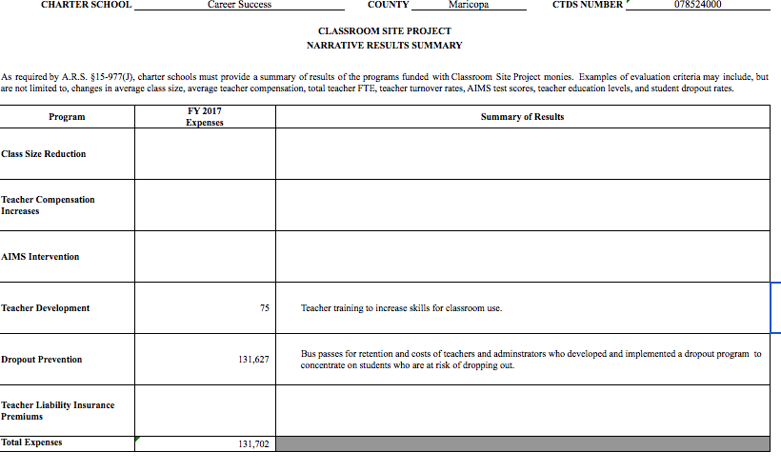

Appendix 10

Compass High School 301 Narrative 2012

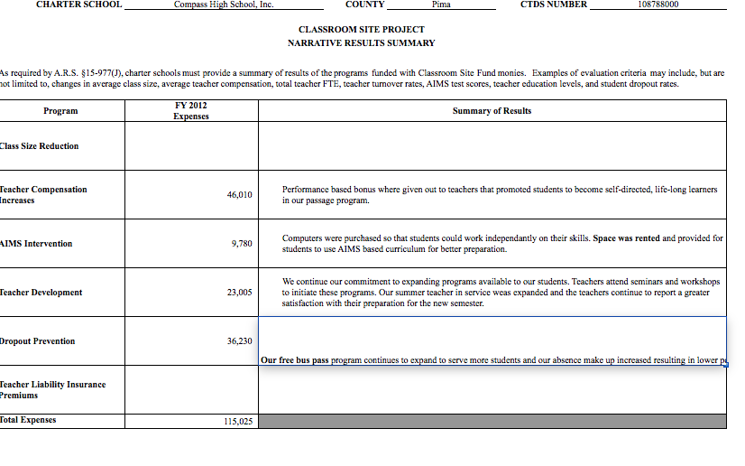

Appendix 11

Compass High School 301 Narrative 2017

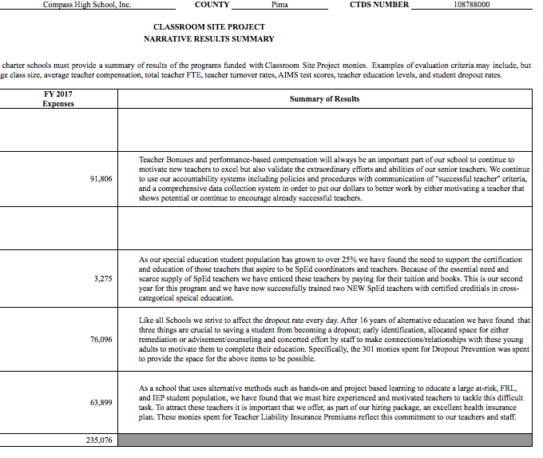

Appendix 12

Compass High School 2017 Annual Financial Report
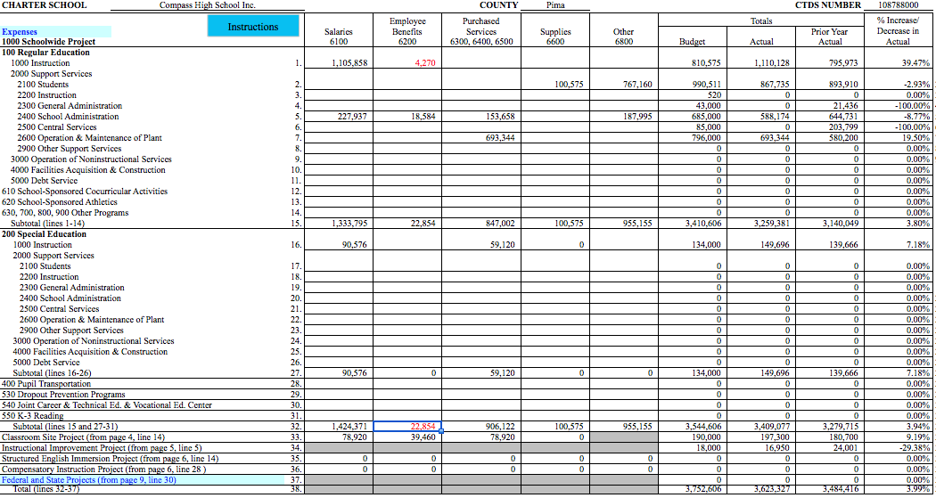

https://www.azauditor.gov/sites/default/files/Prop%20301%20Highlight.pdf
The Career Success 301 Narrative is in Appendix 9, p. 29
Career Success 301 Narratives can be found at: https://www.ade.az.gov/Budget/SubmittedFileStatus/SubmittedFileStatus.asp?NS=True&DR=5&FY=2013&TVR=21-3054&RPP=1&PC=&Subm=True&btnSubmit=++++Go%21++++
Compass High School 2012 301 Narratives are in Appendix 10 p. 30. 2012 Narrative is in Appendix 11 p. 31
See Appendix 12 p. 32 for the 2017 Compass Annual Financial Report
The complete charter 301 data file is available at azcsa.org

